
student academic performance Decision Support System for further education
[Document subtitle]


OMETH DAHAMVIN ILAMPERUMA
Candidate Number: 0362
Centre Number: 12144
Contents
ANALYSIS CHAPTER 3
AN OUTLINE OF THE PROBLEM AND PROPOSED SOLUTION 3
STAKEHOLDERS 3
HOW THE PROBLEM CAN BE SOLVED BY COMPUTATIONAL METHODS 3
THINKING ABSTRACTLY 3
THINKING AHEAD 4
THINKING PROCEDURALLY 4
THINKING LOGICALLY 4
THINKING CONCURRENTLY 4
RESEARCH 5
ANALYSIS OF EXISTING SYSTEMS 7
TES Engage (Progress Tracking System) 7
Google Classroom (Learning Management System) 8
Moodle (Learning Management System) 9
FEATURES OF THE PROPOSED SOLUTION 9
LIMITATIONS 10
HARDWARE AND SOFTWARE REQUIREMENTS 10
HARDWARE: 10
SOFTWARE: 11
SUCCESS CRITERIA 11
DESIGN CHAPTER 14
System Architecture 14
Systems Diagram 14
Database Design 15
Student Table 15
Entities 15
Modules of the Student Performance Decision Support System 16
CSV import 16
Predicted Grade Calculation 16
At Risk Level Identification 16
Suggested Interventions 16
Sorting Student Records 17
Search Students 17
Export Student Report 17
Login 17
User Interface Design 17
Usability Features 20
Simple and Intuitive Login Screen 20
Clean and Consistent Dashboard Layout 21
Role-Based Interface Simplification 22
Validation on Dashboard Functions 23
Clear Feedback and System Status Indicators 23
Consistency in Controls and Terminology 23
Structured and Readable Data Presentation 24
Algorithm Design 24
Key variables and Data structures 37
Test Plans 39
Test data for Iterative testing 39
Post-development test scenarios 44
DEVELOPMENT CHAPTER 47
Introduction 47
Iteration 1 -Database model – 03-March-2026 47
Iteration 2 -Student Class – 07-March-2026 52
Iteration 3 – User Interface - 07-March-2026 55
Iteration 4 – CSV Import -07-3-2026 61
Iteration 5 – Sorting Algorithm - 08-3-2026 65
Iteration 6 – Searching Algorithm- 08-3-2026 68
Iteration 8 – Module Grade Distribution and Visual Analytics -11‑03‑2026 72
Iteration 9 – PDF Report Export- 11‑03‑2026 75
Iteration 10 – Login System and Role-Based User Interface- 15-03-2026 79
EVALUATION CHAPTER 83
Introduction 83
Post-Development Testing 83
Authentication and Role-Based Access 83
CSV Import, Validation, and Robustness 85
Search Functionality and Access Control 86
Sorting Functionality 88
At-Risk Identification and Boundary Testing 89
Export Report Function 90
Suggested Intervention Function 92
Module Grade Distribution Chart 93
Usability Testing 94
Dashboard Layout and Learnability 94
Feedback, Validation, and Error Prevention 95
Role-Based Interface Simplification 97
Evaluation of Success Criteria 98
Fully Met Success Criteria 98
Partially Met Success Criteria 99
Usability Success Criteria 99
Maintenance Considerations and Limitations 99
Further Development 99
Conclusion 100
References 101
APPENDIX 103
Full Code 103

ANALYSIS CHAPTER

AN OUTLINE OF THE PROBLEM AND PROPOSED SOLUTION
In further education institutes in the UK, monitoring and analysing student academic performance is often a time-consuming and largely manual process. Teachers are required to extract student marks from the Virtual Learning Environment (VLE), calculate averages, determine risk levels, estimate predicted grades, and record suggested interventions. These tasks are frequently completed using spreadsheets or separate documents, which increases the likelihood of human error, duplication of work, and inconsistent decision-making. Additionally, generating clear and visual summaries of performance for parents and academic management can be inefficient and lacks standardisation.
Another key issue is the early identification of at-risk students. Without an automated system, teachers must manually interpret grade data to determine which students require additional support. This can delay intervention, potentially affecting student progression and achievement. Furthermore, parents often have limited, delayed, or fragmented access to meaningful information about their child’s academic performance, making it difficult for them to provide timely support.
The proposed Student Performance Decision Support System (DSS) aims to address these challenges by providing a centralised, computational solution that improves efficiency, accuracy, transparency, and early intervention in student performance management. For this project, I am planning to develop a Student Performance Decision Support System (DSS) for further education institutes in the UK. The system will enable teachers to track student grades, identify at-risk students, generate structured reports, produce module-wise grade distribution graphs, and suggest appropriate interventions. It will also provide parents with clear and accessible information about their child’s academic progress. Through automated analysis, the system will determine risk levels, highlight students who may require additional support, and calculate predicted grades for summative examinations, ensuring timely and informed decision-making.
For this system to function effectively, it must support the export of student formative exam data for a given module. The required data includes student ID, student name, module name, average mark, attendance and homework completion. This information can be extracted from the institution’s Virtual Learning Environment (VLE) as a CSV file. The CSV file can then be uploaded into the Student Performance Decision Support System (DSS), allowing the system to store, organise, and retrieve student records efficiently.

STAKEHOLDERS
The primary stakeholders of the system are teachers and parents:
- Teachers: Will use the system to efficiently track student performance, identify issues, and make data-driven decisions.
- Parents: Will use the system to monitor their child’s progress and engage with college interventions.
I have selected Ms. Smith, a Computer Science tutor at ABC College in the UK, to represent the primary target user of the system. She has daily responsibility for tracking student grades, calculating predicted grades, identifying risk levels, and recording intervention strategies. Currently, she performs these tasks manually using Google Documents before transferring the information into a separate computerised system where students can view their grades and feedback.
This process is time-consuming, repetitive, and increases the risk of human error. Ms. Smith has clearly expressed the need for a more automated solution that provides accurate calculations, clear visual summaries, and efficient report generation. Maintaining regular communication with her throughout the development process ensures that the system is designed around real classroom practices and directly addresses the practical challenges faced by teachers.

HOW THE PROBLEM CAN BE SOLVED BY COMPUTATIONAL METHODS
This problem is well-suited for computational methods because the DSS involves data processing, pattern recognition, and algorithmic decision-making. Using computational thinking:

THINKING ABSTRACTLY
Abstraction allows unnecessary complexity to be removed so that the system can focus on the most important elements required for decision-making. In this project, students, grades, modules, and intervention strategies are represented as structured data objects, enabling the system to process and manage information efficiently. Instead of storing excessive historical details, the system generates simplified performance indicators such as predicted grade and risk level to provide clear and meaningful summaries. Student performance is visualised through charts rather than raw numerical data, making trends and concerns easier to interpret. Additionally, role-based access is implemented to abstract the differences between teacher and parent views, ensuring that each user sees only the information relevant to their role while maintaining data privacy.

THINKING AHEAD
Thinking ahead is essential to ensure that the system is developed in a structured and organised manner. The primary inputs to the system include student names, module details, grades, and average scores imported from a CSV file. From these inputs, the system produces meaningful outputs such as individual PDF reports, performance graphs, risk alerts, and suggested interventions. The solution is implemented using Python as the programming language, with Tkinter for the graphical user interface, Matplotlib for data visualisation, ReportLab for PDF report generation, and SQLite for data storage and management. In terms of user interaction, teachers are able to import data, search for students, analyse performance, and generate reports, while parents can securely access their child’s performance summary and downloadable PDF reports.

THINKING PROCEDURALLY
Thinking procedurally involves breaking the system down into clear, manageable components so that it can be developed and implemented in a logical, step-by-step manner. The system is organised into several functional modules. These include importing student performance data from a CSV file, searching and retrieving specific student records, calculating predicted grades, identifying at-risk students based on predefined criteria, and recommending appropriate intervention strategies. The reporting module generates module-wise visual summaries and produces structured PDF reports for teachers and parents. Finally, the access control component ensures that teachers have full access to all student records and analytical features, while parents are restricted to viewing only their own child’s performance information, thereby maintaining data privacy and security.

THINKING LOGICALLY
Thinking logically ensures that the system operates correctly and produces accurate, rule-based outcomes. The system applies conditional logic to analyse student data and make decisions automatically. For example, if a student’s average falls below a predefined threshold, the system flags the student as at-risk and enables appropriate intervention recommendations. When a parent logs into the system, access control logic ensures that only their child’s performance data is displayed, protecting student privacy. Iterative processes are used to calculate class averages and identify performance trends across modules. After all necessary calculations and analysis have been completed, reports are generated automatically based on predefined rules, ensuring consistency, accuracy, and efficiency in decision-making.

THINKING CONCURRENTLY
Efficiency in the system is improved by running operations concurrently. For example, while one process calculated student grades and determines at-risk status, another process can simultaneously update data visualisations such as module grade distributions. Similarly, PDF reports can be generated in the background while the teacher continues to interact with the system, allowing multiple tasks to be completed without unnecessary waiting and improving overall responsiveness and user experience.

RESEARCH
Research – Interview with Teacher: Initial Requirements
To design a system that truly fits classroom needs, an interview was conducted with Ms. Smith, a Computer Science tutor at ABC College in the UK. The goal was to understand her current workflow, challenges, and the features she would like to see in a student performance tracking system.
Plan
The interview aimed to explore the teacher’s daily workflow, difficulties in managing student performance, and desired features for a performance tracking system.
Questions Asked
- How do you currently track student performance?
- What challenges do you face when calculating grades?
- What reports or visualisations would be helpful?
- Should the system provide intervention suggestions?
Transcript Summary
From the discussion, several key points emerged:
- Manual tracking is time-consuming and repetitive.
- Calculating predicted grades and averages by hand increases the risk of errors.
- Identifying at-risk students requires manual review, delaying interventions.
- Reports for parents need to be clear and easy to interpret.
- Automated grade predictions and risk identification would save significant time.
- Visual indicators, dashboards, and alerts are essential for spotting performance issues quickly.
Detailed Analysis of Current Problems
Excessive Administrative Workload
Teachers spend significant time exporting data, entering it into spreadsheets, calculating averages, predicting grades, and determining risk levels manually.
Increased Risk of Human Error
Manual data handling can lead to mistakes in calculations, grade predictions, or risk classification, which may affect academic decisions and parent communication.
Inconsistent Decision-Making
Without structured rules, teachers may apply slightly different criteria when assessing student performance, leading to inconsistencies across classes or modules.
Delayed Identification of At-Risk Students
Manually analysing grades slows the detection of performance drops, delaying timely support for struggling students.
Fragmented Data Storage
Student performance data is often scattered across multiple documents or systems, making it harder to retrieve and increasing the likelihood of outdated or inconsistent records.
Limited Visual Insight
Spreadsheets display raw numbers that do not easily highlight trends, gaps, or grade distributions. Teachers need clear visual summaries for quick, informed decision-making.
Time-Consuming Parent Reporting
Preparing reports manually takes time and may result in inconsistent communication to parents.

How the Proposed System Addresses These Needs
Automated Calculations
Once a CSV file is uploaded, averages, predicted grades, and risk levels are calculated automatically, reducing workload and errors.
Consistent Rule-Based Analysis
Predefined logic ensures fair and consistent assessment of at-risk students across all modules.
Early Risk Alerts: Students below defined thresholds are automatically flagged, allowing proactive support.
Centralised Data Management
A structured SQLite database stores all student records efficiently for easy retrieval.
Visual Dashboards and Graphs
Grade distributions and performance charts provide instant visual insight.
Automated PDF Report Generation
Standardised, professional reports for teachers and parents reduce preparation time.
Secure Role-Based Access
Teachers have full access, while parents see only their child’s data, ensuring privacy and compliance with data protection.
Research Outcome
The research highlights that teachers need a system that is accurate, automated, intuitive, and reduces administrative burden. They require consistent performance analysis, early identification of at-risk students, and clear visual summaries to support decision-making. Parents need structured and accessible reports, with access securely restricted. The proposed Student Performance Decision Support System addresses these needs directly, offering a practical, user-focused solution that aligns with real classroom challenges.

ANALYSIS OF EXISTING SYSTEMS

TES Engage (Progress Tracking System)
TES Engage is a web-based progress tracking platform mainly designed for use on desktop systems within schools. It is a commercial system, meaning schools must purchase a licence to use it.
The platform focuses on monitoring student attainment and predicting future outcomes, such as GCSE grades. It analyses past assessment data, including mock exam results, to generate automatic target grades and highlight students who may be at risk of underperforming.
Some of its key features include progress-over-time graphs, real-time data dashboards, automatic target grade generation, and automatic import of assessment data from exams and internal tests. These tools help teachers quickly identify trends, gaps between expected and actual performance, and sudden drops in achievement, allowing earlier intervention.
A major benefit of TES Engage is its efficiency. Because assessment data can be imported automatically, teachers spend less time on manual data entry and administrative tasks. This allows them to focus more on lesson planning, marking, and supporting students.
However, the system can be complex, especially for new or less experienced users. Staff may require training to use it effectively. In addition, access is usually limited to teachers, meaning students and parents may not be able to independently view real-time progress data.
Overall, TES Engage is a powerful data-driven tool for monitoring and supporting student progress, although its complexity and restricted access may limit usability for some users (www.tes.com, n.d., 2026).

Google Classroom (Learning Management System)
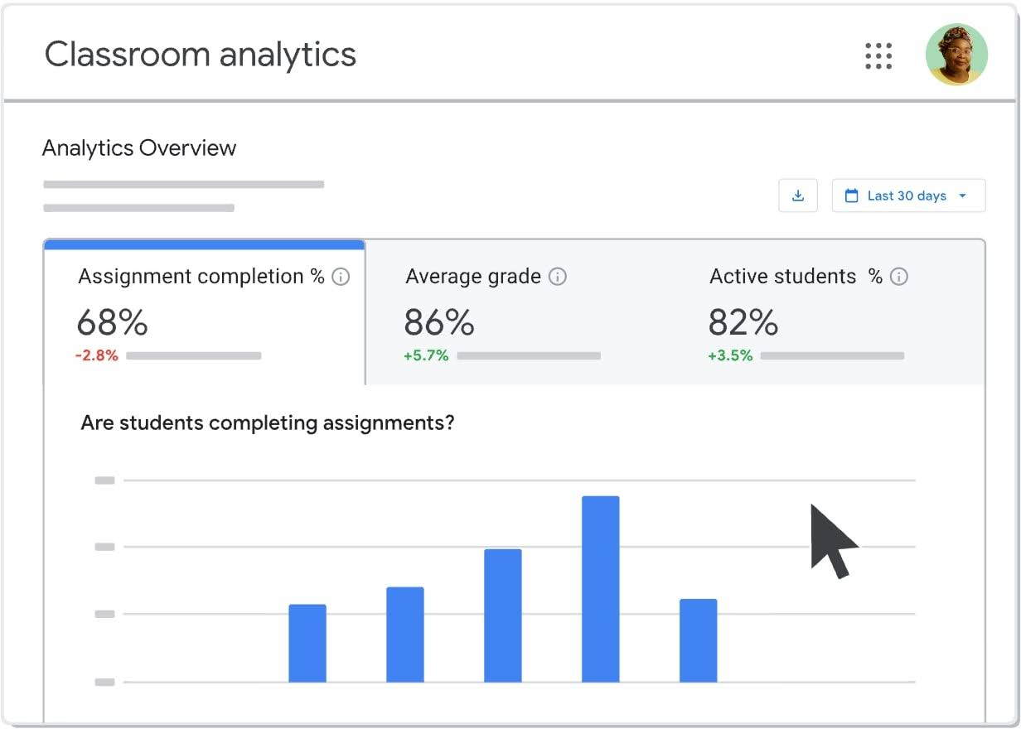

(Google for Education, 2026)
Google Classroom is a web-based platform that can be accessed on both desktop and mobile devices. It is free for schools that use Google Workspace for Education. Although it is mainly designed as a learning management system, it also offers some basic features that help track student progress.
Teachers can create and distribute assignments, collect work online, provide grades and feedback, and communicate with students through announcements and comments. The platform includes assignment tracking, grade summaries, and real-time feedback, as well as integration with tools such as Google Docs, Sheets, and Drive.
One of the main strengths of Google Classroom is how simple and accessible it is. Students can easily check their assignments, deadlines, and grades at any time, which encourages independence and responsibility. Since it works on both computers and mobile devices, it also supports communication outside school hours.
However, Google Classroom has limited analytical features. It does not offer predictive grade calculations, detailed performance dashboards, cohort comparisons, or automatic identification of at-risk students. Progress tracking is mainly based on assignment grades and completion, which may not give a complete picture of long-term academic performance.
Overall, Google Classroom is effective for managing coursework and monitoring basic progress, but it lacks the deeper analytical tools needed for advanced decision-based tracking. (Google for Education, 2026).

Moodle (Learning Management System)
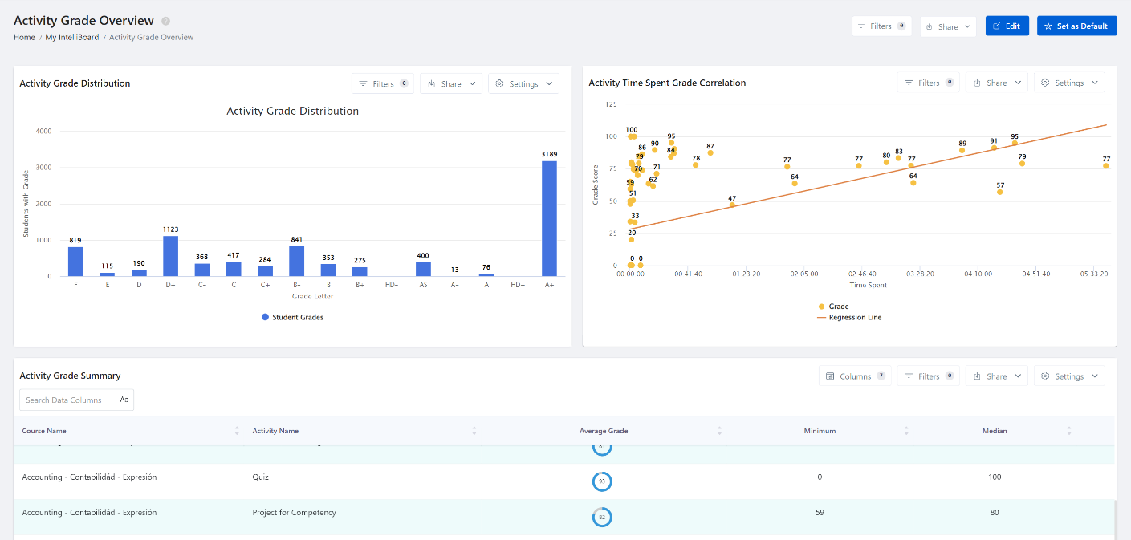

(Moodle, 2017)
Moodle is an open-source learning management system that supports online learning, course organisation, and student progress monitoring. It is web-based and can be accessed from different devices, making it suitable for both classroom and remote learning.
Teachers can upload learning materials, create assignments and quizzes, and manage grades using the built-in gradebook. Moodle also includes activity completion tracking, which allows teachers to see whether students have accessed resources and completed required tasks. This can help identify students who may be disengaged or falling behind.
One of Moodle’s biggest strengths is its flexibility. Because it is open-source, schools can customise the system and add plugins to expand its features, including additional analytics tools. This makes it adaptable to different school requirements.
However, Moodle can be more technical to set up and manage compared to simpler platforms. Its wide range of features may require training and technical support to ensure that all tools, especially progress tracking features, are used effectively.
Overall, Moodle provides a flexible and customisable environment that supports both learning management and student progress monitoring, though it may require more technical expertise to implement successfully (Moodle, 2017).

FEATURES OF THE PROPOSED SOLUTION
- Student Management: Sort and search student records.
- Performance Analysis: Module grade distributions predicted grades and risk flags.
- Intervention Suggestions: Automatic alerts for at-risk students.
- Report Generation: PDFs with charts for teachers and parents.
- Role-Based Access: Teachers have full access; parents have limited access.
- Dashboard: Visual overview of class and individual performance.

LIMITATIONS
One limitation of the system is in its predictive accuracy. Currently, it uses simple thresholds to access student performance, which means it may not capture every factor that affects a learner's results. While this approach is not as precise as advances statistical machine learning models, it was chosen deliberately to keep the system simple, easy to use, and fast for teachers to make decisions.
Scalability is another consideration. The system relies on SQLite as its database, which works well for small to medium-sized colleges or training centres. However, for lager institutions or multi-campus settings, a more powerful database might be needed to handle bigger volumes of data efficiently and maintain smooth performance.
Parent access is also limited in the current design. Parents can view only one student at a time, which helps protect sensitive information and maintain privacy. In the future, this could be expanded if additional security measures are put in place.
Finally, report generation depends on the local computer’s resources, since the system operates offline. This ensures that the system is accessible without an internet connection and keeps it lightweight, but it may make it more difficult to share reports remotely or work collaboratively with other educators.

HARDWARE AND SOFTWARE REQUIREMENTS

HARDWARE:

A standard desktop computer or laptop capable of running a graphical desktop application.

The computer must have at least 4GB of RAM to ensure smooth operation of the user interface, database processing, visual charts, and PDF report generation.

A monitor with sufficient resolution is required so that dashboards, tables, graphs, and pie charts can be displayed clearly and interpreted accurately.

No specialist hardware is required, ensuring the system can be used easily in a typical school or home environment without additional cost.

SOFTWARE:
- Python 3.14, Tkinter, Matplotlib, ReportLab
- SQLite3 database
- A standard desktop computer or laptop capable of running a graphical desktop application.
- The computer must have at least 4GB of RAM to ensure smooth operation of the user interface, database processing, visual charts, and PDF report generation.
- A monitor with sufficient resolution is required so that dashboards, tables, graphs, and pie charts can be displayed clearly and interpreted accurately.
- No specialist hardware is required, ensuring the system can be used easily in a typical school or home environment without additional cost.

SUCCESS CRITERIA
The system will meet several key requirements to ensure it is both effective and practical for educators and parents.
ID | Success Criterion | How it will be Measured/Tested | Justification
SC1 | The system must correctly authenticate users and assign the correct role (teacher/parent). | Attempt valid and invalid logins; verify correct access is granted or denied in 100% of cases. | Ensures secure access to sensitive student data and supports role-based functionality.
SC2 | The system must enforce role-based access control. | Log in as teacher and parent and verify access restrictions (e.g., parents cannot access full dataset). | Protects student privacy and ensures the system meets stakeholder requirements.
SC3 | The system must successfully import CSV data and store it without errors. | Import a CSV file and verify that all records are correctly stored and persist after restart. | Reduces manual data entry and demonstrates efficient computational data handling.
SC4 | The system must allow accurate searching by student name or ID. | Perform searches using valid and invalid inputs; confirm correct results and validation messages. | Improves efficiency compared to manual searching and enhances usability.
SC5 | The system must correctly identify at-risk students. | Test students with averages above and below 50; verify correct classification in all cases. | Supports early intervention, which is a key requirement identified in the problem.
SC6 | The system must calculate predicted grades accurately and consistently. | Input identical data multiple times and confirm the same predicted grade is produced. | Ensures reliable, standardised decision-making and reduces human error.
SC7 | The system must generate appropriate intervention suggestions. | Compare outputs against predefined rules for different performance levels. | Provides actionable insights, supporting teachers in decision-making.
SC8 | The system must generate accurate visualisations (pie charts). | Generate charts and compare values against actual dataset distributions. | Enhances understanding of data through visual representation.
SC9 | The system must generate a complete PDF report. | Export a report and verify all required fields and charts are included and correctly formatted. | Automates reporting, reducing workload and ensuring consistency.
SC10 | The system must correctly sort student data. | Apply ascending and descending sorting and verify correct order of records. | Demonstrates use of algorithms and improves data analysis.
SC11 | The system must handle errors without crashing. | Test invalid inputs, missing files, and incorrect CSV formats; confirm appropriate error messages appear. | Ensures system reliability and suitability for real-world use.
SC12 | The system must provide a user-friendly interface. | Observe users completing tasks (search, report generation) without assistance. | Ensures accessibility for both teachers and parents.
SC13 | The system must perform efficiently. | Measure response time for key actions (search, sort, report generation) — should be under 2–3 seconds. | Demonstrates the effectiveness of computational methods over manual processes.

DESIGN CHAPTER

System Architecture
The Student Academic Performance Decision Support System will be designed as a modular desktop application and will be developed using the Python programming language. The system will follow a layered architecture to ensure maintainability, clarity, and separation of concerns.
The architecture consists of:
- Presentation layer (TKinter UI)
- Application Logic layer (Processing and Algorithms)
- Data storage layer (SQLite Database)
This layered architecture ensures that the user interface, processing logic and database operations are independent. This reduces complexity and allows each component to be tested individually.

Systems Diagram
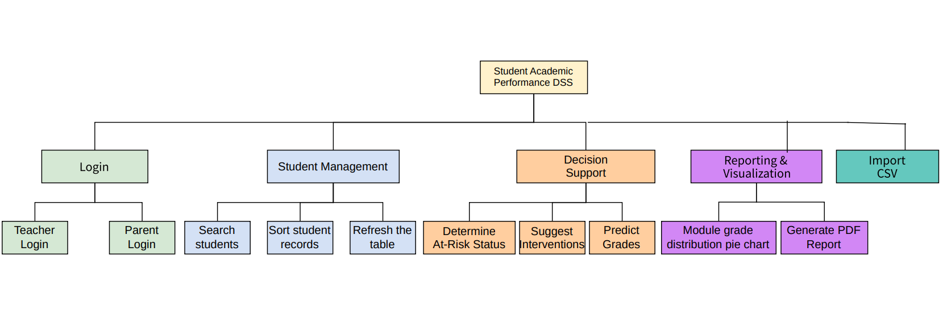

Using top-down modular design helps me plan and structure my solution before I start coding. By breaking the overall problem into smaller, manageable parts, I can focus on each component individually and understand its specific requirements. This approach allows me to apply computational thinking skills such as thinking ahead by identifying the required inputs and expected outputs for each module before implementation and thinking logically by determining where decisions are needed and evaluating how those decisions may affect other parts of the system. Overall, this method gives my solution a clear structure, making it easier to develop the program systematically and efficiently while reducing errors and improving maintainability.

Database Design
The backend of the Student Academic Performance DSS utilises a Relational Database Management System (RDBMS) via SQLite. The design follows a Single-Table Schema (Flat File approach), optimised for high-speed read/write operations during CSV imports from college Virtual Learning Environments (VLEs).
The system centralises all academic metrics into a single entity: students. This structure ensures that the DSS can perform real-time calculations (such as Predicted Grade, Suggested Interventions and Risk Analysis) without the overhead of complex table joins.

Student Table
Attribute | Data Type | Constraint | Description
studentid | TEXT | PRIMARY KEY | Unique identifier used to prevent duplicate records during VLE imports.
name | TEXT | NOT NULL | The full name of the student for reporting purposes.
module | TEXT | NOT NULL | The specific academic module or course code.
average | REAL |  | The numerical mean score; the primary driver for grade logic.
attendance | REAL | DEFAULT 100 | Percentage of presence, used for grade prediction weighting.
homeworkcomplete | INTEGER | DEFAULT 1 | A boolean flag (1/0) indicating task completion status.
Table Name: Student

Entities
Since the current version of the DSS will focus on a specific snapshot of student performance, the system will contain only one strong entity: Student.
- Primary Key (PK): The studentid acts as the unique anchor.
- Other non-primary key attributes: name, module, average, Letter Grade, GPA, attendance and homework complete

Modules of the Student Performance Decision Support System

CSV import
The purpose of the CSV file import module is to allow educators to efficiently upload and store multiple student records into the system at once instead of entering them manually. It reads structured data from a CSV file, validates and converts necessary fields (such as average and attendance), and saves the information into the SQLite database while preventing duplicate entries. After importing, it updates the system’s internal data and refreshes the display so the newly added students can be viewed and managed within the Academic Performance Decision Support System.

Predicted Grade Calculation
The Predicted Grade Calculation module estimates a student’s likely final grade based on their current academic performance and encouragement factors. It starts with the student’s average mark and then adjusts it according to attendance and homework completion. If attendance is below certain thresholds, marks are reduced, and an additional deduction is applied if homework is incomplete. The adjusted score is then constrained within valid limits (0–100) and converted into a letter grade (A–E). The purpose of this module is to provide an early performance forecast, helping teachers and parents identify potential risks and take corrective action before final assessments.

At Risk Level Identification
The At-Risk Level Identification module helps identify students who may be struggling academically. It looks at a student’s current average score and flags them as “at risk” if it falls below a certain threshold, such as 50%. Students performing above this level are considered safe. The main goal of this module is to give educators and parents an early warning so they can provide support or take intervention measures before the student’s performance declines further.

Suggested Interventions
The Suggested Interventions module provides recommendations to help improve a student’s academic performance based on their current results. Depending on their average score, attendance, and homework completion, the system suggests appropriate actions, such as extra practice, tutoring, or immediate intervention for students who are falling behind. The purpose of this module is to guide educators and parents in offering timely support to help students succeed and prevent further academic difficulties.

Sorting Student Records
The Sorting Student Records module allows users to organise student data in a meaningful order based on different criteria such as student ID, name, module, average score, letter grade, GPA, attendance, or homework completion. This makes it easier to analyse performance, compare students, and quickly locate specific records. The module improves data accessibility and helps educators manage and interpret student information more efficiently.

Search Students
The Search Students module enables users to quickly find specific students within the system by entering a student ID or name. It filters the records and displays only the matching results, making it easier to access individual student information without manually browsing through the entire list. This module helps educators and parents save time and efficiently monitor or review a student’s performance.

Export Student Report
The Export Student Report module allows users to generate and save a detailed report of a student’s academic performance. The report includes information such as average scores, letter grades, GPA, attendance, homework completion, at-risk status, suggested interventions, and predicted grades. It can also include visual representations like grade distribution charts. This module helps educators and parents easily review, share, and keep a record of student performance for evaluation and decision-making purposes.

Login
The Login module controls access to the system by verifying the identity of users. Each user, such as a teacher or parent, must enter a valid username and password to gain access. Based on their role, the system grants appropriate permissions, ensuring that sensitive student information is secure and only accessible to authorised users. This module helps maintain data privacy and provides a personalised experience for different types of users.

User Interface Design

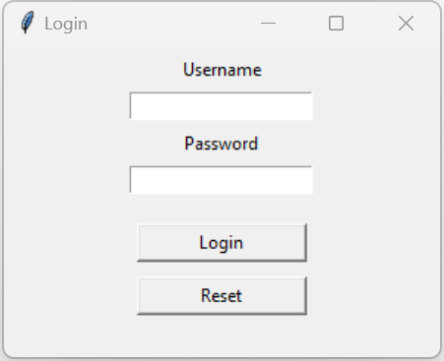
Login Screen

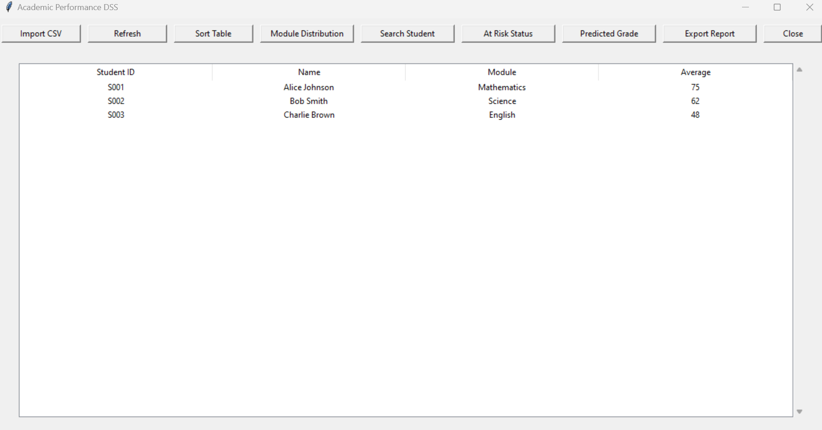
Student Academic Performance Decision Support System Dashboard – Teacher View

Student Academic Performance Decision Support System Dashboard – Parent View

Student Academic Performance Decision Support System Dashboard – Parent View
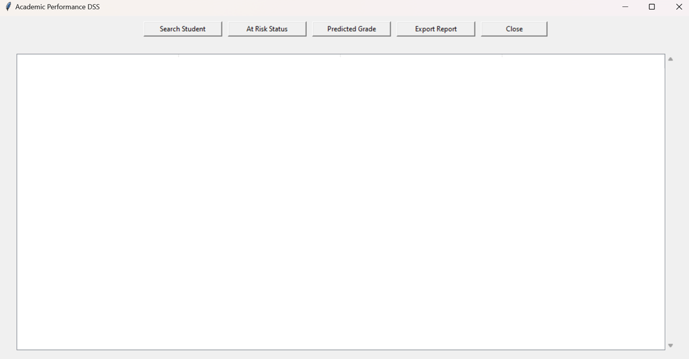

Module Distribution Graph
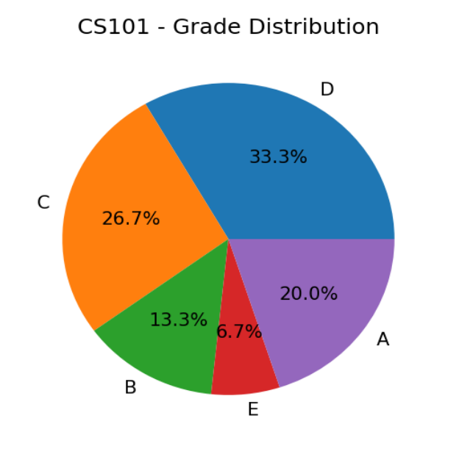

Student Progress Report
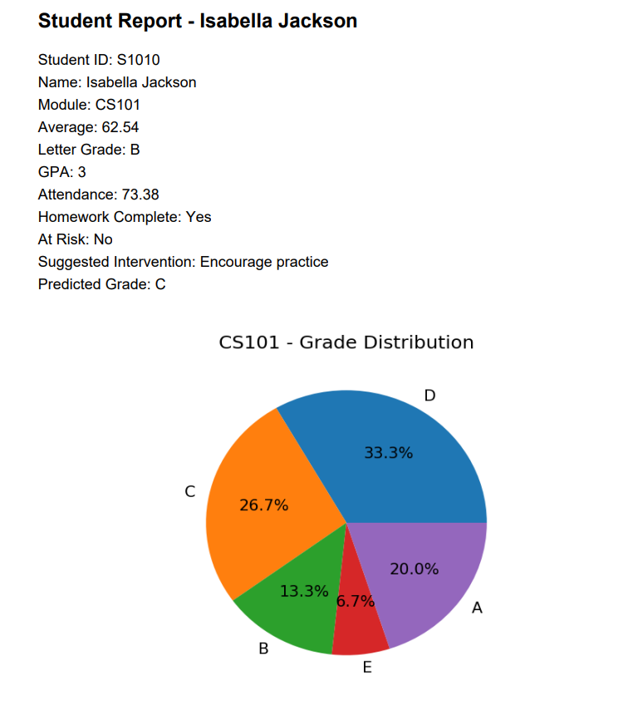

Usability Features
The Student Academic Performance Decision Support System (DSS) is designed with usability in mind, ensuring that both educators and parents can navigate the system easily, interpret academic data accurately, and perform tasks without confusion or errors. The system incorporates features that enhance learnability, accessibility, feedback, and error prevention. The following highlights the key usability features in the Login Screen and Main Dashboard.


Simple and Intuitive Login Screen
Invalid credentials
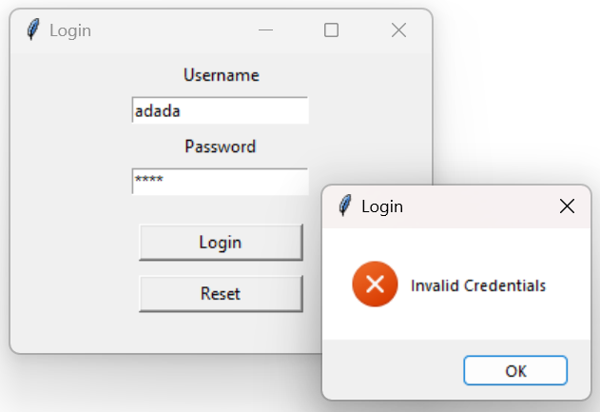

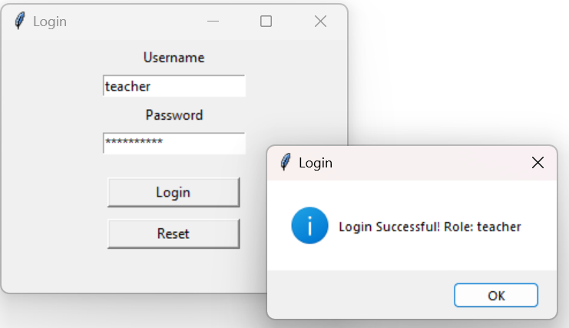
valid credentials

The login screen is designed to be simple and intuitive, displaying only the essential elements: Username, Password, and the two action buttons—Login and Reset. Each input field has a clear label positioned above it, making the interface easy to follow. The password field includes masking, ensuring input privacy. Validation is built into the login process: if incorrect credentials are entered, the system presents a clear “Invalid Credentials” error dialog, guiding the user to correct the mistake. When valid details are provided, a “Login Successful” confirmation dialog appears, giving users immediate feedback. The inclusion of the Reset button further enhances usability by allowing users to quickly clear both fields and re-enter their information. Together, these features prevent user errors, maintain security, and provide helpful feedback throughout the login process.

Clean and Consistent Dashboard Layout

Figure : Student Performance Decision Support System main application dashboard

The main dashboard uses a clear, structured layout. A horizontal button bar at the top provides access to all key functions, while a central table displays student data. Buttons are arranged logically to follow a natural workflow, and the table uses uniform column widths with center-aligned text. Clear column headings help users quickly identify each data field. This structure reduces visual clutter and makes the system easier for both new and experienced users to navigate.

Role-Based Interface Simplification
Teachers can see all functions & student details table



Figure : Student Performance Decision Support System- Teacher main application dashboard

Only few features are enabled for parents

Parents cannot see student details table. Instead, they can see only
their child’s academic records

Figure : Student Performance Decision Support System- Parent main application dashboard

The interface adapts based on the user’s role. Teachers see all functions, including CSV import, table sorting, and module distribution, while parents see only non-editing features like searching students and viewing interventions. This prevents confusion, avoids accidental misuse, and ensures users only see relevant features.
Validation on Dashboard Functions
All dashboard actions include validations to maintain proper system operation:
- The Search Student feature provides a message if no matching student is found.
- Table Actions require a student to be selected before displaying information such as At-Risk Status, Predicted Grade, or Suggested Interventions.
- The CSV Import function only accepts .csv files, fills in missing values with default data, validates all data types, and ignores duplicate student IDs.
- The Report Export feature ensures a student is selected before generating a report and safely creates charts and PDF files.

These validations prevent runtime errors, protect data integrity, and guide users in correct system usage.
Clear Feedback and System Status Indicators
The system provides real-time feedback through dialogs: success messages (e.g., “Report Exported Successfully”), errors (e.g., “Invalid credentials”), warnings (e.g., “Select student first”), and information messages (e.g., “No student found”). This transparency keeps users informed about system actions and aligns with good usability practices.
Consistency in Controls and Terminology
Button labels consistently use verbs (e.g., Search Student, Export Report), and table formats, icons, and styling remain uniform throughout the system. Consistency reduces learning time, avoids confusion, and makes the interface predictable.


Structured and Readable Data Presentation
The Treeview table presents student data clearly, with consistent numeric formatting, textual values for status indicators (e.g., Yes/No for homework), and automatic updates after sorting or refreshing. This makes it easy for users to detect low grades, poor attendance, or missing homework and supports faster decision-making.

Algorithm Design
- CSV Import module
Pseudocode
FUNCTION import_csv(file_path)
OPEN file
FOR each row in csv:
READ student_id, name, module, average, letter_grade, GPA
CONVERT average to float
INSERT OR REPLACE into database
COMMIT changes
CLOSE database
LOAD students into memory list
END FUNCTION

Flowchart
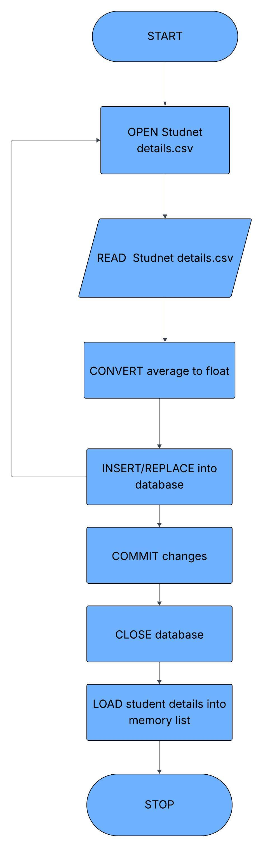

- Predicted grade calculation

Pseudocode

FUNCTION predicted_grade:
SET score TO average

IF attendance < 75 THEN
SUBTRACT 10 FROM score
ELSE IF attendance < 90 THEN
SUBTRACT 5 FROM score
END IF

IF homework is NOT complete THEN
SUBTRACT 5 FROM score
END IF

IF score > 100 THEN
SET score TO 100
ELSE IF score < 0 THEN
SET score TO 0
END IF

IF score >= 70 THEN
RETURN "A"
ELSE IF score >= 60 THEN
RETURN "B"
ELSE IF score >= 50 THEN
RETURN "C"
ELSE IF score >= 40 THEN
RETURN "D"
ELSE
RETURN "E"
END IF
END FUNCTION

Flowchart
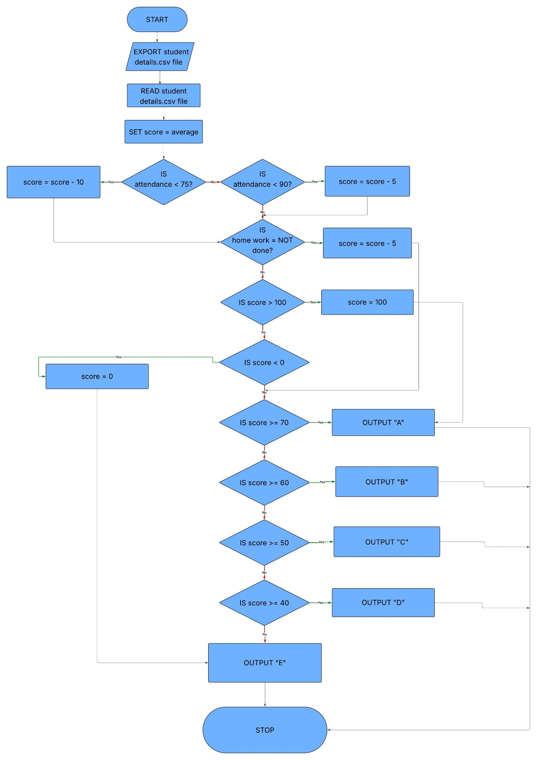

- At risk level identification
Pseudocode

FUNCTION at_risk(average)
IF average < 50:
RETURN "Yes"
ELSE:
RETURN "No"
END FUNCTION

Flowchart

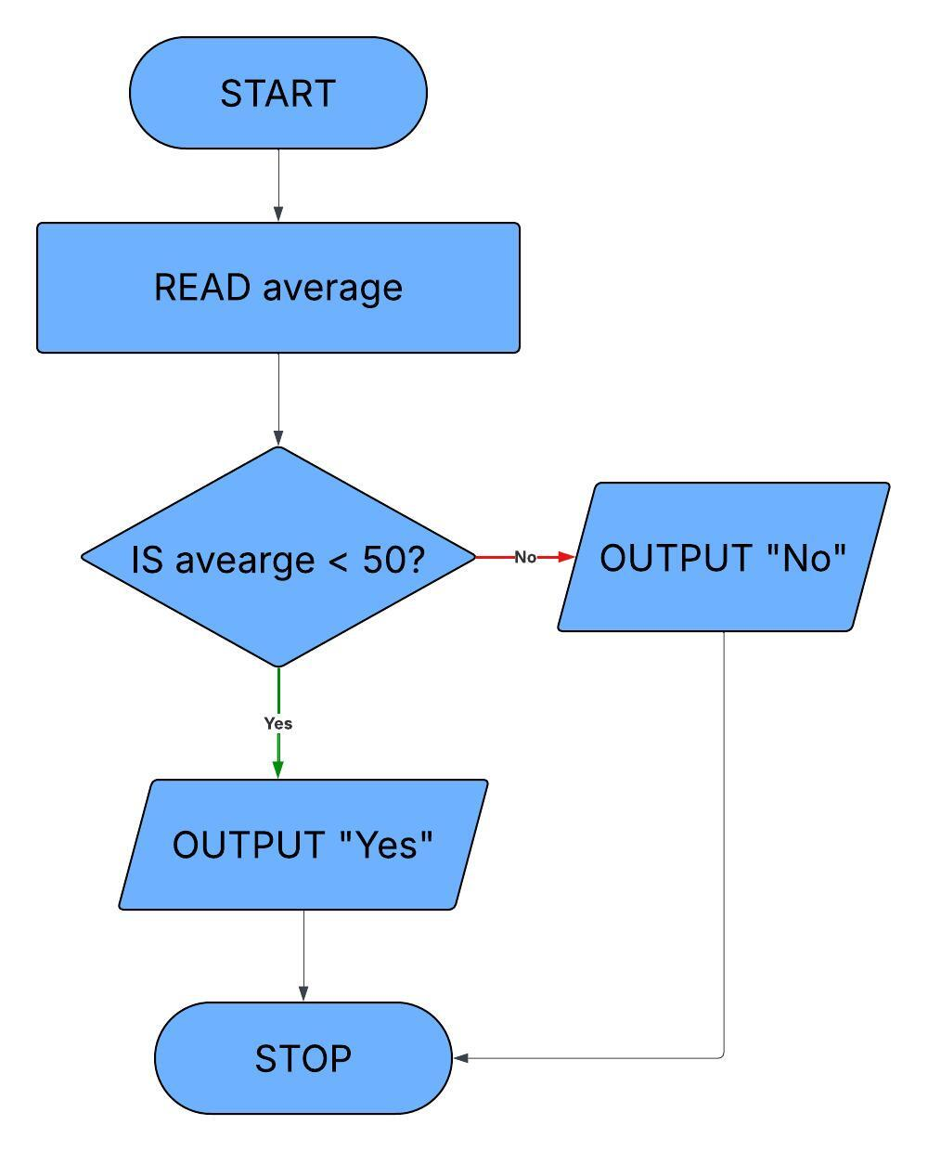

- Suggested interventions

Pseudocode

FUNCTION suggested_intervention(average)

IF average ≥ 70:
RETURN "None"

ELSE IF average ≥ 60:
RETURN "Encourage practice"

ELSE IF average ≥ 50:
RETURN "Extra tutoring"

ELSE:
RETURN "Immediate intervention"

END FUNCTION
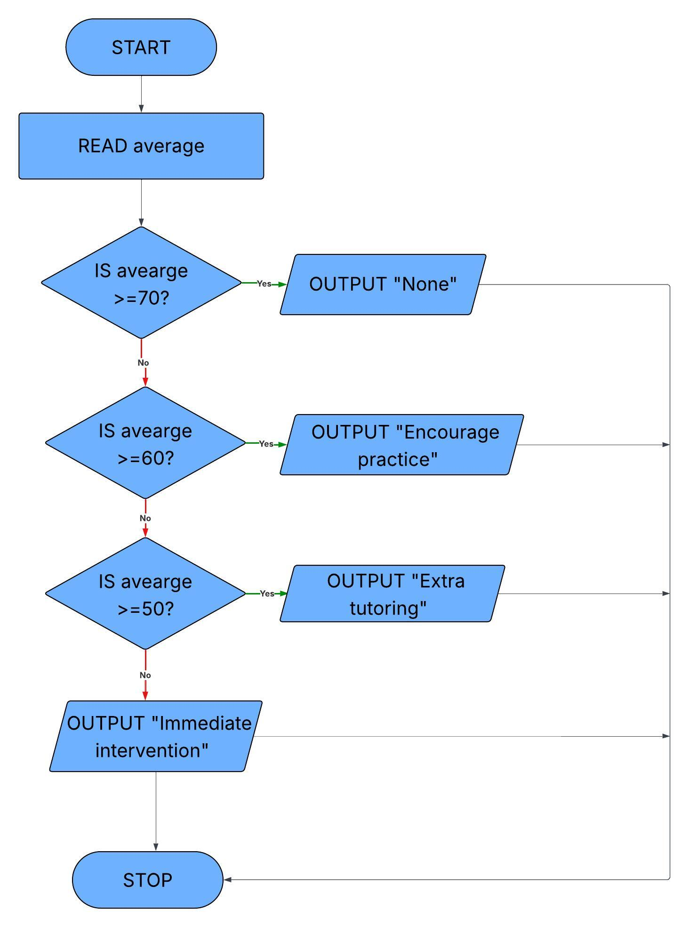
Flowchart

- Sorting student records
Pseudocode

PROCEDURE sort_all_columns

SORT students BY:
lowercase(student_id),
lowercase(name),
lowercase(module),
average,
attendance,homework_completion

IF sort_asc = FALSE THEN
REVERSE students list
ENDIF

TOGGLE sort_asc

CALL refresh_table(students)

END PROCEDURE

Flowchart

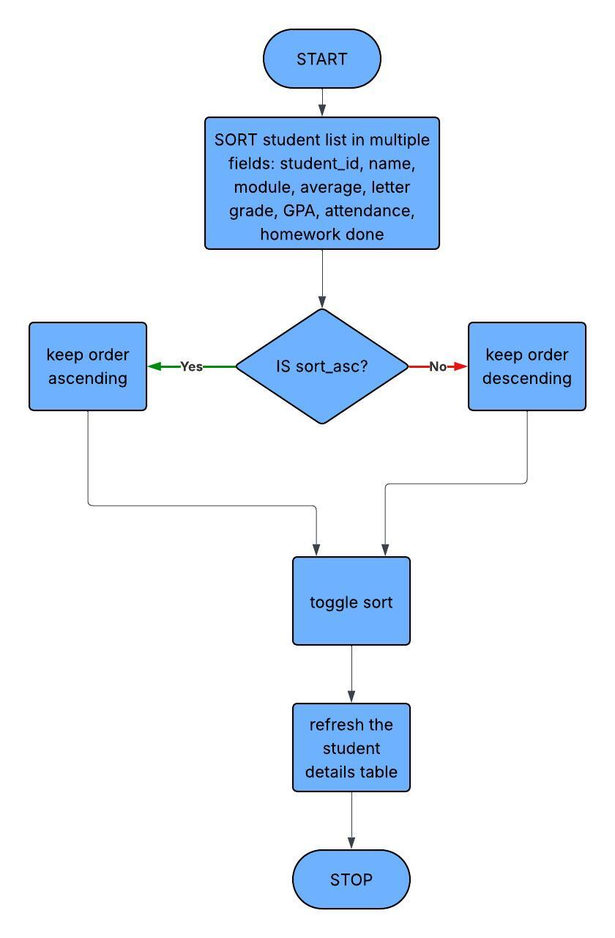

- Search students

Pseudocode

FUNCTION search_student
ASK user for input "Enter Student ID or Name"
IF input is empty
RETURN
CONVERT input to lowercase
FILTER students WHERE student ID or name contains input
IF no students found
SHOW message "No student found"
RETURN
DISPLAY filtered students in table
END FUNCTION

Flowchart
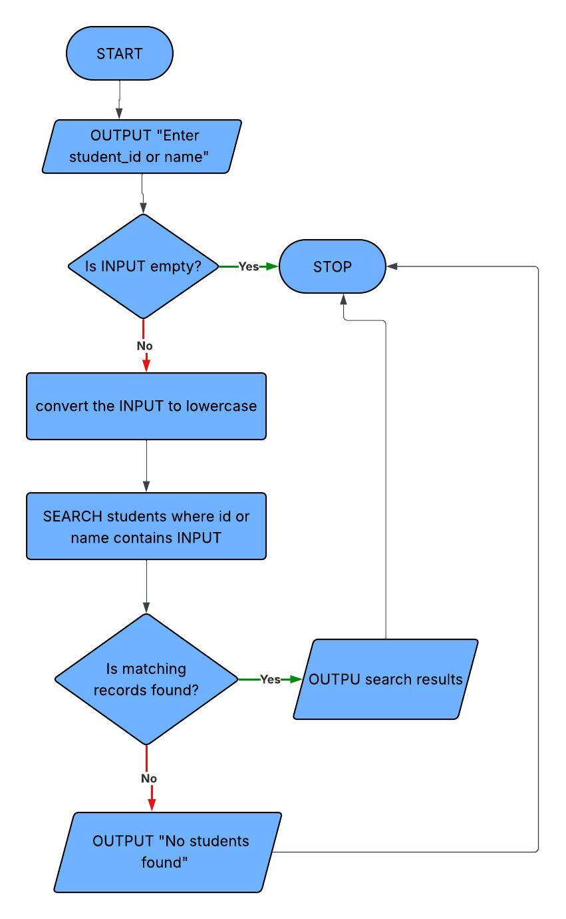

- Export student report

Pseudocode

FUNCTION export_student_report
SELECT student s
IF no student selected
SHOW warning "Select student first"
RETURN

GET all students in s's module → module_students
COUNT letter grades → grades
CREATE pie chart → image

ASK user where to save PDF
CREATE PDF
WRITE student details
ADD pie chart
SAVE PDF

SHOW "Report Exported Successfully"
END FUNCTION

Flowchart

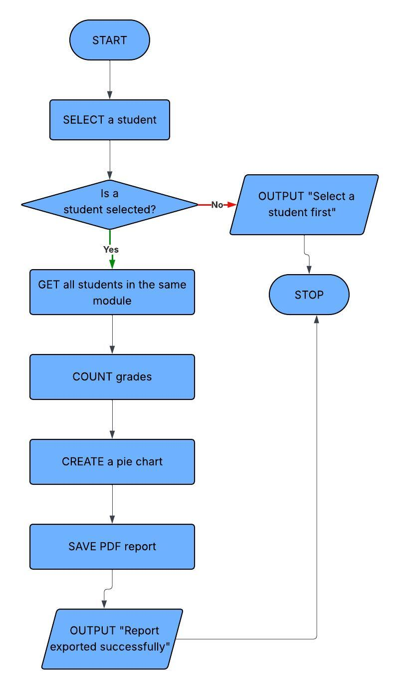

- Login

Pseudocode

FUNCTION login
GET username from username_entry
GET password from password_entry

IF username exists in USERS AND password matches
SET current_role to user's role
CLOSE login window
OPEN main application window
ELSE
SHOW error "Invalid credentials"
END FUNCTION

Flowchart
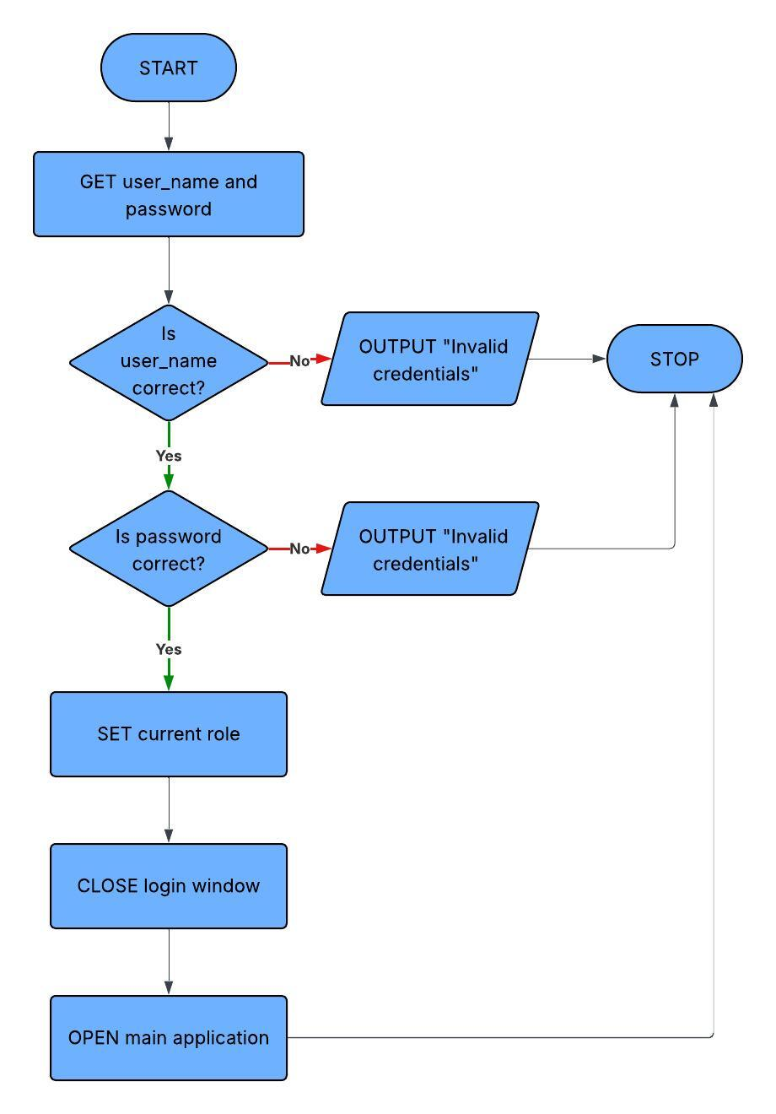

Key variables and Data structures

Method / Structure / Variable | Name | Data Type | Purpose | Justification & Validation
Class | Student | Class | Encapsulates all student academic data and decision logic | Supports Object-Oriented design (modularity, maintainability). Input validation required for marks (0–100), attendance (0–100), and homework (Boolean).
Attribute | student_id | String | Unique identifier for each student. | Defined as PRIMARY KEY in database to prevent duplicates. Must be non-empty and unique.
Attribute | name | String | Stores student name. | Must not be empty. Prevents incomplete records.
Attribute | module | String | Stores subject/module name. | Should be validated to avoid inconsistent spellings.
Attribute | average | Float | Stores average mark. | Must be validated between 0–100 to ensure correct grade calculation.
Attribute | attendance | Float | Stores attendance percentage. | Must be validated between 0–100. Default = 100 to prevent null errors.
Attribute | homework_complete | Integer (0/1 Boolean) | Indicates homework completion status. | Restricted to 0 or 1. Prevents prediction miscalculations.
Method | at_risk() | Function | Identifies students below pass mark (<50). | Provides decision-support indicator based on validated average.
Method | suggested_intervention() | Function | Recommends support level based on performance. | Implements DSS logic using defined performance thresholds.
Method | predicted_grade() | Function | Predicts final grade using average, attendance, homework. | Combines validated inputs. Score is clamped (0–100) to prevent invalid values.
Data Structure | students | List | Stores student records in memory. | Allows sorting, searching, filtering. Integrity depends on validated database entries.
Data Structure | USERS | Dictionary | Stores login credentials and roles. | Enables role-based access control. Username must exist and password must match.
Variable | current_role | String | Tracks logged-in user role. | Controls system permissions (teacher vs parent). Must match predefined roles only.
Database Table | students | SQLite Table | Persistent storage of student records. | Enforces structure and PRIMARY KEY constraint. Numeric fields validated during CSV import.
Method | import_csv() | Procedure | Imports student data from CSV file. | Converts data types (float/int). Should validate missing fields and numeric conversion errors.
Method | module_distribution() | Procedure | Generates and displays grade distribution for a selected module | Ensures valid input and handles missing data before visualizing results
Method | sort_students() | Function | Sorts a list of student objects in ascending or descending order using multiple attributes | Validates input and ensures consistent sorting using defined comparison keys
Method | search_students() | Function | Searches for students by name or ID and returns matching results | Ensures search term is valid and performs case-insensitive matching for accuracy
Method | search_ui() | Function | Handles user input, validation, and displays search results based on user role | Validates input, manages different user roles, and provides appropriate feedback for results or errors

Test Plans

Test data for Iterative testing

CSV Export
ID | Testing Type | Data | Expected
CSV1 | Valid | S1001, John Smith, CS101, 47.62, D, 72.66, No | CSV exports correctly: all fields present and formatted properly
CSV2 | Valid | S1004, Olivia Davis, CS101, 53.38, C, 71.56, Yes | CSV exports correctly: numeric and string fields preserved
CSV3 | Valid | S1010, Isabella Jackson, CS101, 62.54, B, 73.38, Yes | CSV exports correctly: Boolean field (Homework) exported as Yes/No
CSV4 | Boundary | S1021, Matthew Lee, CS101, 71.53, A, 84.46, Yes | CSV includes boundary averages: numeric precision preserved
CSV5 | Boundary | S1017, Alexander Robinson, CS101, 60.09, B, 91.82, No | Boundary grade included letter grade exported correctly
CSV6 | Boundary | S1009, James Thomas, CS101, 39.20, E, 90.72, Yes | Lower boundary average: data exported accurately
CSV7 | Invalid | S1026, Elizabeth King, CS101, 48.84, ? , 53.74, Yes | Invalid attendance: CSV exports with flagged error
CSV8 | Invalid | S1027, David Wright, CS101, 93.49, 73.28, 0 | Homework field invalid format: CSV exports with flagged error
CSV9 | Invalid | S1016, Amelia Martinez, CS101, 39.83, 96.17, 1 | Average very low, tests system handling of extreme low values
CSV10 | Invalid | S1020, Evelyn Lewis, CS101, 57.46, -10, 0 | Negative attendance: CSV exports value but flagged as invalid

Justification
The CSV export test data ensure the system handles valid, boundary, and invalid inputs correctly while maintaining data accuracy. Valid cases confirm proper formatting, boundary cases check precision, and invalid cases ensure errors are safely handled without crashing, making the feature reliable for real-world use.

Predictive Grade Calculation
ID | Testing Type | Data | Expected
PG1 | Valid | S1021, Matthew Lee, CS101, 71.53, A, 84.46, Yes | Predicted grade correct; boundary for A grade
PG2 | Valid | S1017, Alexander Robinson, CS101, 60.09, B, 91.82, No | Predicted grade correct; boundary for B grade
PG3 | Boundary | S1004, Olivia Davis, CS101, 53.38, C, 71.56, Yes | Predicted grade calculation correct; boundary for C grade
PG4 | Boundary | S1003, Liam Brown, CS101, 42.67, D, 83.92, No | Predicted grade deduction applied for incomplete homework
PG5 | Invalid | S1027, David Wright, CS101, 93.49, A, 73.28, 0 | Invalid homework field: predicted grade capped, system handles gracefully

Justification
The predictive grade calculation test data were designed to check that the system applies grading rules correctly in different situations, including normal, edge, and invalid cases. Valid tests confirm that grades are assigned accurately at key boundaries like A, B, and C. Boundary tests ensure that deductions, such as for incomplete homework, are applied consistently. Invalid input tests show that unusual or incorrect values are handled safely, with grades kept within valid limits instead of causing errors. Overall, this shows that the predictive grade feature is reliable, robust, and useful for supporting academic decision

Low Attendance & Missing Homework

ID | Testing Type | Data | Expected
LA1 | Valid | S1001, John Smith, CS101, 47.62, D, 72.66, No | Predicted grade deduction applied for low attendance; homework complete handled
LA2 | Boundary | S1002, Emma Johnson, CS101, 47.44, D, 51.55, No | Very low attendance + missing homework; cumulative penalties tested
LA3 | Boundary | S1006, Ava Moore, CS101, 48.32, D, 78.62, No | Attendance just below threshold; homework incomplete applied
LA4 | Boundary | S1008, Sophia Anderson, CS101, 53.35, C, 62.06, No | Attendance moderate; homework penalty applied; upper boundary tested
LA5 | Invalid | S1020, Evelyn Lewis, CS101, 57.46, -10, 0 | Negative attendance; predicted grade handled gracefully

Justification
The test data were designed to ensure that the predictive grade algorithm correctly applies penalties for attendance and homework in a range of situations, including normal, edge, and invalid cases. Valid and boundary tests confirm that deductions are applied accurately when attendance drops below set thresholds or when homework is incomplete, even near the limits. The invalid test checks that unrealistic attendance values are handled safely, with grades kept within valid ranges instead of causing errors. This shows that the system models real-world academic penalties effectively while remaining stable and reliable.

Module Distribution – Pie Chart

ID | Testing Type | Data | Expected
MD1 | Valid | S1001, John Smith, CS101, 47.62, D, 72.66, No | Pie chart includes D grade correctly
MD2 | Valid | S1004, Olivia Davis, CS101, 53.38, C, 71.56, Yes | Pie chart includes C grade correctly
MD3 | Valid | S1010, Isabella Jackson, CS101, 62.54, B, 73.38, Yes | Pie chart includes B grade correctly
MD4 | Boundary | S1021, Matthew Lee, CS101, 71.53, A, 84.46, Yes | Pie chart includes boundary grade for A
MD5 | Invalid | S1003, Liam Brown, CS101, 42.67, D, 83.92, No | Very low grade included; ensures pie chart handles extremes

Justification
These test data were created to ensure that the module grade distribution pie chart accurately represents all predicted grade categories, including normal, edge, and extreme values. Valid and boundary tests check that each grade (A–D) is correctly counted and displayed, even at the threshold between grades. Extreme or very low grades are also handled safely, without causing errors or distorting the chart. This shows that the charting feature reliably visualises real-world data and provides a clear, meaningful overview of module performance.

Report Export – PDF
ID | Testing Type | Data | Expected
RE1 | Valid | S1001, John Smith, CS101, 47.62, D, 72.66, No | PDF report generated with all fields correctly
RE2 | Valid | S1004, Olivia Davis, CS101, 53.38, C, 71.56, Yes | PDF report includes at-risk status and suggested intervention
RE3 | Boundary | S1006, Ava Moore, CS101, 48.32, D, 78.62, No | PDF report shows predicted grade deduction for homework
RE4 | Boundary | S1021, Matthew Lee, CS101, 71.53, A, 84.46, Yes | PDF report includes pie chart and boundary grade formatting
RE5 | Invalid | S1020, Evelyn Lewis, CS101, 57.46, -10, 0 | Very low/negative attendance; ensures PDF handles extreme predicted grade without crashing

Justification
These test data were created to ensure that the PDF report export function produces complete, accurate, and reliable reports across normal, boundary, and extreme data scenarios. Valid tests check that all student details, at-risk status, and suggested interventions are included correctly. Boundary tests make sure that grade thresholds, deductions, and visual elements like the module distribution pie chart are displayed properly. Extreme or illogical values, such as negative attendance, are handled safely without causing errors, showing that the report generation works reliably in all situations.

Login & Role Handling

ID | Testing Type | Data | Expected
L1 | Valid | Username: teacher, Password: teacher123 | Role: Teacher; full dashboard visible
L2 | Valid | Username: parent, Password: parent123 | Role: Parent; limited dashboard, teacher-only buttons hidden
L3 | Invalid | Username: teacher, Password: wrongpass | Login fails; error message displayed
L4 | Invalid | Username: wronguser, Password: teacher123 | Login fails; error message displayed
L5 | Boundary | Username: (empty), Password: (empty) | Login fails; prompts for credentials
L6 | Boundary | Username: parent, Password: TEACHER123 | Login fails; password is case-sensitive
L7 | Valid | Username: teacher, Password: teacher123 | Role verification; teacher-only functions accessible
L8 | Valid | Username: parent, Password: parent123 | Role verification; teacher-only functions NOT visible
L9 | Boundary | Username: teacher, Password: teacher123 | Multiple consecutive logins; session resets correctly
L10 | Boundary | Username: parent, Password: parent123 | Logout and re-login; dashboard refresh works

Justification
These test data were created to make sure the login system works securely and enforces role-based access correctly. Valid tests check that users are given the right role and see the appropriate dashboard, with teacher-only features hidden from parents. Invalid and boundary tests confirm that wrong credentials, empty fields, or case-sensitive password mismatches are properly rejected with clear messages. Session-handling tests show that repeated logins and dashboard refreshes reset the system state correctly. Overall, this demonstrates a reliable and secure login system that protects sensitive student data.

Post-development test scenarios

Test Scenario 1: Teacher – Importing Student CSV Data
• Open the system
• Log in as Teacher
- UserName: teacher
- Password: teacher123
- Click Import CSV
- Select file: students_post_dev.csv
- Verify the following students are loaded correctly in the table:
- Student ID: S1001, Name: John Smith, Module: CS101, Average: 47.62, Attendance: 72.66, Homework: No
- Student ID: S1004, Name: Olivia Davis, Module: CS101, Average: 53.38, Attendance: 71.56, Homework: Yes
- Student ID: S1007, Name: William Taylor, Module: CS101, Average: 68.18, Attendance: 97.78, Homework: Yes
- Student ID: S1010, Name: Isabella Jackson, Module: CS101, Average: 62.54, Attendance: 73.38, Homework: Yes
- Student ID: S1013, Name: Lucas Martin, Module: CS101, Average: 82.80, Attendance: 82.60, Homework: No
- Click Refresh Table to ensure all imported data displays correctly
- Exit the system

Test Scenario 2: Teacher – Predictive Grade and Intervention
• Open the system
• Log in as Teacher
- UserName: teacher
- Password: teacher123
- Select Student ID: S1010, Isabella Jackson
- Click Predicted Grade
- Verify predicted grade: Average 62.54, Attendance 73.38, Homework Yes → Predicted Grade: B (attendance deduction applied)
- Click At Risk Status
- Verify student is not at risk
- Click Suggested Intervention
- Verify intervention: “Extra tutoring”
- Repeat for Student ID: S1002, Emma Johnson
- Predicted Grade considers Attendance 51.55, Homework No → grade deduction applied
- At Risk: Yes
- Suggested Intervention: “Immediate intervention”
- Exit the system

Test Scenario 3: Teacher – Export Student Report
• Open the system
• Log in as Teacher
- UserName: teacher
- Password: teacher123
- Select Student ID: S1001, John Smith
- Click Export Report
- Save file as JohnSmith_Report.pdf
- Open PDF and verify:
- Student ID, Name, Module, Average, Letter Grade, GPA, Attendance, Homework
- At Risk Status: Yes
- Suggested Intervention: Immediate intervention
- Predicted Grade: E (after low attendance & homework deduction)
- Module distribution pie chart included for CS101
- Repeat export for Student ID: S1007, William Taylor
- Verify predicted grade deduction applied correctly for attendance/homework
- At Risk Status: No
- Suggested Intervention: None
- Exit the system

Test Scenario 4: Teacher – Module Distribution Visualization
• Open the system
• Log in as Teacher
- UserName: teacher
- Password: teacher123
- Click Module Distribution
- Enter module: CS101
- Verify pie chart displays grades for students:
- A: Lucas Martin, Charlotte Thompson, William Taylor
- B: Isabella Jackson, Noah Wilson
- C: Olivia Davis, Sophia Anderson
- D: John Smith, Liam Brown
- E: James Thomas, Amelia Martinez
- Close chart and exit the system

Test Scenario 5: Parent – Viewing Student Performance
• Open the system
• Log in as Parent
- UserName: parent
- Password: parent123
- Verify teacher-only buttons (Import CSV, Sort Table, Module Distribution) are not visible
- Search Student: S1003, Liam Brown
- Click Predicted Grade
- Verify predicted grade matches system calculation
- Click At Risk Status
- Verify student flagged correctly as At Risk
- Click Suggested Intervention
- Verify recommendation matches system logic
- Attempt to access teacher-only features
- Confirm access denied
- Exit the system

Test Scenario 6: Post-Deployment – Boundary & Invalid Data
• Open the system
• Log in as Teacher
- UserName: teacher
- Password: teacher123
- Import CSV with boundary and invalid data:
- S1006, Ava Moore, CS101, 48.32, 78.62, No (boundary low average)
- S1027, David Wright, CS101, 93.49, 73.28, 0 (invalid homework format)
- S1020, Evelyn Lewis, CS101, 57.46, -10, 0 (invalid negative attendance)
- Verify boundary case (S1006) loaded correctly; predicted grade calculated accurately
- Invalid fields (S1027, S1020) flagged or handled gracefully
- Attempt Export Report for S1006 and S1027
- Ensure system generates PDF without crashing
- Predicted grades capped appropriately for invalid values
- Exit the system

‌

DEVELOPMENT CHAPTER

Introduction
The Academic Performance Decision Support System (DSS) was developed using an iterative development approach. This method allowed the system to be built step by step through several development stages. In each stage, a specific feature was designed, a prototype was created, the functionality was tested, and the results were reviewed. Based on the findings from each stage, necessary improvements were made before moving on to the next step.
This approach helped me to identify and resolve issues early in the development process. It also ensured that the final system closely aligned with the requirements and objectives that were identified during the analysis phase.
The system was implemented using the Python programming language due to its extensive support for database management, graphical interfaces, and data processing. Several Python libraries were used to support development, including:
Library | Purpose
Tkinter | Graphical User Interface
SQLite3 | Database storage
Matplotlib | Data visualisation
ReportLab | PDF report generation
CSV | Importing student data

The solution was designed to be modular and maintainable, with different sections of the program responsible for different tasks such as database management, data processing, decision support analysis, and user interface management.

Iteration 1 -Database model – 03-March-2026
Objective
Prototype 1:
A backend-only prototype focusing on persistent data storage using SQLite, without a graphical user interface.
The first stage of development focused on creating a system that could permanently store student records that were extracted from the college Virtual Learning Environment (VLE) in a CSV file. The aim was to ensure that the data could be saved and easily accessed by the application when needed.
The database was designed to store key pieces of student information, including:
- Student ID
- Student Name
- Module
- Average
- Attendance
- Homework Completion
Code Snippet
Defines the database file name

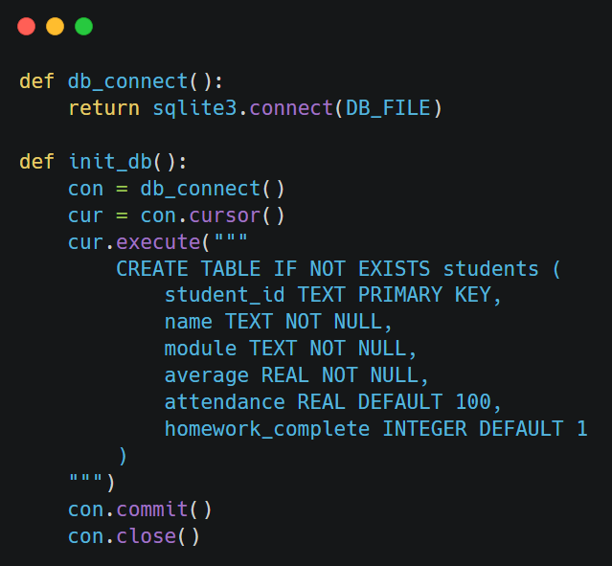

Opens a connection to the DB file

Establishes DB connection

Creates a cursor to execute SQL commands

creates the students table only if it does not already exist

Commit and close connection

Justification
SQLite was chosen as the database system for several reasons. First, it integrates easily with Python, making it straightforward to connect the database with the application. It also does not require a separate server installation, which simplifies the setup process and reduces system complexity.
In addition, SQLite is well suited for small-scale desktop applications like this project, as it is lightweight while still providing reliable data management. It also allows the system to store student information permanently, ensuring that the data remains available even after the application is closed.
To maintain data integrity, the student_id field was set as the primary key. This ensures that each student record is unique and prevents duplicate entries from being added to the database.
Given the small dataset size expected in a school environment, the performance overhead of SQLite was minimal and entirely acceptable for this stage of development.
Testing
The database functionality was tested to ensure that student records could be stored, retrieved, and updated reliably. Testing focused on verifying that the database structure worked as intended and that student data was saved permanently and remained accessible across multiple runs of the application.
Test Case ID | Test Case | Test Description | Expected Outcome | Result
TC1 | Database creation | Run application with no existing database file | Database file and student table created successfully | Pass
TC2 | Insert valid record | Manually insert a valid student record into database | Record stored correctly in database | Pass
TC3 | Retrieve records | Reload application after closing | Previously stored student records loaded correctly | Pass
TC4 | Unique student ID | Attempt to insert a record using an existing student ID | Duplicate prevented or existing record updated | Fail  Retested and passed in the prototype 3(Iteration 4)
TC5 | Data storage | Close and reopen application | Student data retained in database | Pass
TC6 | Invalid data type | Attempt to insert text into numeric database field | Error handled, record not stored | Fail  Retested and passed in the prototype 3(Iteration 4)
TC7 | Missing required field | Attempt to insert record with missing required values | Insert rejected, error reported | Fail  Retested and passed in the prototype 3(Iteration 4)

Problems Encountered and Solutions
During testing of the database model, I added a set of sample student records by writing a function and printed them. However, a few test cases were initially failed. These failures were expected at this stage of development and helped identify areas requiring improvement in later iterations.
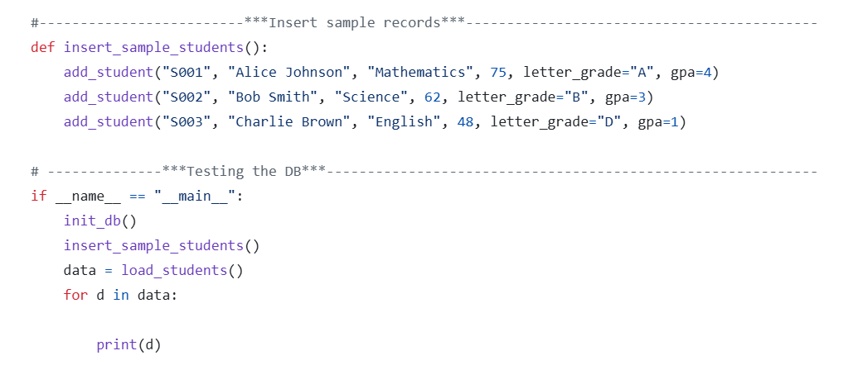
These code lines were written to test the database functionality
Problem 1: Duplicate student ID
When attempting to add a student with an ID that already existed, the database raised an error and stopped the insertion. Validations were not added to handle this error.

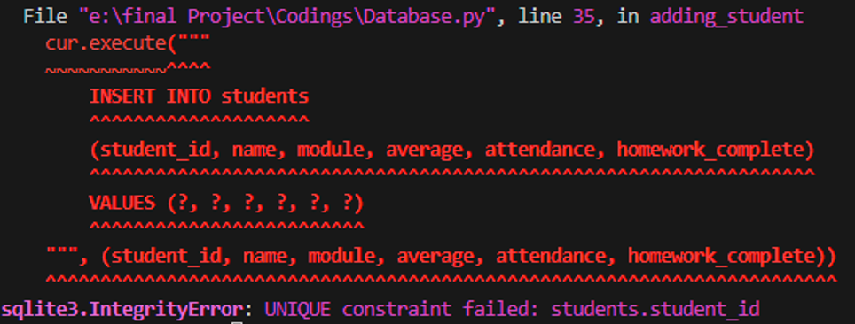
Solution:
This behaviour was accepted at this stage as it confirmed that the database correctly prevents duplicate records using a unique student ID. In later iterations, this was improved by handling the error more smoothly.
Problem 2: Invalid data type
When text was entered into numeric fields such as average or attendance, the database produced an error.
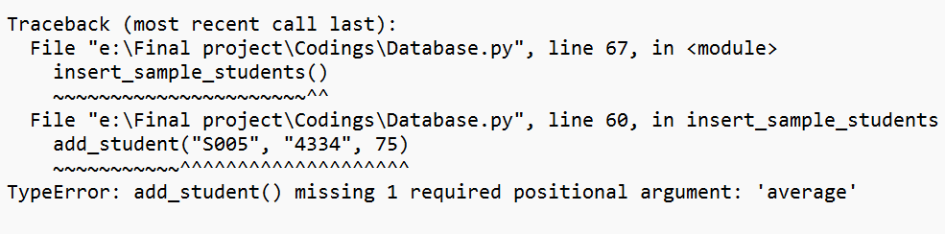
Solution:
This highlighted the need for input validation. Error handling and validation were added in later stages to prevent incorrect data from being inserted.
Problem 3: Missing required fields
Records with missing mandatory information could not be inserted, causing an error.
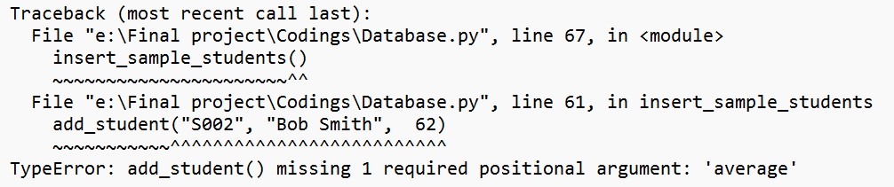
Solution:
The database constraints worked as intended by rejecting incomplete records. User-friendly validation and error messages were added in later iterations to improve system reliability.

Iteration 2 -Student Class – 07-March-2026
Objective
Prototype 1 (extended):
Prototype 1 was extended to include an object-oriented Student model capable of generating decision-support outputs.
The second stage of development focused on creating an object-oriented data model to represent student records within the system. Using objects helps organise the program more effectively and makes the code easier to maintain and expand in the future.
Implementation
A Student class was created to represent each individual student record stored in the system. Each object of the class holds the data imported from the CSV file and saved in the database, including details such as student ID, name, module, average score, attendance, and homework completion.
The class provides functions that give useful insights from the data.
- At-Risk Detection: Checks if a student’s average score is below 50 and flags them as “at risk,” helping identify students who may need additional support.
- Predicted Grade: Estimates a student’s final grade by considering average score, attendance, and homework completion. Attendance below 90% or incomplete homework reduces the score slightly, and the final letter grade (A–E) is assigned based on the adjusted score.
- Suggested Intervention: Recommends support measures depending on performance. High scorers require no intervention, mid-range students may be encouraged to practice or receive extra tutoring, while students below 50 are flagged for immediate intervention.
This design ensures that actionable insights are generated automatically for each student object without altering the original data imported from the CSV file.

Code Snippet
Constructor method to initialize student details
Define a class called Student
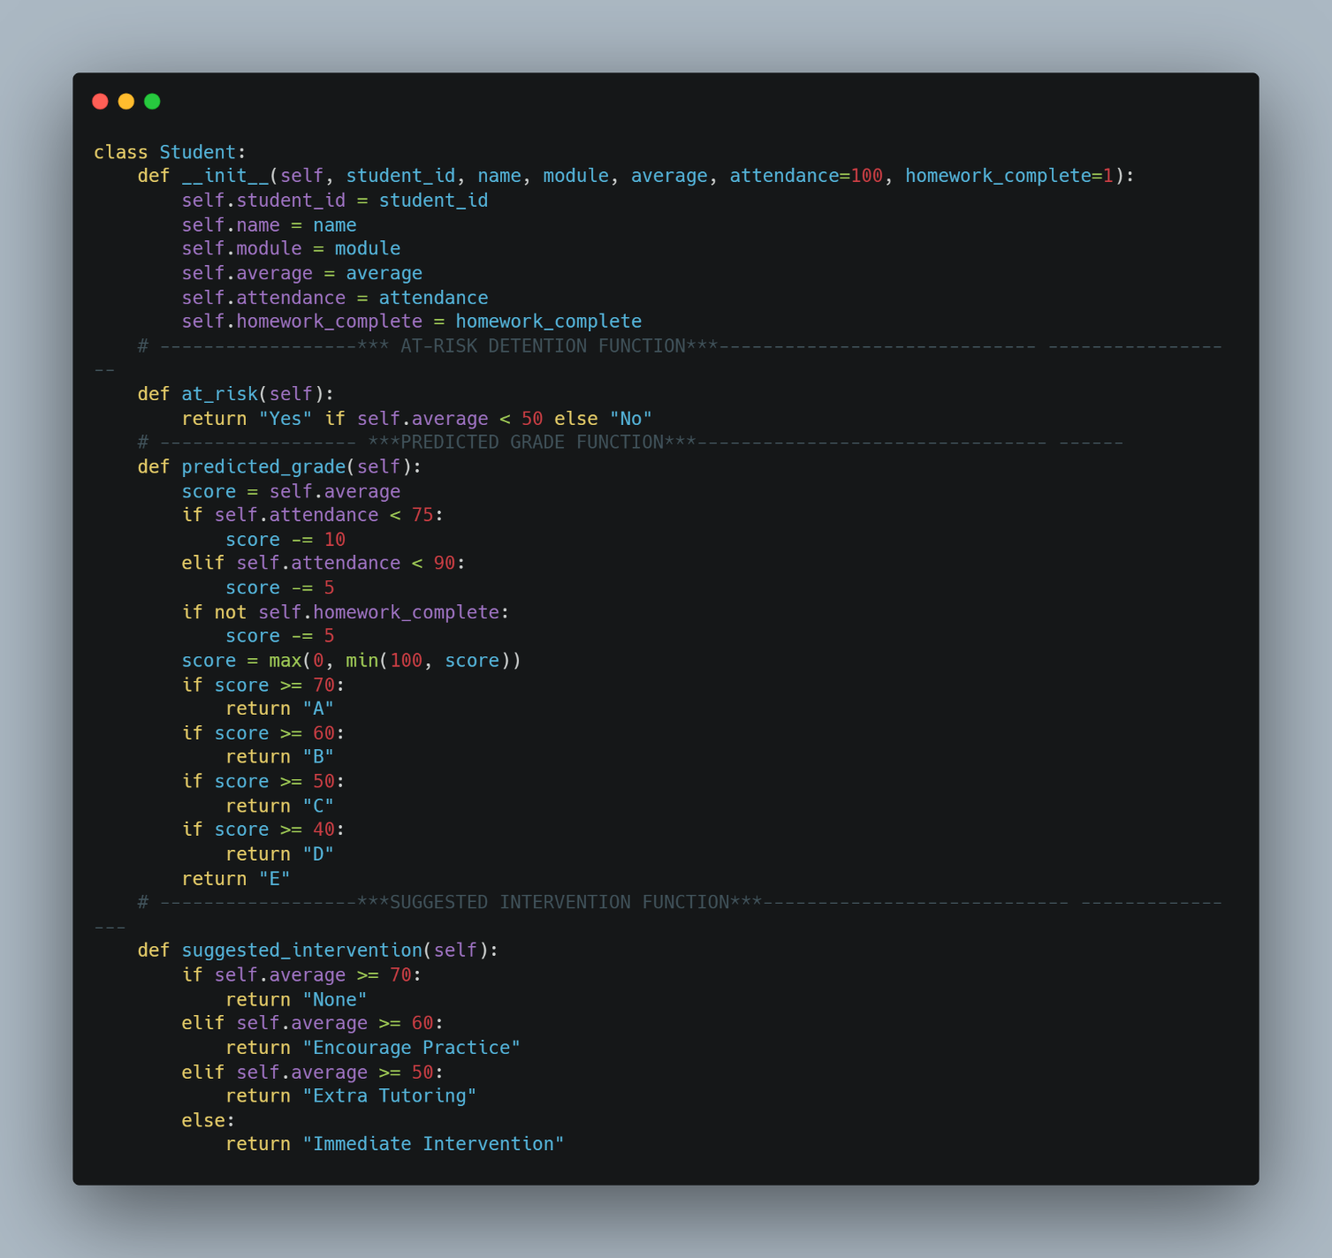

A function to Checks if the student is at academic risk

A function to calculate the predicted grade based on average, attendance, and homework

A function to Suggests academic support based on the student's average

- The constructor initialises all student attributes required by the system.
- The at_risk() method checks whether the average score falls below the defined threshold.
- The predicted_grade() method adjusts the score based on attendance and homework before applying grade boundaries.
Justification
Using an object-oriented design has several benefits. It keeps all student-related data together in one organised structure, making the system easier to understand. This improves how the code is organised and makes it more readable and modular. It also makes the system easier to maintain, update, and fix when needed. In addition, it allows the program to handle multiple student records efficiently and automatically generate useful insights.
Testing
Testing confirmed that student records stored correctly and accessed accurately. The system also successfully flagged at-risk students, predicted grades, and suggested interventions based on the imported data.

The following sample was created to test the student class
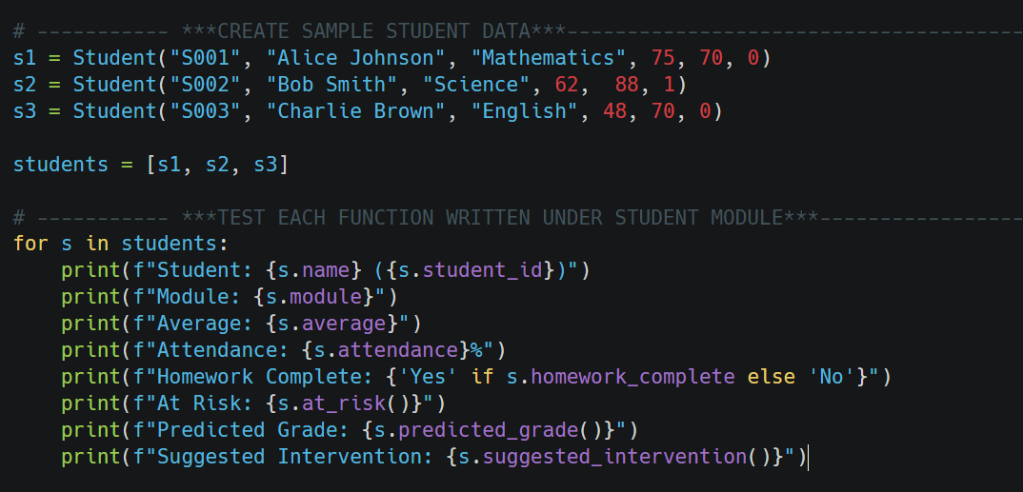

Test cases
Test Case ID | Test Case | Test Description | Input Data | Expected Outcome | Result
TC 8 | Create student | Create student object with valid data | Student ("S001", "Alice Johnson", "Mathematics", 75, 70, 0) | Student object created successfully | Pass
TC 9 | Store attributes | Assign values to all fields | ID: S001, Name: Alice Johnson, Module: Mathematics, Average: 75 | All values stored correctly | Pass
TC 10 | At-risk status | Check at-risk status for low average | Average = 75 | At-risk returns "No" | Pass
TC 11 | Not at risk | Check at-risk status for acceptable average | Average = 55 | At-risk returns "No" | Pass
TC 12 | Predicted grade | Calculate grade with good performance | Average = 72, Attendance = 92, Homework = 1 | Correct grade returned (A) | Pass
TC 13 | Predicted grade penalty | Calculate grade with penalties applied | Average = 72, Attendance = 70, Homework = 0 | Grade reduced correctly | Pass
TC 14 | Suggested intervention | Low performance intervention | Average = 48 | "Immediate Intervention" returned | Pass
TC 15 | No intervention needed | High performance intervention check | Average = 75 | "None" returned | Pass

Problems Encountered and Solutions
Duplicate Student Records
student_id field accepted duplicate entries.
Solution: The student_id field was set as the primary key in the database, preventing duplicate records.

Iteration 3 – User Interface - 07-March-2026
Objective
Prototype 2:
A functional graphical user interface displaying student data using sample records, without full backend integration.
The main objective was to provide a clear, user-friendly interface that allows users to interact with student performance data efficiently while supporting different user roles within the system.
Implementation
The user interface was developed using the Tkinter and ttk libraries in Python, which provide standard GUI components suitable for desktop applications.
The user interface consists of two primary windows:
Login Window
The login interface allows users to authenticate themselves before accessing the system. It includes:
• A username input field
• A password input field with masked characters
• A Login button to validate credentials
• A Reset button to clear all input fields
User credentials are validated against a predefined in memory data structure. Upon successful login, the system identifies the user’s role and launches the main dashboard interface accordingly. If the credentials are invalid, an error message is displayed to notify the user.
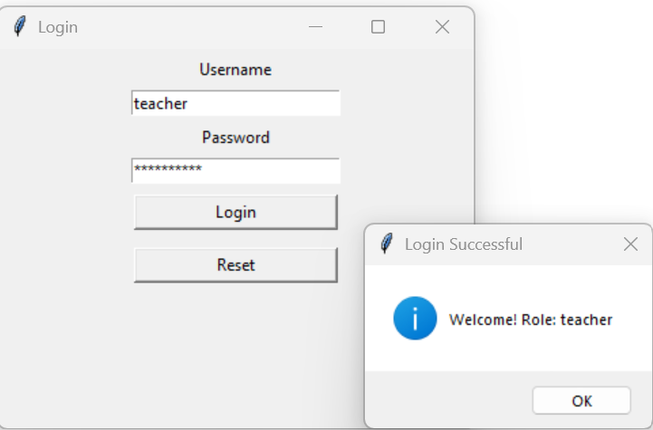
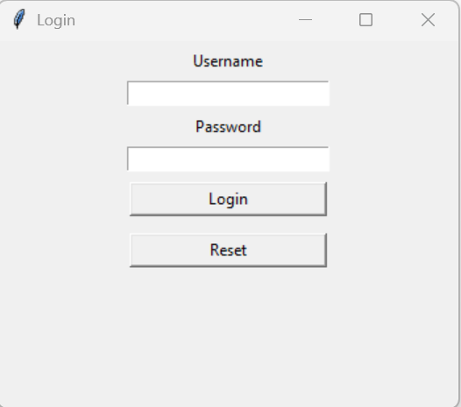
Successful login message
Login Screen UI

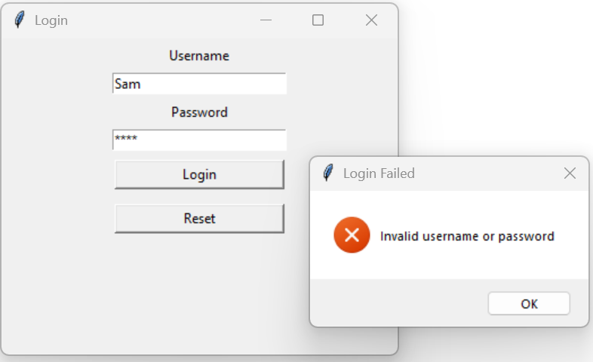
Unsuccessful login message

Main Dashboard Window
After authentication, users are redirected to the Academic Performance DSS dashboard, which serves as the central hub of the system. The dashboard includes:
• A role-based toolbar containing action buttons
• A student data table for visualising academic performance data
Role Based Interface
The system supports two user roles:

Teacher role
Teachers are granted access to additional administrative and analytical functions, including:
- Import CSV
- Refresh data
- Sort Table
- Search students
- Module distribution
- At risk status
- Predicted grade
- Suggested interventions
- Export report

A vertical scrollbar is included to support larger datasets. Sample student data is used in this iteration to demonstrate the layout and behaviour of the interface.
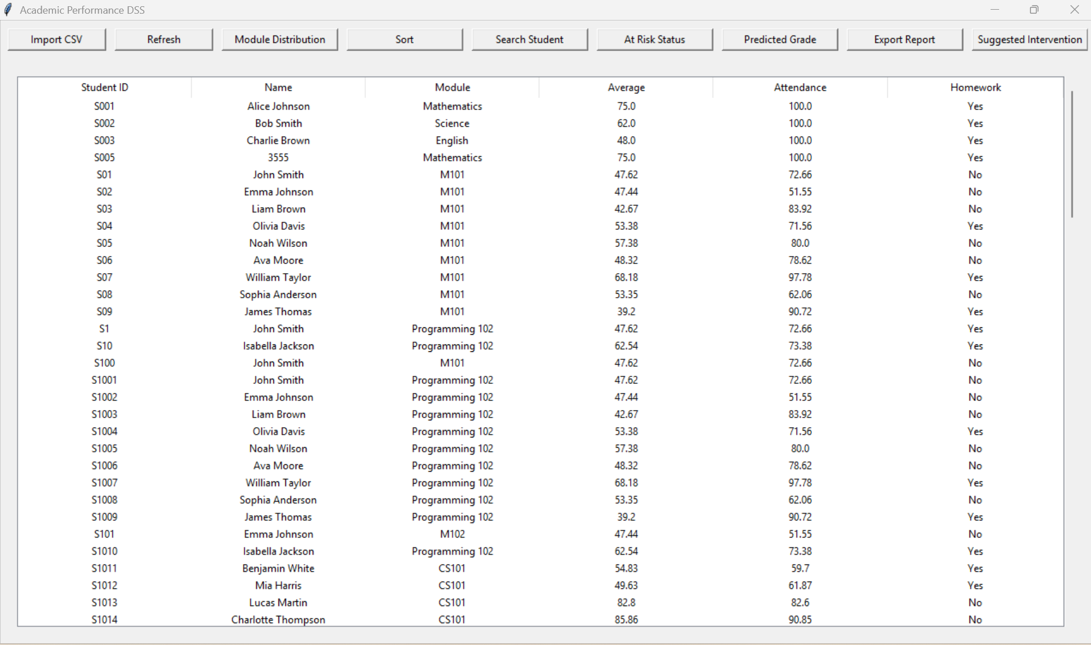
The main dashboard for teachers

Parent role
Parents have access only to informational features and cannot modify data.
This role-based UI design ensures that users see only the functions relevant to their responsibilities, improving usability and security. Parents can only search for their child, view the at-risk level, suggested interventions, predicted grade, and export the report. A pop-up message is displayed when the at-risk level, suggested interventions, or predicted grade buttons are clicked, showing the student’s performance details.
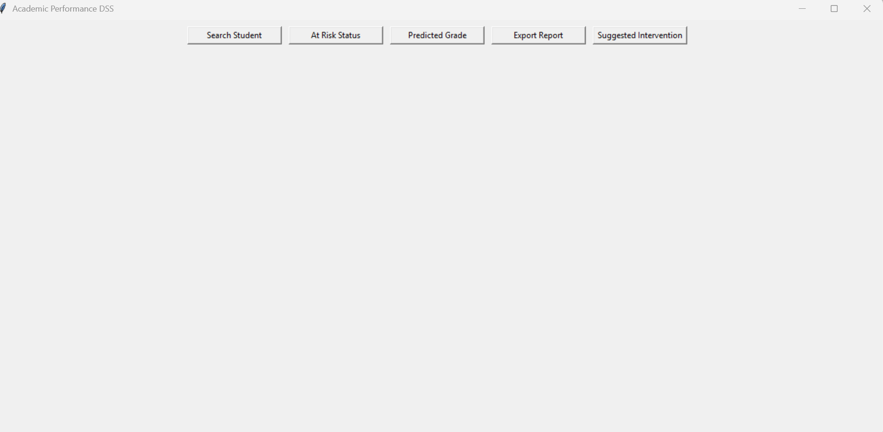
The main dashboard for parents

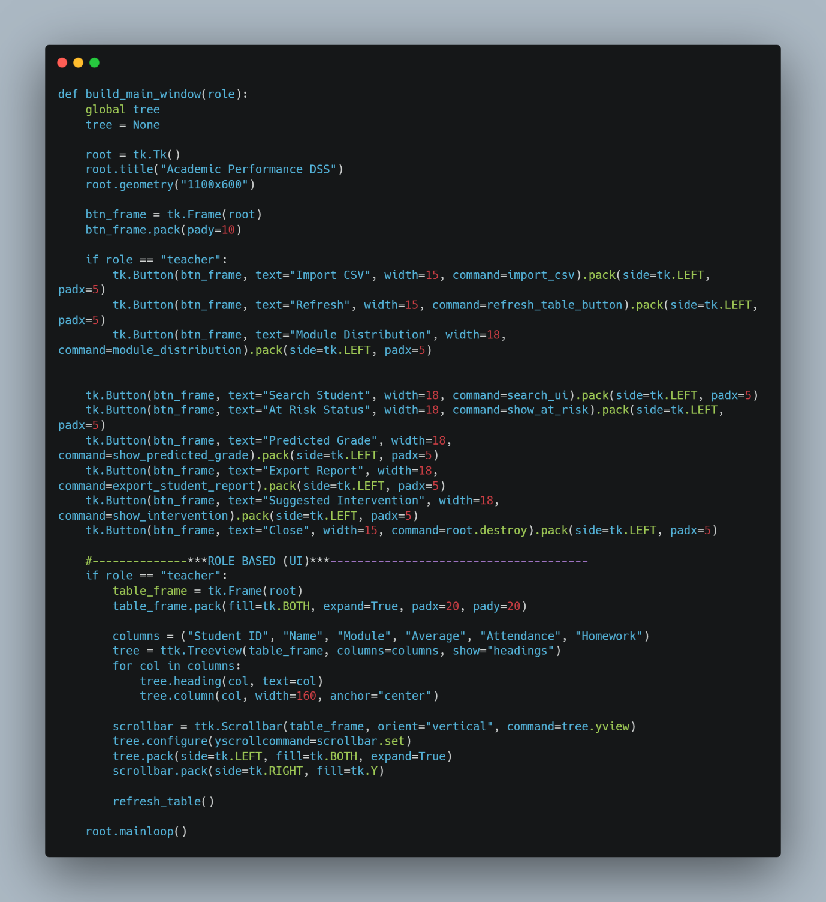
Code Snippet for the main window UI
Function to build the main application window based on user role

Create the main window

These buttons appear only if the user role is teacher

Common buttons for all users

If the user is a teacher, display the student data table

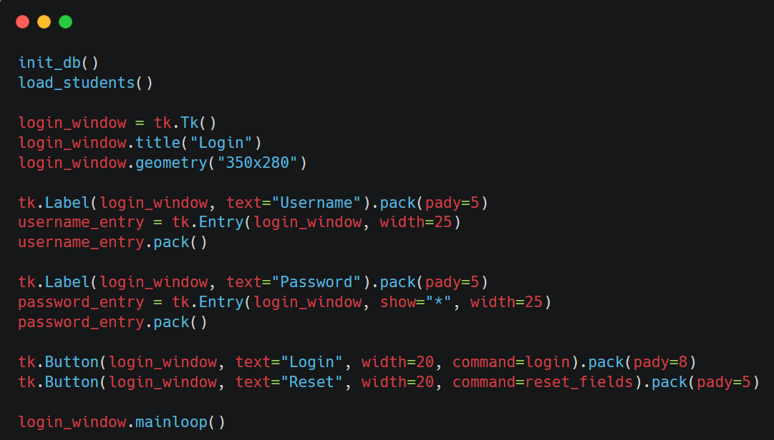
Code snippet for the login UI
Create the login window
User name input

Password input

login button

Reset button

Justification
The user interface design was developed to provide a clear, structured, and easy-to-use experience for all users. Separating the login interface from the main dashboard improves clarity and security by ensuring that authentication is completed before access to system features is granted. This reduces the risk of unauthorised access and supports controlled system navigation.
The interface also implements role-based access control at the user-interface level. Different features are displayed depending on whether the user is a teacher or a parent, ensuring that users only see functionality relevant to their role. This improves usability while also helping to protect sensitive student data.
Reusable interface components such as buttons and tables were used consistently throughout the application. This improves visual consistency and reduces code duplication, making the system easier to maintain and modify. The modular structure of the interface also supports future expansion, as additional features can be added without requiring major changes to the existing layout.
Tkinter was chosen as the interface toolkit because it is platform-independent and integrates directly with Python. This allows the application to run on multiple operating systems without modification and supports rapid development and testing of the interface. Overall, the design choices create a user interface that is efficient, maintainable, and suitable for the requirements of the system.
Interface responsiveness was prioritised, and with only a small number of students, the system performed smoothly during testing.

Test cases
Test case ID | Test Case | Test Description | Input Data | Expected Outcome | Result
TC16 | Successful login | Log in with valid teacher credentials | Username: teacher  Password: teacher123 | Teacher dashboard loads correctly | Pass
TC17 | Successful login (parent) | Log in with valid parent credentials | Username: parent  Password: parent123 | Parent dashboard loads correctly | Pass
TC18 | Invalid login | Log in with incorrect credentials | Username: teacher  Password: wrongpass | Error message displayed | Pass
TC19 | Role-based UI | Compare teacher and parent interfaces | Teacher vs Parent login | Teacher sees admin controls; Parent sees restricted view | Pass
TC20 | Reset fields | Click reset on login screen | Username and password entered | Fields cleared correctly | Fail  Retested after fixing the issue and passed.

Problems Encountered and Solutions
1. UI Clutter with Multiple Buttons
The toolbar initially appeared cluttered with all controls displayed together.
Solution:
Removed the close button to avoid this issue.
2. No Backend Integration in Early Stage
The UI initially lacked real data sources and analytics.
Solution:
Sample student data was used to design and test the UI layout, enabling smooth integration with the data model and database in later iterations.
3. Cursor Reset Issue
After clicking the reset button, the input fields cleared but the cursor did not return to the username field, reducing usability.
Solution:
Added username_entry.focus() to the reset function to automatically place the cursor back in the username field.
Once the cursor focus issue was resolved, the reset functionality was re-tested and passed, confirming improved usability and correct behaviour.

Iteration 4 – CSV Import -07-3-2026
Objective
Prototype 3:
A partially integrated prototype combining the graphical interface with live database and CSV data import functionality.
The aim of this iteration was to allow student data to be imported from a CSV file into the system automatically. This reduces the need for manual data entry and allows student records exported from the college Virtual Learning Environment (VLE) to be added quickly and accurately to the application’s database.
Implementation
The CSV import feature is implemented using Python’s built-in csv module and an SQLite database. When triggered, a file dialog allows the user to select a CSV file, and the function exits safely if no file is chosen. The program ensures the student table exists, then reads the file using csv.DictReader and inserts each row into the database using an INSERT OR REPLACE statement to avoid duplicates.
Numeric values are converted appropriately, with default values used where needed, and data is standardised for consistency. After processing, changes are saved, the database is closed, and the user interface is refreshed. Basic error handling is included to manage issues such as missing files, invalid data, or missing columns.

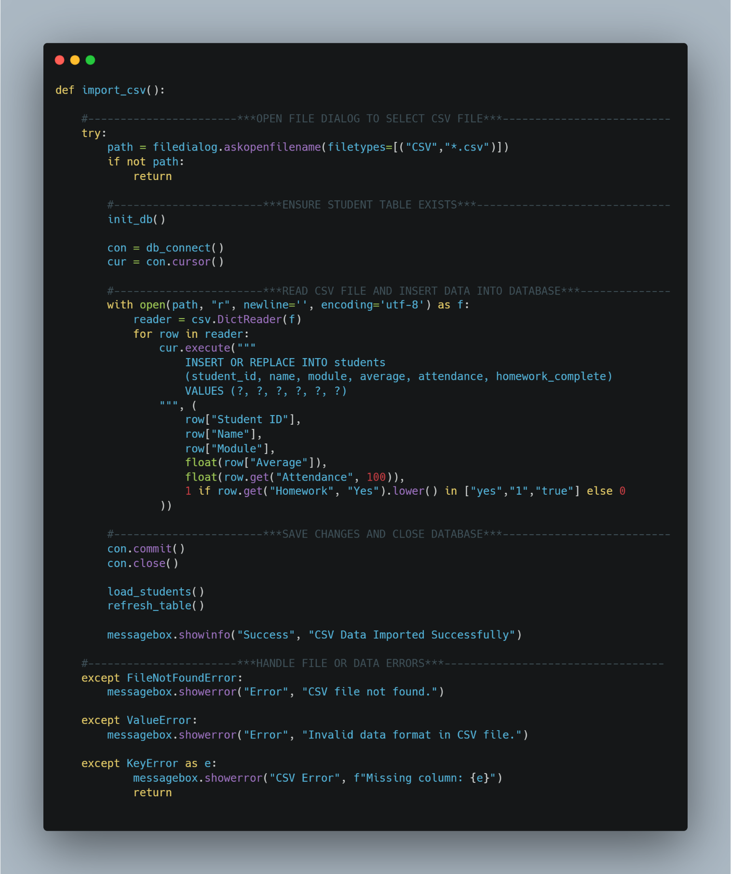
Code snippet

Allows the user to select an external CSV file using a file dialog.

Prevents execution if no file is selected by the user.

Ensures the required database table exists before processing data.

Establishes a database connection and cursor to execute SQL commands.

Reads structured CSV data using column headers as dictionary keys and process each student record sequentially.

Maintains data integrity by preventing duplicate student records

Saves all database changes and releases system resources safely.

Error handling for missing csv file, invalid data formats & missing required columns

Justification
CSV was chosen as the import format because it is widely supported and easily exported from spreadsheet software and learning platforms. Using Python’s built-in csv module provides a reliable and simple way to read structured data while reducing the risk of file formatting issues.
The use of INSERT OR REPLACE improves data integrity by ensuring that each student record remains unique based on student ID. This avoids duplicate entries and allows updated data to overwrite older records when needed.
Including exception handling improves the robustness of the system by preventing crashes and providing clear feedback when errors occur. Overall, the design is suitable for the size and purpose of the application and supports efficient data management.
Alternative data import formats such as JSON were considered however, CSV was chosen due to its widespread support and compatibility with existing school systems.
Testing
The CSV import feature was tested using several different scenarios to ensure it works correctly in different situations.
Test Case ID | Test Case | Input Data | Expected Outcome | Result
TC21 | Valid CSV import | Correct CSV file selected | Student records imported successfully | Pass
TC22 | Duplicate student ID | CSV containing existing ID | Record updated, no duplicate created | Fail  Retested after fixing and passed
TC23 | Cancel file selection | Cancel file dialog | Import safely cancelled | Pass
TC24 | Invalid data format | Text in numeric field | Error message displayed | Fail  Retested after fixing and passed
TC25 | Missing CSV column | Column removed from CSV | Error message displayed, import stopped | Fail  Retested after fixing and passed

Problems Encountered and Solutions
During the development of the CSV import feature, several issues were identified and resolved to improve reliability and usability.
Issue 1: Duplicate student records
When importing a CSV file containing an existing student ID, the database initially raised an error due to the primary key constraint.
Solution:
The SQL statement was changed to use INSERT OR REPLACE. This ensures that if a student ID already exists, the existing record is updated rather than creating a duplicate. This maintains data integrity and prevents repeated records.
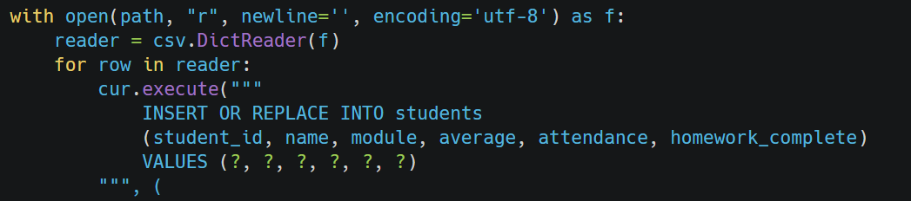

Issue 2: Invalid data types in CSV files
Early testing showed that importing text values into numeric fields such as average score or attendance caused runtime errors.
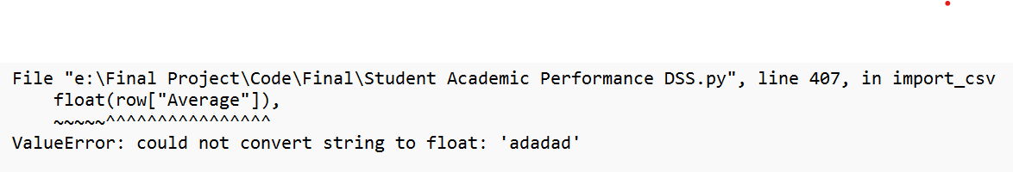

Solution:
Data type conversion was added using float() and exception handling (ValueError) was implemented. This prevents the program from crashing and displays a clear error message to the user when incorrect data is detected.
Issue 3: Missing columns in CSV file
If a CSV file did not contain all required column headers, the program raised a KeyError, stopping the import process.
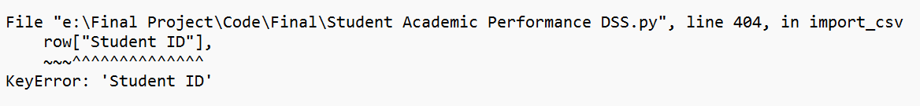
Solution:
A KeyError exception handler was added to detect missing columns and display a helpful error message. This informs the user of the problem and prevents invalid data from being imported.
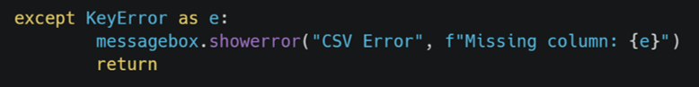

After adding exception handling for invalid data and missing columns, the CSV import feature was re-tested using all previously failing scenarios and passed in every case.
Evaluation
The CSV import feature successfully meets its objective by allowing student records to be imported in a widely compatible format. It integrates well with the existing database and user interface, supports administrative tasks, and makes the system more practical for real-world use.
The modular design of the feature also allows for future improvements, such as importing filtered records or supporting additional file formats. Overall, the functionality enhances the usefulness and flexibility of the system.

Iteration 5 – Sorting Algorithm - 08-3-2026
Objective
Prototype 3 (refined):
Prototype 3 was refined to include dynamic sorting of student records within the teacher dashboard.
The aim of this iteration was to allow teachers to sort student records so that academic performance could be analysed more easily and patterns within the data could be identified.
Implementation
A Bubble Sort algorithm is used to sort a list of student objects by repeatedly comparing and swapping neighbouring records when they are in the wrong order. Each student is assigned a tuple-based comparison key containing attributes such as student ID, name, module, and average score, allowing multi-criteria sorting using lexicographical comparison. The algorithm also supports both ascending and descending order, controlled by a Boolean flag, making the sorting flexible and adaptable.

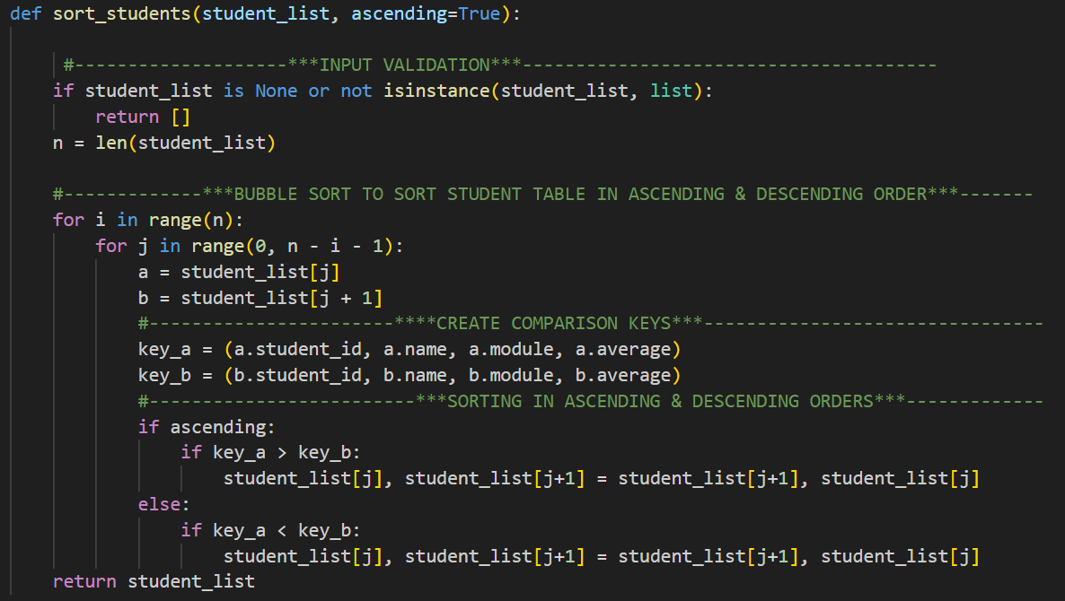
Code snippet

Justification
A Bubble Sort algorithm was used to sort the list of student objects as the dataset is small, making a simple algorithm sufficient without adding unnecessary complexity. Bubble Sort is easy to understand and implement, which is suitable for an educational application. The algorithm uses a tuple-based comparison key (student ID, name, module, and average score), allowing Python to perform multi-field sorting. First, it compares the student ID, which acts as the primary sorting field. If two students have the same ID, the system then compares their names. If the names are also identical, it moves on to compare the module. Finally, if all previous fields are the same, the average score is used as the last sorting criterion. This ensures a consistent and structured ordering of student data.
It also supports both ascending and descending order using a Boolean parameter, improving flexibility. Input validation ensures only valid data is processed, increasing reliability. Overall, the design prioritises simplicity, readability, and functionality.
More efficient algorithms like Quick Sort were considered, but Bubble Sort was chosen as it is simple and sufficient for the small dataset.

Testing
Test Case ID | Test Case | Test Description | Input Data | Expected Outcome | Result
TC26 | Valid sort (ascending) | Sort list in ascending order | List of student objects | Students sorted correctly | Pass
TC27 | Valid sort (descending) | Sort list in descending order | List of student objects | Students sorted correctly | Fail  Retested after fixing and passed.

Problems Encountered and Solutions
Sorting comparisons not working correctly
Initially, clicking the Sort button in the main window always produced the same ordering of student records. Users could not switch between ascending and descending order, which limited the usefulness of the sorting feature and caused confusion during testing.
Solution:
The issue was resolved by introducing a Boolean control variable called sort_ascending. This variable tracks the current sort direction and allows the sorting order to toggle each time the Sort button is pressed.
The sort_students_ui() function was updated to:
- Pass the current sort direction to the sorting algorithm
- Reverse the sort direction after each button press
- Refresh the table to display the newly sorted data

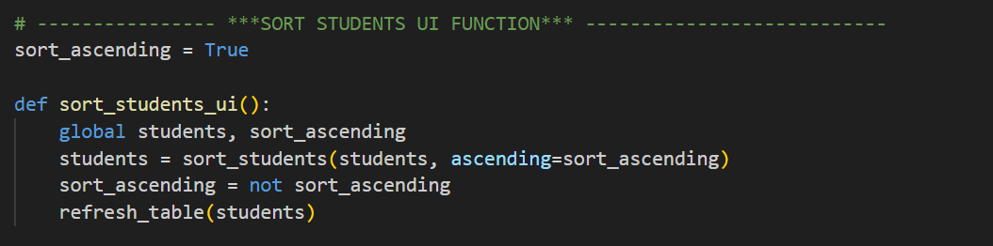
Code snippet
Toggles between ascending and descending sorting of the student list and updates the table display.

The algorithm works by comparing neighbouring student records using a combined set of key values. A simple Boolean flag controls whether the list is sorted in ascending or descending order. Once sorting is complete, the updated list is applied directly, and the table refreshes to display the new order.
Evaluation
The sorting module now works reliably and meets its intended purpose. It allows student records to be organised clearly, supports different viewing needs, and integrates well with the user interface. The simple design makes the function easy to understand and maintain, while still providing effective sorting functionality for the system.

Iteration 6 – Searching Algorithm- 08-3-2026
Objective
Prototype 3 (extended)
Prototype 3 was extended to support validated searching with role-based output control.
The aim of this iteration was to enable users to locate individual student records by searching using either a student ID or a student name. At the same time, the system enforces role-based access control, ensuring that teachers can view multiple student records, while parents are restricted to viewing information related only to their own child.
Implementation
The search functionality was implemented using a linear search algorithm, as the dataset size is small and does not require a more complex approach. Each student record is checked sequentially to determine whether the search term appears in the student’s name or student ID. This provides a clear and efficient solution appropriate for the scale of the system.
To improve robustness, the search is performed in a case-insensitive manner, ensuring users can find records without exact formatting. Input validation is applied before the search using a separate function. This ensures the search term is not empty and follows valid formats for student IDs and names. If the user cancels the search or enters invalid input, the system exits safely and displays clear feedback, preventing unnecessary processing.
Once results are found, role-based behaviour is applied. Teachers can view all matching records within the table, supporting administrative tasks. Parents are restricted to viewing only the first matching student’s details, including performance indicators such as predicted grade and intervention. This enforces data privacy and aligns with real-world data protection requirements.

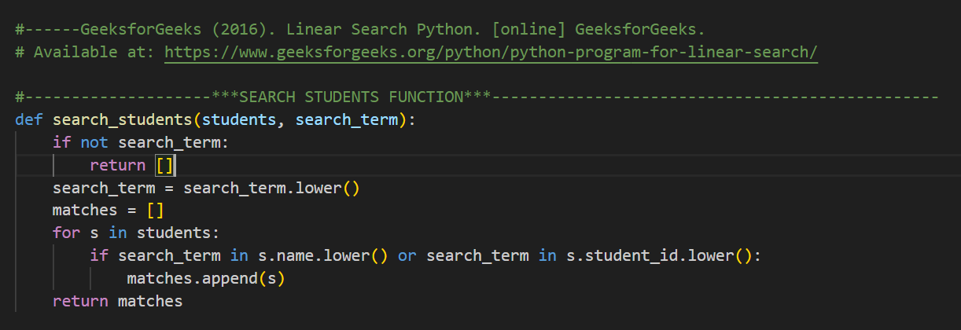
Code Snippets

Performs a linear search through the student list, returning all records where the name or student ID matches the search term (case-insensitive).

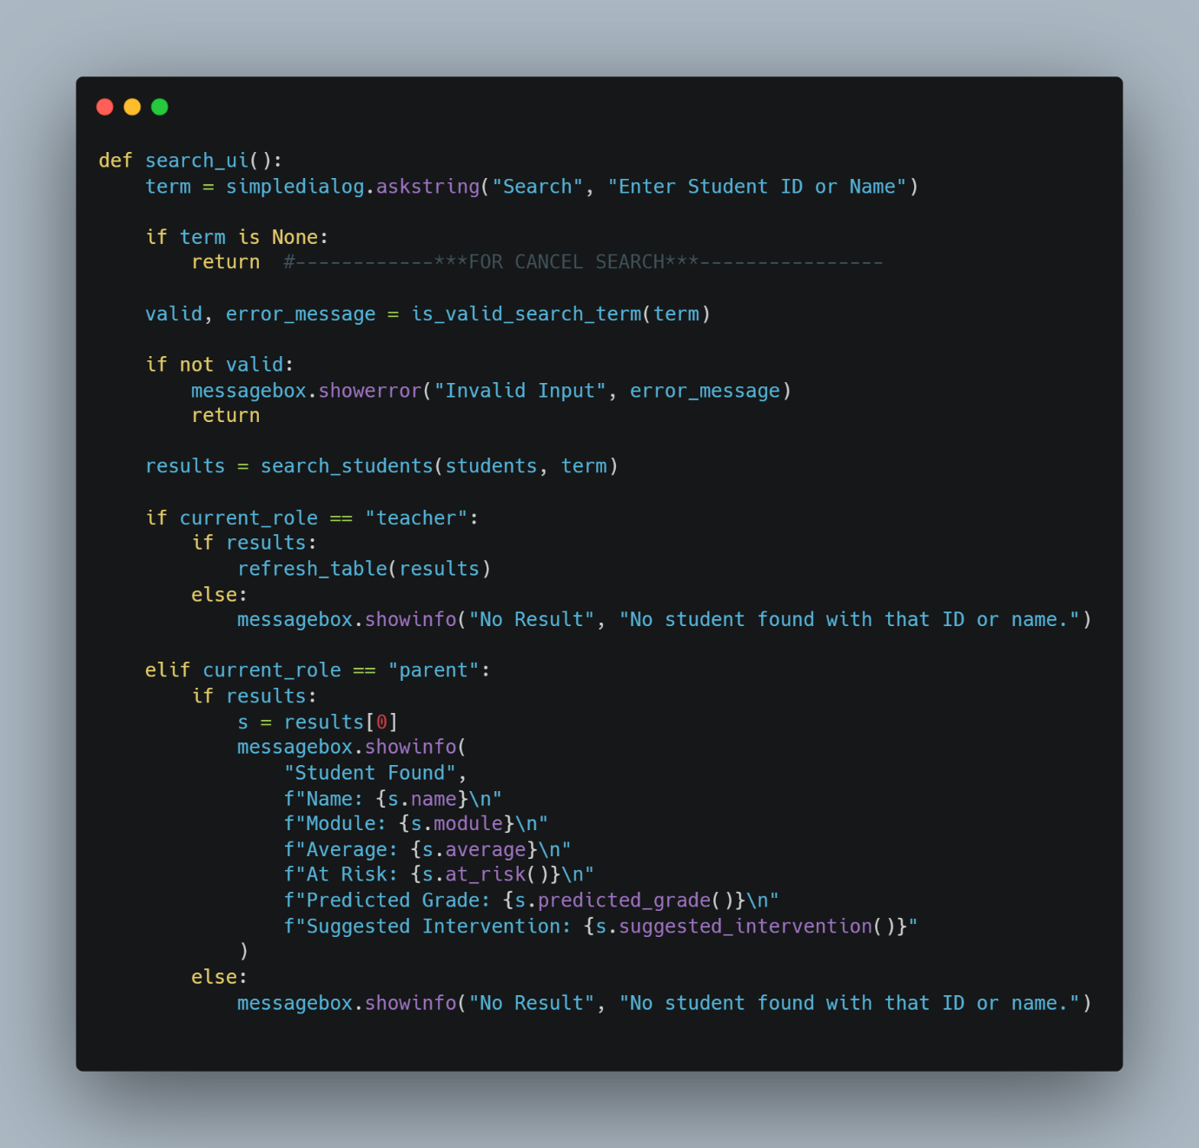

Prompts the user to search for a student by ID or name and displays results differently based on their role (teacher or parent).

Test cases
The following test cases were carried out to verify the search functionality of the system
Test Case ID | Test Case | Input Data | Expected Outcome | Result
TC28 | Valid student ID | S12 | Matching student returned | Pass
TC29 | Valid student name | Daniel | Matching student(s) returned | Pass
TC30 | Case-insensitive search | dAnIeL | Match found regardless of case | Fail  Retested and passed.
TC31 | Partial match | Dan | Student(s) with matching name returned | Pass
TC32 | Empty input | "" | Validation error message displayed | Fail  Retested and passed.
TC33 | Cancel search | Cancel dialog | Search exits safely with no action | Pass
TC34 | Invalid characters | @@@ | Validation error message displayed | Fail  Retested and passed.
TC35 | Non-existent ID | S99 | “No student found” message displayed | Fail  Retested and passed.
TC36 | Teacher role search | Valid name | Table refreshed with matching results | Pass
TC37 | Parent role search | Valid ID | Student details shown in popup only | Fail  Retested and passed.

Problems Encountered and Solutions
Issue 1: Invalid search input caused unexpected behaviour
Problem:
Early testing showed that empty input or invalid characters could be entered, which led to unnecessary searching or unclear system behaviour.
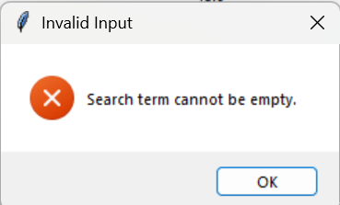
Solution:
A separate validation function (is_valid_search_term) was implemented to check input before performing the search. Invalid input now triggers a clear error message, and the search does not proceed. This improves robustness and user feedback.

Error message for empty inputs

Issue 2: Case-sensitive searches returned no results
Problem:
Initially, searches failed if users entered names or IDs with different capitalisation.
Solution:
Both the search term and student attributes were converted to lower case before comparison. This made the search case-insensitive and improved usability.
Issue 3: Parents could potentially view multiple records
Problem:
Without role-based logic, parents could view search results in the same way as teachers.
Solution:
Role-based behaviour was added. Teachers can view all matching results in the table, while parents are restricted to viewing only the first matching student’s details. This protects sensitive data and enforces access control.
Issue 4: No feedback when no results were found
Problem:
When a search matched no records, the system initially gave no response.
Solution:
An informative message box was added to notify users when no matching student is found. This improves clarity and user experience.
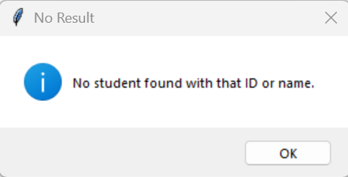
Validation for the invalid inputs

After implementing input validation and role-based output handling, all search test cases were re-executed and successfully produced the expected results.
Evaluation
The search algorithm now works reliably and securely. Input validation prevents incorrect data from being processed, while role-based access control ensures data privacy. Testing and user feedback guided improvements, resulting in a user-friendly and robust feature that integrates effectively with other decision-support components of the system.

Iteration 8 – Module Grade Distribution and Visual Analytics -11‑03‑2026
Objective
Prototype 4:
A fully integrated prototype combining decision-support logic with graphical data visualisation
The aim of this iteration was to allow teachers to visually analyse student performance within a specific module. By displaying the distribution of predicted grades in graphical form, the system supports quicker interpretation of trends and patterns, enabling more informed academic decision-making.
Implementation
The module grade distribution feature uses Matplotlib, a Python data visualisation library, to create a pie chart showing the predicted grades for a selected module. Matplotlib allows data to be presented graphically, making it easier to interpret patterns and trends compared to raw data. The user is prompted to enter a module name, and the system filters the relevant students in a case-insensitive way. If no students are found, a message is shown and the process stops safely.
For the matching students, each predicted grade is calculated and stored in a list. The system then counts the frequency of each grade and passes this data to Matplotlib to generate a pie chart. The chart displays the proportion and percentage of each grade, along with a clear title, providing an easy-to-understand visual summary of overall module performance. In the parent view, this graph is included in the generated PDF report to give a clear overview of the module’s grade distribution.

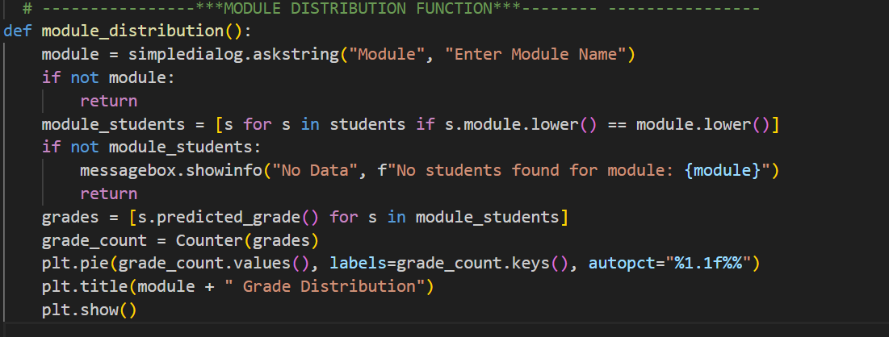
Code snippet

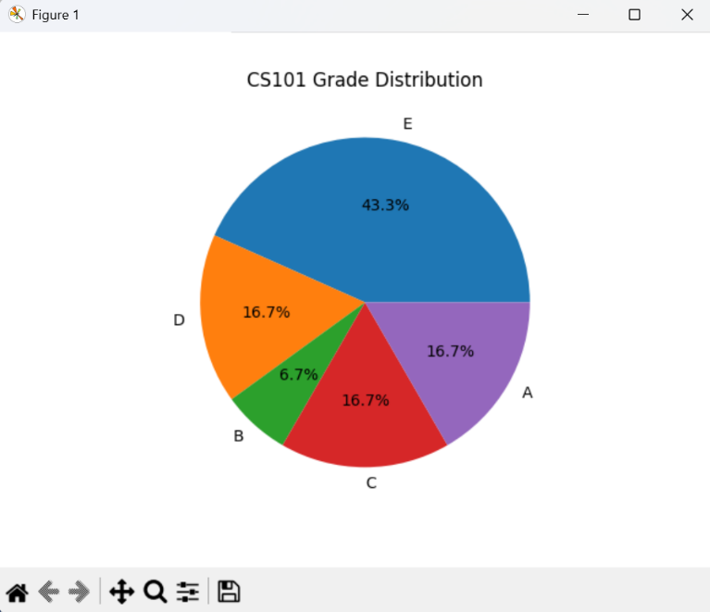
Module grade distribution graph

Justification
The module grade distribution feature uses Matplotlib to generate a pie chart showing predicted grades for a selected module. Graphical visualisation is used to help users interpret data quickly, with pie charts effectively displaying grade proportions. The system prompts the user for a module name and filters student records in a case-insensitive manner, ensuring relevant results and handling cases where no data is found.
For matching students, predicted grades are calculated dynamically and their frequencies are counted using a Counter. This data is then used to create a pie chart with percentage labels and a clear title. The feature provides a quick visual summary of overall module performance, and in the parent view, the chart is included in the generated PDF report.
Testing
The following test cases were executed to verify the module distribution functionality of the system.
Test Case ID | Test Case | Input | Expected Result | Result
TC38 | Valid module | M205 | Pie chart displayed | Pass
TC39 | Valid module (lower case) | m205 | Pie chart displayed | Fail  Retested and passed.
TC40 | Invalid module | M999 | “No students found” message | Fail  Retested and passed.
TC41 | Empty input | Cancel / blank | Function exits safely | Pass

Problems Encountered and Solutions
Issue 1: Case-Sensitive Module Matching
Initial testing showed that entering a module name with incorrect capitalisation resulted in no data being found.
Solution:
Both the user input and student module values were converted to lower case before comparison, making the search case-insensitive and improving usability.
Issue 2: No Feedback When Module Was Not Found
Early versions of the feature produced no visible response when no students were enrolled in the specified module.
Solution:
A user-friendly message was added to inform the user when no data is available for the selected module.
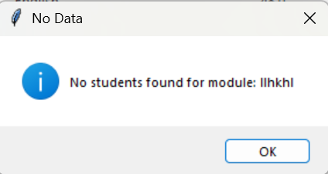
Validation message for an invalid module name
Evaluation
The module grade distribution feature successfully meets its objective by providing a clear visual representation of student performance within a module. It integrates effectively with existing analytical functions such as predicted grade calculation and supports informed decision-making. The feature enhances the system’s analytical capabilities and provides a strong foundation for future developments, such as exporting charts or combining multiple modules in a single visualisation.
The feature was re-tested after introducing case-insensitive matching and user feedback messages, and all tests passed successfully.

Iteration 9 – PDF Report Export- 11‑03‑2026
Objective
Prototype 4 (refined)
Prototype 4 was refined to include professional PDF report generation with embedded visual analytics.
The objective of this iteration was to allow teachers and parents to generate a detailed academic performance report for an individual student. The report combines key performance data with visual analysis in a professional PDF format that can be saved, shared, or reviewed outside the system.
Implementation
This feature uses the ReportLab library, which allows Python to create professional PDF documents, along with Matplotlib for generating charts. When the export function is used, the system checks the user’s role: parents search for their child by ID or name, while teachers select a student from the table, ensuring that sensitive data is accessed appropriately. The system collects all relevant information for the student, such as average score, attendance, homework completion, at-risk status, predicted grade, and suggested intervention. It also looks at all students in the same module to calculate the predicted grade distribution. A pie chart is then created using Matplotlib and added to the PDF, giving a clear, visual summary of student performance.

Code snippet
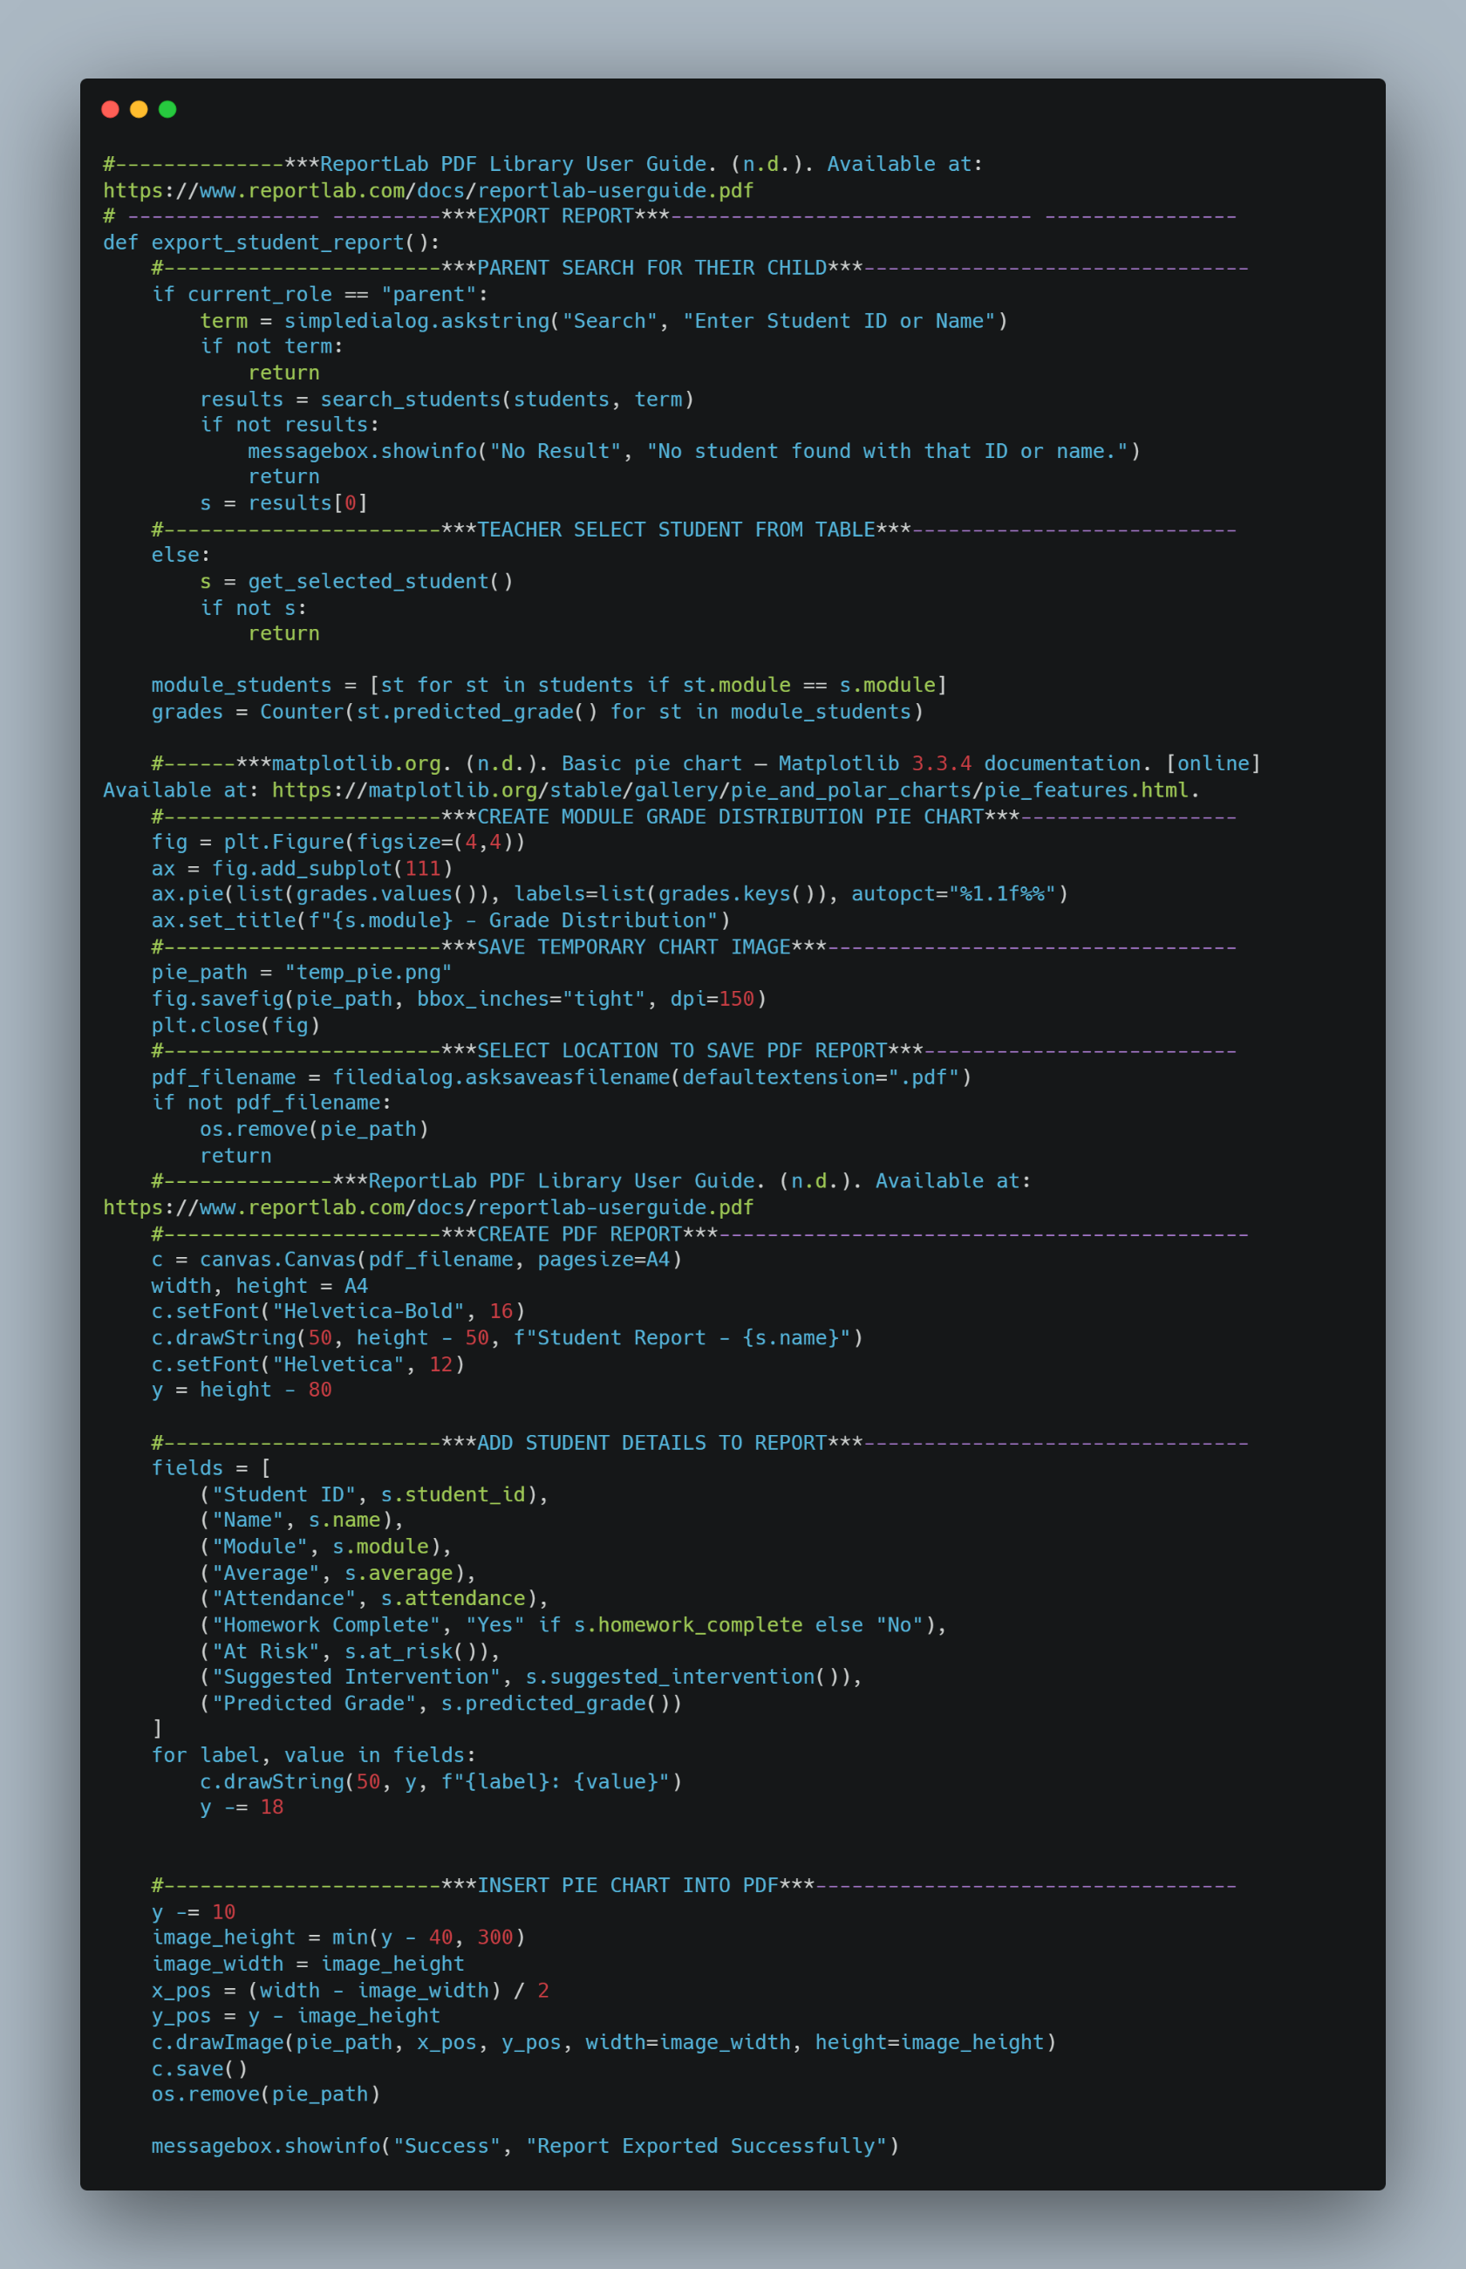

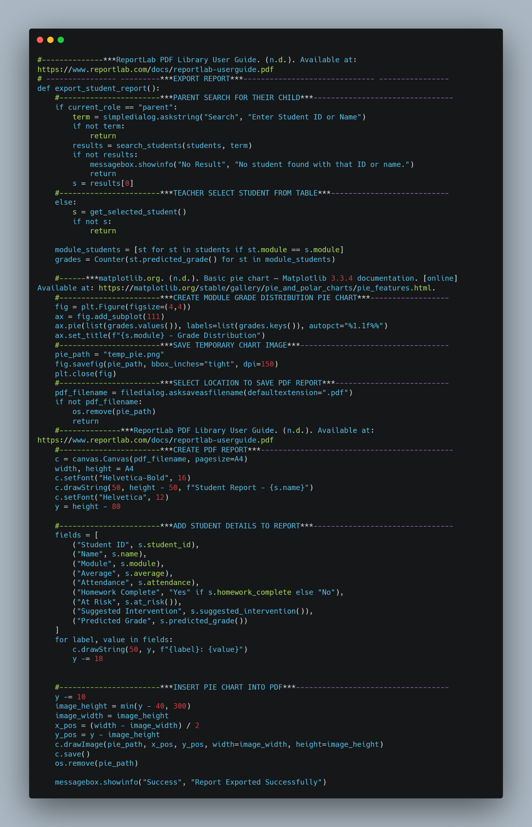

Sample PDF Report
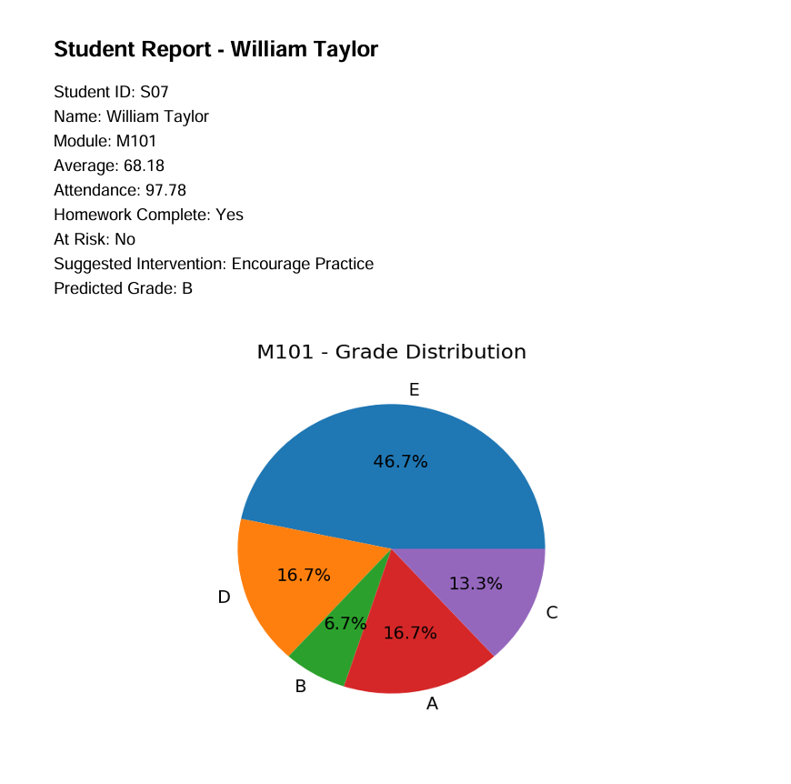

Test cases
The following test cases were executed to verify the PDF report generation functionality of the system.
Test Case ID | Test Case | Input | Expected Outcome | Result
TC42 | Teacher report export | Teacher selects a student and clicks Export Report | PDF report generated successfully | Pass
TC43 | Parent report export | Parent searches valid student ID/name | Correct PDF report generated | Pass
TC44 | Cancel student search (parent) | Parent cancels search dialog | Cannot export PDF without a valid student id/name | Pass
TC45 | Cancel save dialog | Cancel file save dialog | Export cancelled, no PDF created | Pass
TC46 | Pie chart generation | Student in a module with others | Chart included in PDF | Fail  Retested and passed.
TC47 | Single-student module | Only one student in module | Pie chart generated correctly | Pass

Problems Encountered and Solutions
The PDF report was generated without including the module distribution pie chart.
Solution:
ReportLab cannot directly embed a Matplotlib figure object. To solve this, the pie chart was first saved as a temporary image file, which was then inserted into the PDF. After embedding, the temporary file is deleted to keep the system clean and prevent unnecessary storage use.
Code to save as a temporary image file
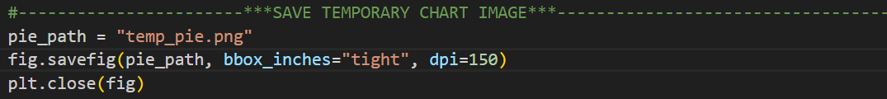

After embedding the pie chart as a temporary image file, the report generation feature was re-tested and successfully produced complete PDF reports in all scenarios.
Justification
The report generation feature uses ReportLab to create professional PDFs and Matplotlib to include a visual grade distribution. The system identifies the student based on the user’s role. Parents search for their child, while teachers select from the table, ensuring sensitive data is protected. It collects key academic information, calculates predicted grades for the module, and generates a pie chart, which is embedded in the PDF.
Users choose where to save the report, and temporary files are removed after export. The PDF includes a clear title, student details, and the grade distribution chart. Using PDFs ensures formatting is preserved across devices, while combining text and visuals makes the report informative. Role-based access keeps data secure, and the modular use of Matplotlib and ReportLab ensures maintainability. Overall, this feature provides a clear, professional summary of academic performance, supporting the system as a decision support tool.
Alternative reporting formats such as HTML were considered, but PDF was chosen for portability and consistent formatting across devices.

Evaluation
This iteration successfully met its objective by providing a clear, well-structured student performance report. The combination of textual data and visual analysis improves understanding and supports informed decision-making. The feature integrates effectively with existing system components and enhances the overall usefulness of the application.

Iteration 10 – Login System and Role-Based User Interface- 15-03-2026
Objective
Final Prototype (Prototype 4)
A complete, role-secured academic performance decision support system ready for deployment.
The objective of this iteration was to control access to the system by introducing a login mechanism and to adapt the user interface according to the role of the logged-in user. This ensures that teachers and parents are presented with appropriate functionality and that sensitive student data is protected through role-based access control.

Implementation
The login system was implemented using a simple authentication mechanism based on predefined user credentials. When a user attempts to log in, the system retrieves the username and password entered in the login fields and checks them against stored user records.
If the entered credentials are valid, the user’s role is determined and stored in a global variable. A confirmation message is displayed, the login window is closed, and the main application window is launched. The main interface is then built dynamically based on the user’s role.
If the credentials are invalid, an error message is shown, and access to the system is denied. This prevents unauthorised users from accessing the application.
A reset function was also implemented to allow users to quickly clear the login fields. This improves usability and reduces frustration if incorrect details are entered.
Role-Based Interface Construction
Once a user logs in successfully, the build_main_window function creates the main interface and displays features based on their role. Teachers have access to administrative tools such as importing CSV files, refreshing data, sorting records, viewing module grade distributions, and accessing full student tables. Parents have restricted access, allowing them to search for a student and view performance-related information while protecting data privacy.
All users can search for students, view at-risk status, predicted grades, suggested interventions, and export reports. The main student table, displayed only for teachers, uses a scrollable TreeView to ensure easy navigation of large datasets.
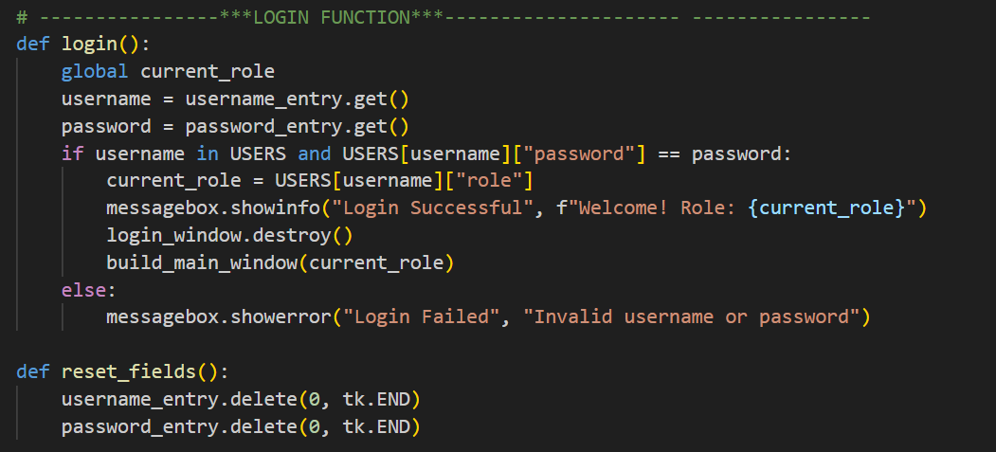
Code snippets
Verifies user credentials, assigns the appropriate role, and opens the main interface upon successful login.

Clears the username and password input fields to allow the user to re-enter credentials.

Justification:
The login feature ensures that only authorised users can access the system. When a user enters their username and password, the login() function checks these against stored records and assigns a role, which determines what features they can see and use. This keeps sensitive student data secure and ensures teachers and parents only access information relevant to them.
The reset_fields() function lets users quickly clear the input fields, making the login process easier and more user-friendly. Using Tkinter provides a simple, intuitive interface, and keeping the login logic separate from the main interface makes the system easier to maintain and extend in the future.
Testing
The login and role-based interface functionality was tested using a range of scenarios.
Test Case ID | Test Case | Input | Expected Result | Result
TC48 | Valid teacher login | Correct credentials | Access granted, full interface shown | Pass
TC49 | Valid parent login | Correct credentials | Access granted, restricted interface shown | Pass
TC50 | Incorrect password | Wrong password for parent/teacher | Error message displayed | Pass
TC51 | Unknown username | Invalid username for parent/teacher | Error message displayed | Pass
TC52 | Empty fields | No input | Login denied | Pass
TC53 | Reset fields | Click reset | Fields cleared | Pass

Problems Encountered and Solutions
Issue:
Initially, all users were shown the same interface regardless of their role.
Solution:
The interface was modified to dynamically display features based on the logged-in user’s role. Administrative tools and full data views were restricted to teachers only.
Evaluation
This iteration successfully introduced secure access and role-based user interaction. By combining authentication with a dynamically constructed interface, the system ensures usability, security, and ethical handling of student data. The solution integrates smoothly with existing components and provides a strong foundation for future improvements, such as enhanced authentication or additional user roles.

EVALUATION CHAPTER

Introduction
The purpose of this evaluation is to assess the effectiveness of the Student Performance Decision Support System (DSS) in meeting its intended objectives and success criteria defined during the analysis stage. The system was designed to improve the efficiency, accuracy, and usability of student performance monitoring for teachers and parents.
This evaluation uses test evidence, user feedback, and success criteria to determine whether the system has been successful. It also considers usability, limitations, maintenance, and potential future improvements.

Post-Development Testing
Extensive post-development testing was carried out to ensure that the system functions correctly and handles errors effectively.

Authentication and Role-Based Access
Post-development testing confirmed that user authentication and role allocation behave correctly under normal and invalid conditions.

Successful teacher login showing full dashboard
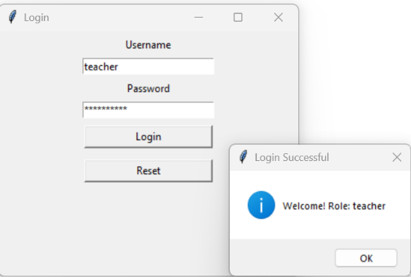
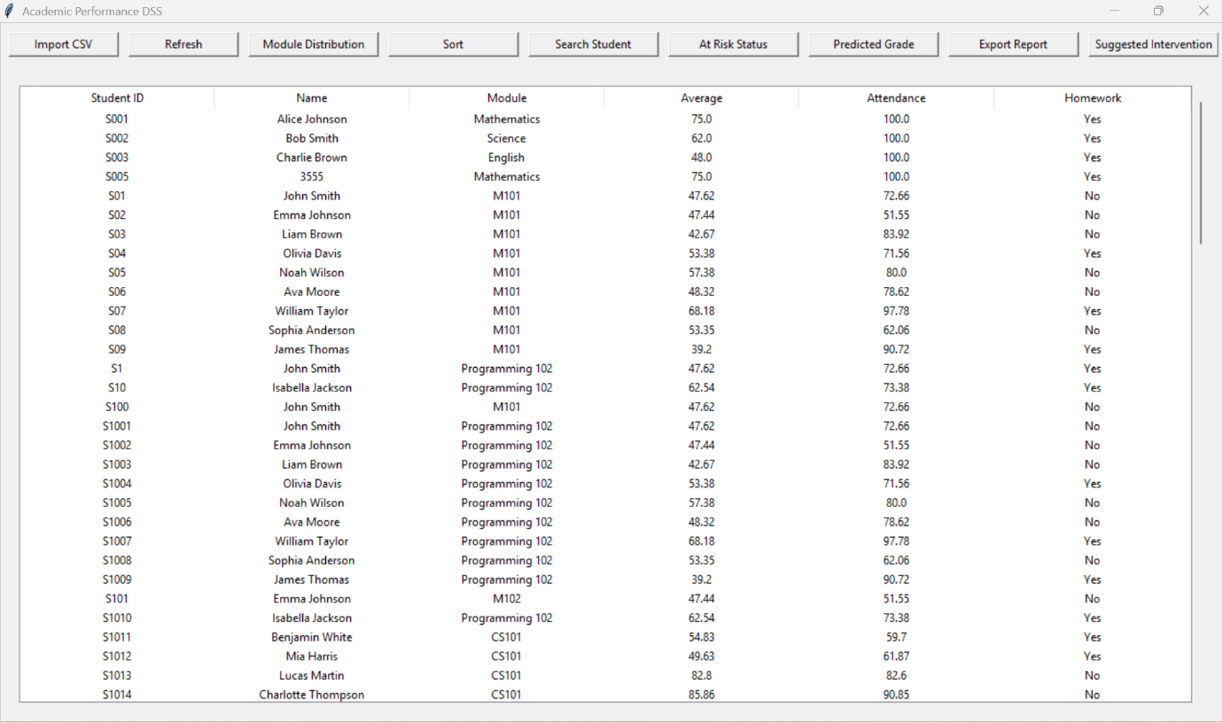

Figure 1
The Figure 1 demonstrates successful teacher authentication. The full dashboard is visible, confirming that valid credentials correctly assign the teacher role, satisfying success criteria SC1 identified in the analysis stage.

Parent dashboard (restricted view)
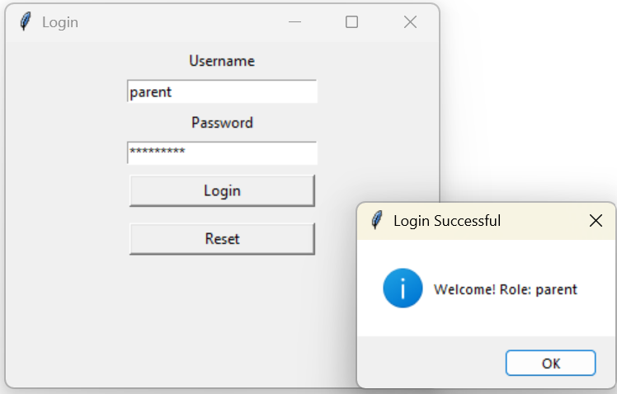


Figure2
Main dashboard for parents

Figure2 shows the restricted parent interface, where administrative features are hidden. This confirms that role-based access control is enforced immediately after successful login, satisfying success criteria SC2 identified in the analysis stage.


Invalid login error message

Figure3
Figure3 shows an error message displayed for invalid credentials. This confirms that unauthorised access is prevented, demonstrating secure authentication.
All authentication and access control tests behaved as expected in every case; therefore , success criteria identified in the analysis stage, SC1 and SC2 are fully met.

CSV Import, Validation, and Robustness
Post-development testing verified the system’s ability to import valid data and handle invalid or malformed CSV files safely.

Successful CSV import populating the table
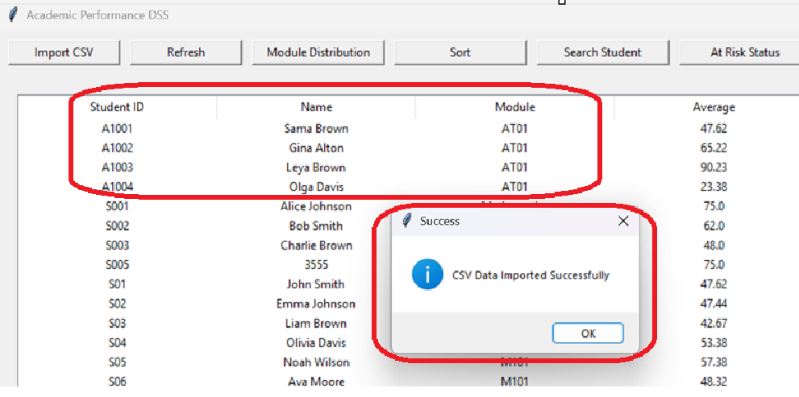
New csv file successfully adds and updated the table view

Figure 4

Figure 4 shows successful import of a valid CSV file, confirming that student records are stored and displayed correctly, meeting success criteria (SC3) identified in the analysis stage.

Validation message for missing CSV column
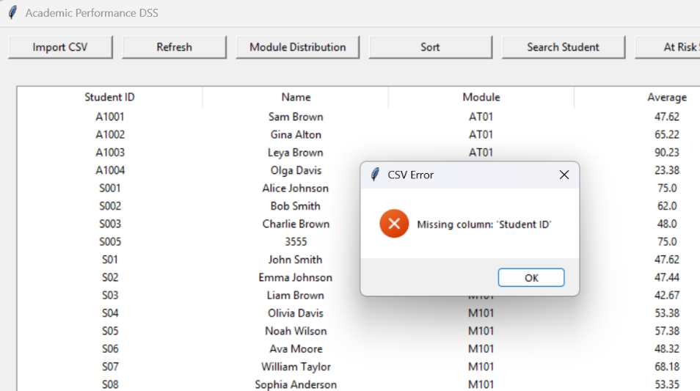
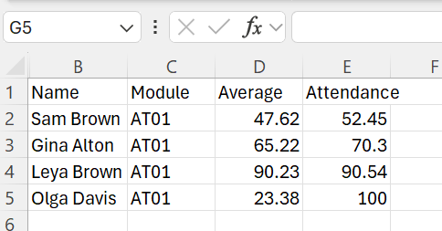
Validation message prompt for missing columns in the csv file

Figure 5
Figure 5 demonstrates the system detecting missing CSV columns and displaying a warning without crashing, confirming robust error handling, meeting success criteria (SC11) identified in the analysis stage.

Validation message for invalid data type
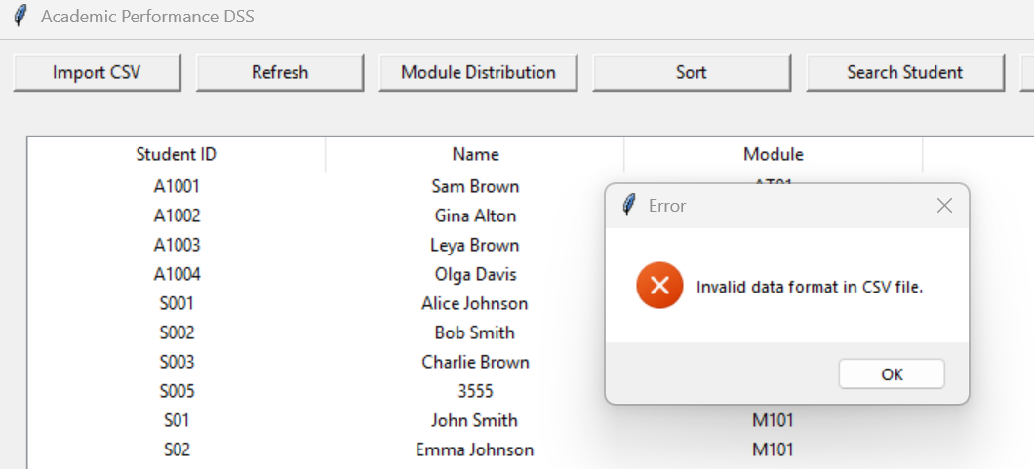
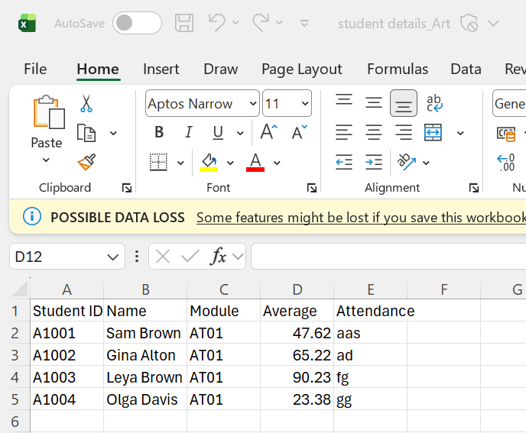
Validation message prompt for invalid data format in the csv file

Figure B3 shows the system rejecting invalid numeric input in a CSV file, preventing incorrect data from being processed.

Figure 6 shows the system rejecting invalid numeric input in a CSV file, preventing incorrect data from being processed.
The system handled all invalid CSV scenarios safely and remained stable. Therefore, success criteria (SC3 and SC11) identified in the analysis stage are fully met.

Search Functionality and Access Control
Search testing confirmed that students can be located accurately using valid identifiers, while invalid input is handled safely.

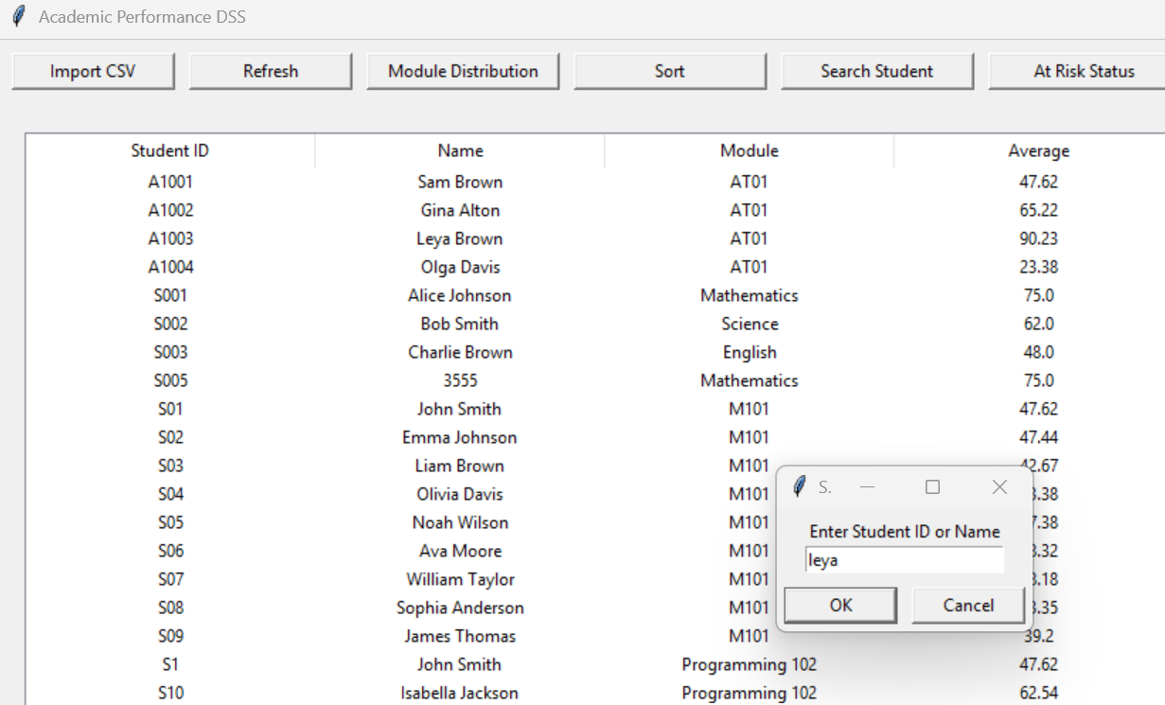
Valid student ID search result

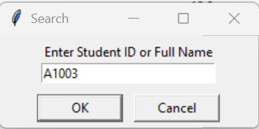

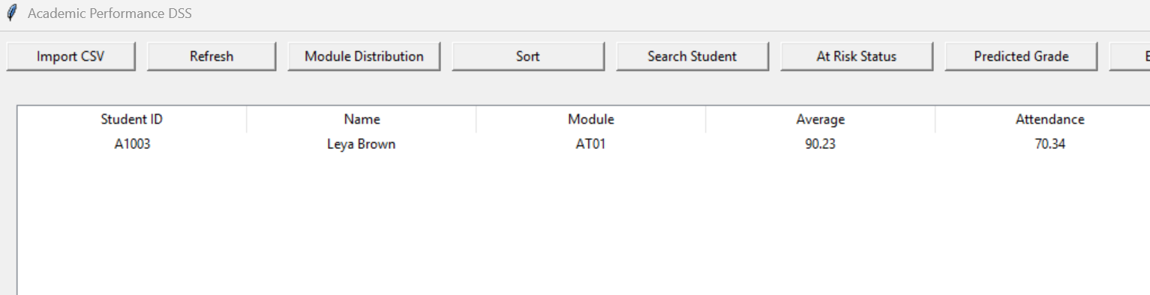

Figure 7

Figure 7 shows the table refreshing with matching results for a valid student ID, confirming accurate search functionality; the identified success criterion (SC4) in the analysis stage is fully met.

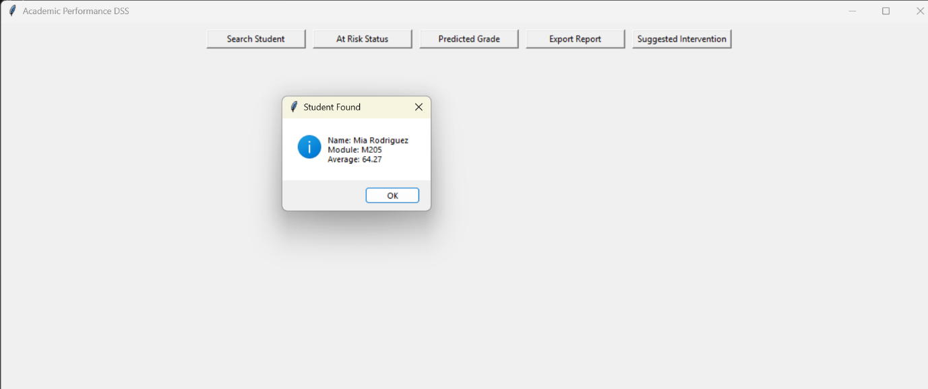
Parent search result shown as popup only

Student details shown in popup only

Figure C2 demonstrates that parent searches display student details in a popup only, confirming that access to full datasets is restricted by role (SC2).
“No student found” / validation message
Figure 8

Figure 8 demonstrates that parent searches display student details in a popup only, confirming that access to full datasets is restricted by role, identified success criterion (SC2) in the analysis stage is fully met.

“No student found” / validation message


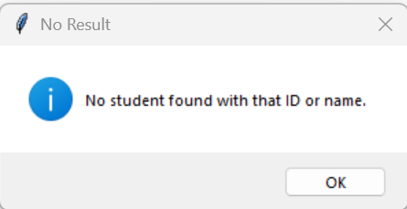

Figure 9
Figure 9 confirms that invalid or empty search input is detected and handled safely without processing, demonstrating robustness; the identified success criterion (SC11) in the analysis stage is fully met.
Search functionality was reliable, role-aware, and robust, therefore success criteria (SC4, SC2, and SC11) are fully met.

Sorting Functionality
Sorting was tested to ensure users can organise data effectively while maintaining access restrictions.

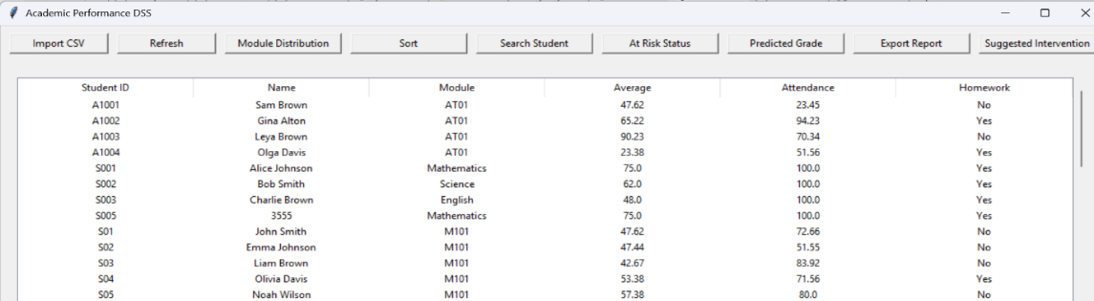
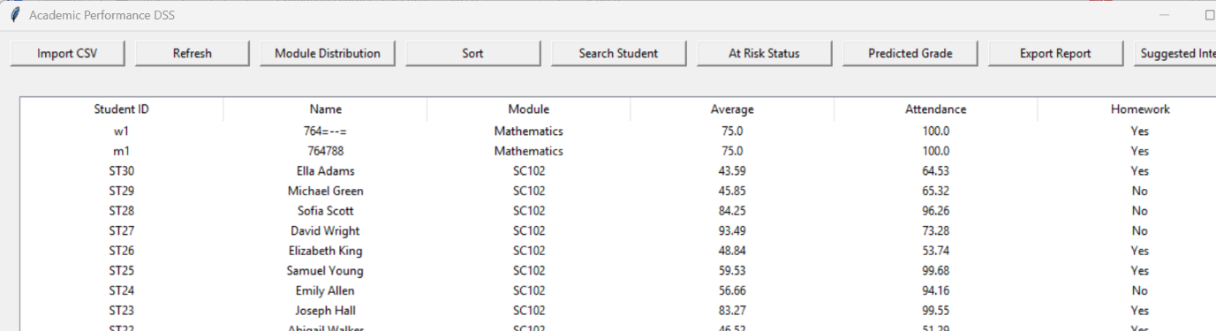
Teacher view sorted ascending/descending
Sorting in ascending order
Sorting in descending order

Figure 10

Figure 10 shows student records correctly sorted in ascending and descending order in the teacher view, confirming that the system meets the sorting requirement; the identified success criterion (SC10) in the analysis stage is fully met.

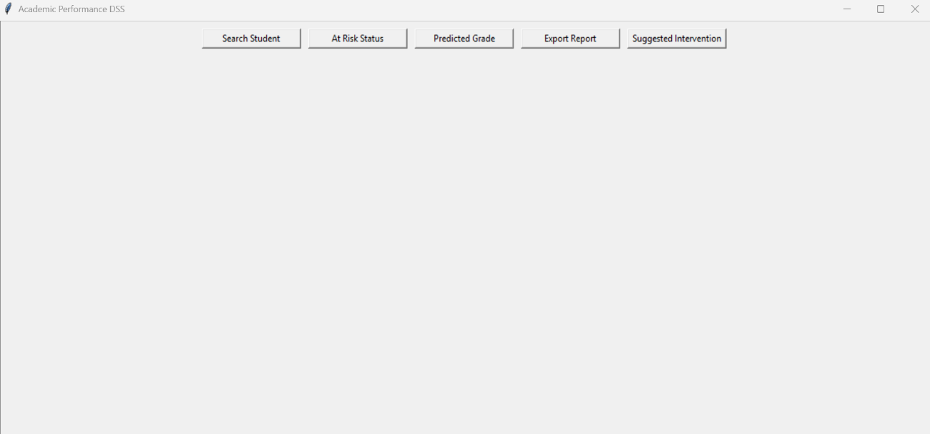
Parent view without sort button
Sort button is not enabled in the parent view

Figure11
Figure 11 shows the absence of the sort button in the parent view, confirming that restricted users cannot modify data organisation.
Overall, sorting behaved exactly as required from the user perspective; therefore, successful criterion (SC10) is fully met.

At-Risk Identification and Boundary Testing

Student below threshold flagged at risk
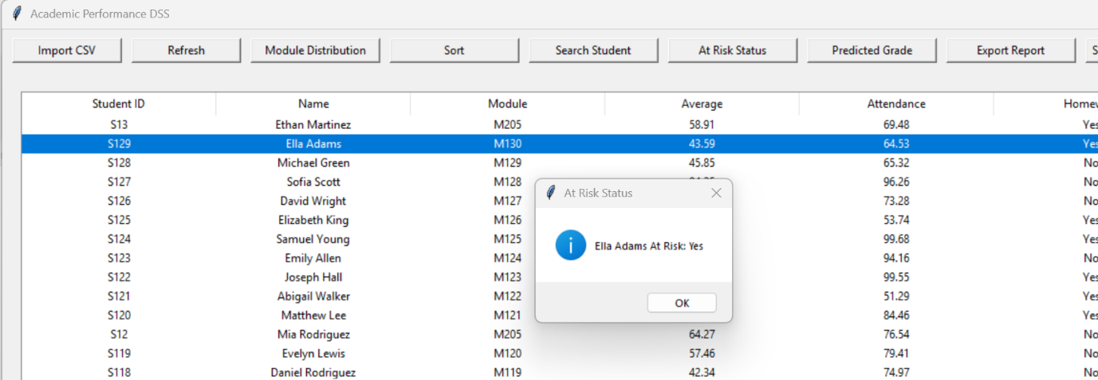

Figure 12

Figure 12 shows a student with an average below 50% correctly flagged as at risk, confirming accurate classification; the identified success criterion (SC5) in the analysis stage is fully met.

Boundary value at 50%
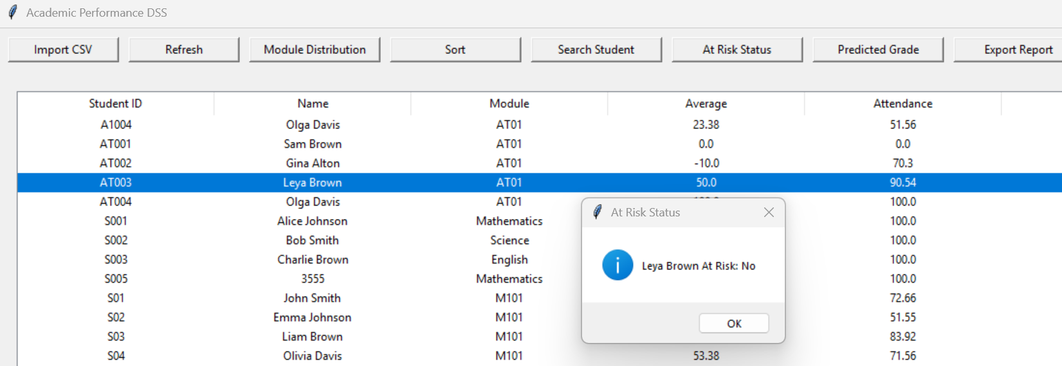
Figure 13
Figure 13 demonstrates correct handling of the boundary value, where a student scoring 50% is not flagged as at risk.

Invalid value adjusted
Adjusted to valid range
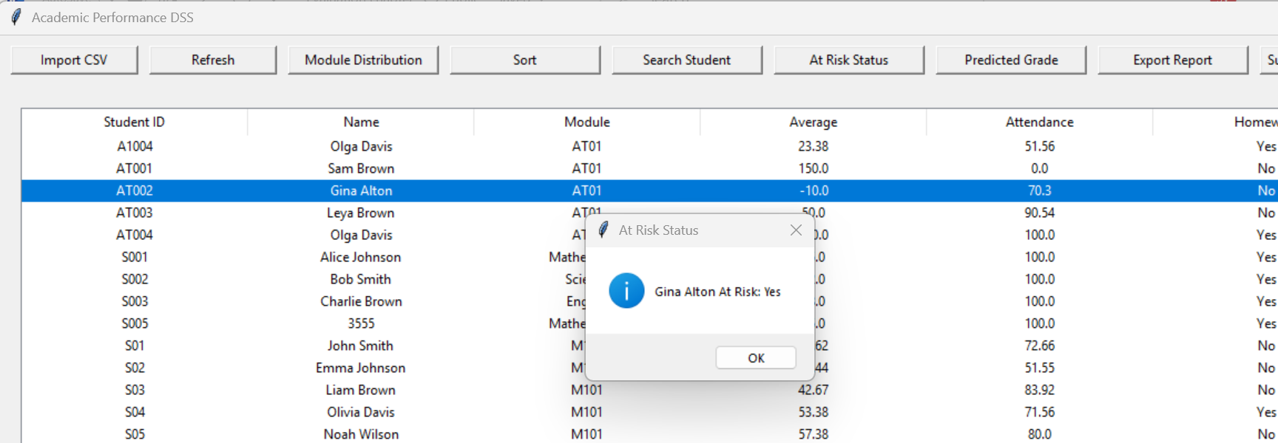

Figure 14

Figure 13 shows invalid input being adjusted to a valid range, preventing incorrect risk evaluation and demonstrating robustness; the identified success criterion (SC11) in the analysis stage is fully met.
Boundary and validation testing confirmed reliable classification and stability; therefore, SC5 and SC11 are fully met.

Export Report Function
Post-development testing was carried out to verify that the Export Report function generates a complete and accurate PDF report for both teachers and parents while enforcing role-based access control.
For teachers, testing confirmed that a report can only be generated once a student is selected from the table. If no student is selected, the system displays a warning message and prevents the operation from continuing. This ensures that reports are not produced with missing or incorrect data. For parents, testing confirmed that the system requires a valid student ID or name before generating a report, and that parents can only generate reports for their own child.

Successful PDF export for a selected student
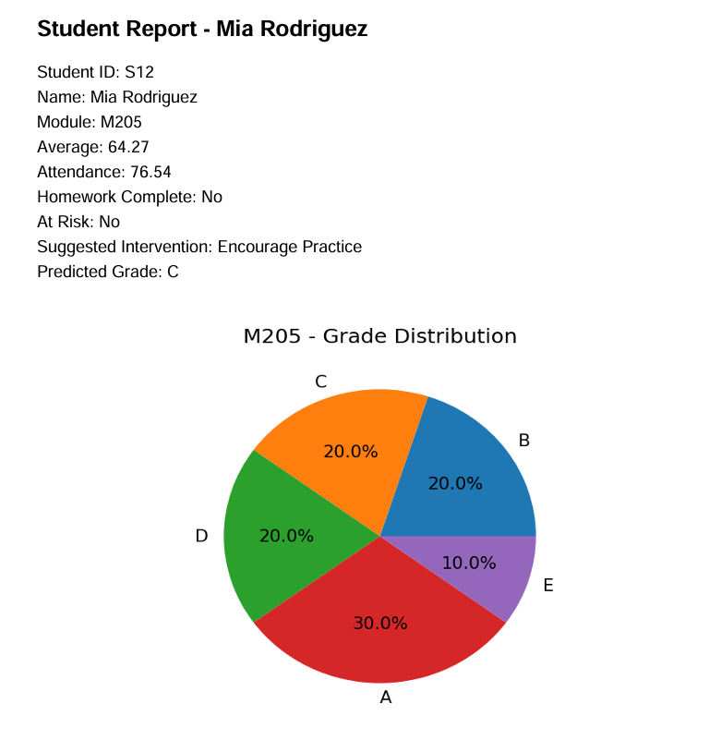
Figure 15

Figure 15 shows a successfully generated PDF report containing student details, at-risk status, predicted grade, suggested intervention, homework completion, attendance and a module grade distribution chart. This confirms that the Export Report function produces a complete and accurate report, meeting the success criterion (SC9) identified in the analysis stage.
During testing, invalid actions such as cancelling the save dialog or attempting to export without selecting or searching for a student were handled safely, with appropriate error messages displayed and no system crashes observed.
The Export Report function consistently generated correct PDF reports, enforced role-based restrictions, and handled invalid inputs robustly. Therefore, SC9 (report generation), SC2 (role-based access), and SC11 (robustness) are fully met.

Suggested Intervention Function
Post-development testing confirmed that the Suggested Intervention function correctly displays appropriate intervention recommendations based on a student’s average score.
Testing showed that:
- High-performing students receive “None”
- Medium-performing students receive “Encourage Practice” or “Extra Tutoring”
- Low-performing students receive “Immediate Intervention”
For teachers, the intervention is displayed for the currently selected student in the table. For parents, the system requires a valid student ID or name before displaying the intervention for their child. Attempts to access the intervention feature without selecting or searching for a student resulted in validation error messages, preventing incorrect processing.

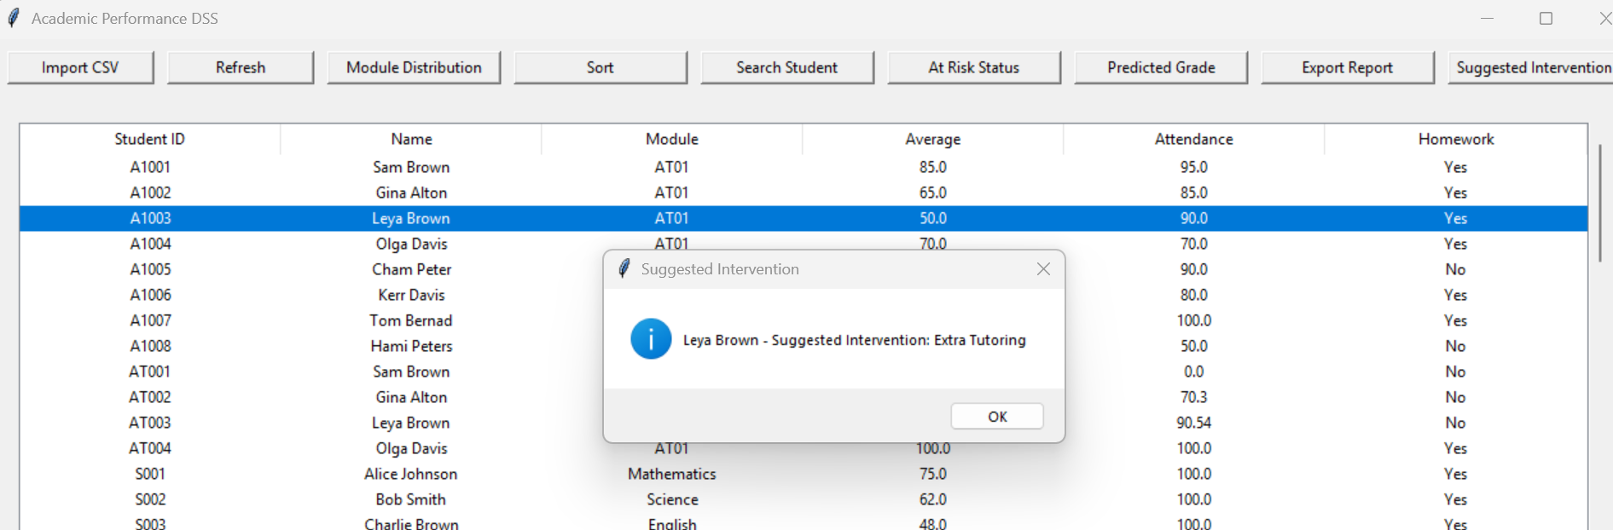
Suggested intervention displayed for a student

Figure 16

Figure 16 shows an intervention recommendation generated based on the student’s performance. This confirms that the system applies the defined decision rules correctly and supports informed decision-making, meeting the success criterion (SC7) identified in the analysis stage.
The Suggested Intervention function behaved consistently with predefined rules, enforced role-based access, and safely handled invalid inputs. Therefore, SC7 (intervention generation), SC2, and SC11 are fully met.

Module Grade Distribution Chart
Post-development testing was conducted to verify that the Module Grade Distribution function accurately generates visual summaries of predicted grades.
Testing confirmed that when a valid module name is entered, the system correctly:
- Filters students belonging to the selected module
- Calculates predicted grades for each student
- Displays a pie chart showing the distribution of grades
If an invalid module name is entered or no students are found for the specified module, the system displays an informative message and exits safely without error.

Module grade distribution pie chart
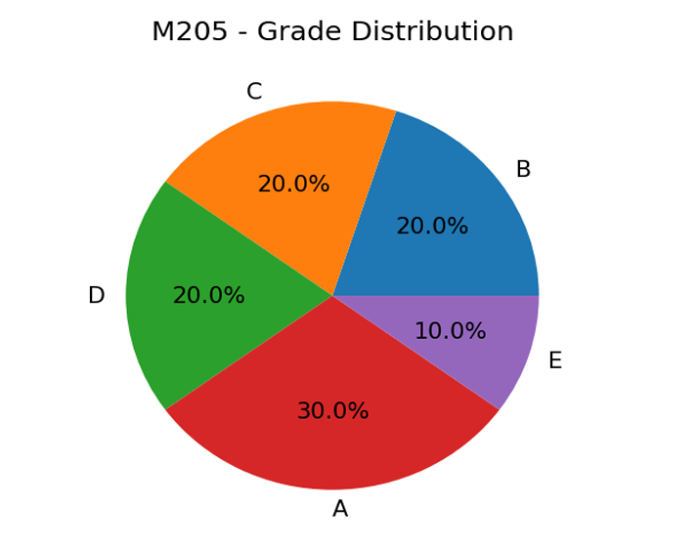
Figure 17

Figure 17 shows a correctly generated pie chart displaying predicted grade distribution for a selected module. This confirms accurate data aggregation and effective visualisation, meeting the success criterion (SC8) identified in the analysis stage.
The same chart is reused in the PDF report, confirming consistency between on-screen analysis and report generation.
The module distribution chart function produced accurate visualisations and handled invalid input safely. Therefore, SC8 (visualisation accuracy) and SC11 (robustness) are fully met.

Usability Testing
Usability testing was carried out to assess whether both teachers and parents could use the system effectively, intuitively, and without the need for additional instructions or training. Testing focused on key usability principles including learnability, clarity of layout, feedback, error prevention, and role-based interface simplification. The outcomes of this testing are supported by annotated visual evidence.

Dashboard Layout and Learnability
The main dashboard was tested to determine whether users could immediately recognise available functions and complete common tasks such as searching for students, checking performance indicators, and generating reports.
Teachers can see all functions & student details table

Clean teacher dashboard


Figure 18

Figure 18 shows a logically structured teacher dashboard with clearly labelled buttons arranged in a consistent layout. Core actions are grouped together and displayed prominently, allowing users to complete tasks without additional guidance. This demonstrates that the interface is intuitive and easy to learn, fully meeting the success criterion (SC12) identified in the analysis stage.
Usability testing showed that teachers were able to import data, sort records, analyse performance, and export reports without confusion. Parents, who are presented with a reduced interface, were able to locate their child’s information and view performance indicators easily. The removal of unnecessary controls for parents reduced cognitive load and prevented accidental misuse of administrative features, further improving usability.

Feedback, Validation, and Error Prevention
A key aspect of usability testing was verifying that the system provides clear and immediate feedback when users perform actions or attempt invalid operations. This ensures users understand what the system is doing and how to correct mistakes.

Validation message guiding user
All dashboard actions include validations to maintain proper system operation:
- As per the figure 19, the Search Student feature provides below message if no matching student is found.

Figure 19

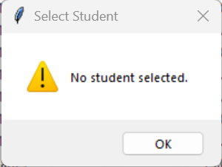
- As per the figure 20, table Actions require a student to be selected before displaying information such as At-Risk Status, Predicted Grade, report generation, or Suggested Interventions. Below validation message indicates the user to select a student first before displaying information.

Figure 20

- As per the figure 21, the system validates search input to reject invalid character patterns. The validation error message confirms that incorrect data is detected early, preventing logical errors within the search algorithm and improving system robustness (SC4 and SC11 fully met).
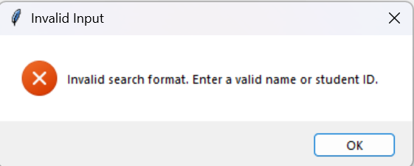
Figure 21

- As per the figure 22, the system correctly completes the search process when no matching records exist. Displaying a “No student found” message confirms that the algorithm handles empty result sets correctly without crashing or producing incorrect data (SC4 fully met).


Figure 22

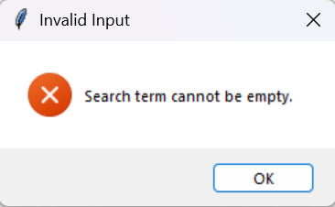
- As per the figure 23, the system correctly validates input before executing the search algorithm. The display of a validation error message confirms that empty inputs are detected and prevented from triggering unnecessary processing, demonstrating correct input validation logic (SC4 and SC11 fully met).

Figure 23
These validations prevent runtime errors, protect data integrity, and guide users in correct system usage.

Role-Based Interface Simplification
Usability testing also evaluated the effectiveness of role-based interface design. Teachers and parents were presented with different interfaces tailored to their needs and permissions.
Teachers were given access to all analytical and administrative tools, while parents were restricted to viewing only relevant information about their own child. This simplification reduced confusion, improved ease of use, and ensured that users were not overwhelmed by unnecessary features. Testing showed that both user types were able to complete tasks efficiently, confirming that the role-based design was effective from a usability perspective.
Overall usability testing confirms that the system is user-friendly, intuitive, and appropriate for both teachers and parents. Users were able to complete all key tasks without assistance, validation messages reduced errors, and feedback helped users understand system responses.

Login screen


Figure 24

The figure 24 shows the login interface with clearly labelled fields and password masking enabled. This reduces user error and protects sensitive information, contributing to effective usability identified in success criterion (SC12) in analysis stage.

Login feedback



Figure 26
Figure 25
In figure 25 and 26 demonstrates immediate success/error feedback following a login attempt, allowing users to understand system responses without assistance. This improves confidence and confirms effective usability identified in success criterion (SC12) in analysis stage.

Evaluation of Success Criteria
The success criteria defined during the analysis stage were evaluated using evidence from post-development testing, robustness testing, and usability testing. The evaluation below summarises which criteria were fully met, partially met, or implicitly met, with justification based on observed system behaviour and annotated evidence.

Fully Met Success Criteria
The majority of the success criteria were fully met, supported by consistent testing outcomes and annotated evaluation evidence.
The system successfully authenticated users and assigned correct roles, ensuring secure access to sensitive student data (SC1). Role-based access control was correctly enforced, restricting parents from administrative features such as sorting, CSV import, and access to full datasets, while allowing teachers full functionality (SC2).
CSV import and data storage operated reliably, with valid files imported correctly, data persisting after restart, and duplicate student IDs handled appropriately (SC3). The search feature functioned accurately for student names and IDs, including case-insensitive, partial, invalid, and empty inputs, all of which produced correct results or validation messages (SC4).
Decision-support features were consistently accurate. At-risk student identification correctly classified students above, below, and at the boundary threshold of 50% (SC5). Predicted grades were calculated reliably and consistently for identical inputs, with attendance and homework penalties and value clamping applied correctly (SC6). Suggested interventions followed predefined rules for all performance bands (SC7).
Analytical and reporting features were also fully met. Visualisations accurately represented grade distributions using pie charts derived from correct datasets (SC8). PDF report generation produced complete, well-formatted reports containing all required fields and charts for both teachers and parents (SC9).
The system handled invalid input, missing files, and incorrect formats without crashing, displaying appropriate error messages and maintaining stability (SC11).
One success criterion was initially partially met during development. Sorting student data (SC10) required refinement to correctly toggle between ascending and descending order. Although this issue was resolved in later development and the final implementation behaves as intended. Functionally, SC10 is fully met in the final system.

Partially Met Success Criteria
System performance efficiency (SC13) was judged primarily through observation rather than formal timing measurements. During testing, all key actions such as searching, sorting, and generating reports completed without noticeable delay. However, no explicit response-time measurements were recorded. Therefore, SC13 is best described as partially met or implicitly met, depending on interpretation. For the scope and dataset size of this system, performance was acceptable, but future evaluation could include formal timing tests.

Usability Success Criteria
Usability testing confirmed that users were able to complete key tasks without assistance, supported by a clear layout, informative feedback, and role-based interface simplification (SC12).

Maintenance Considerations and Limitations
The system has been designed with maintainability in mind through a modular and structured approach. Core functionalities such as authentication, searching, sorting, CSV import, reporting, and decision-support logic are implemented as separate functions and classes. This modular design makes the system easier to maintain, as individual components can be updated, tested, or replaced without affecting the entire program. The use of descriptive function and variable names further supports readability and long-term maintenance.
However, several limitations were identified during evaluation. The system uses SQLite as its database, which is suitable for a small to medium-sized dataset and simplifies deployment. While this is appropriate for the scope of the project, SQLite may become a limitation if the system were scaled to support very large datasets or simultaneous multi-user access. In such scenarios, performance and concurrency could be affected.
Another limitation is the rule-based approach used for at-risk identification, predicted grades, and intervention suggestions. Although this approach is transparent and consistent, it relies on predefined thresholds and does not account for more complex factors such as long-term trends or correlations between multiple performance indicators. This limits predictive accuracy when compared to more advanced analytical techniques.
Finally, the system operates as an offline desktop application, which restricts collaboration and remote access. While this improves simplicity and data privacy, it limits the ability for multiple users to access the system simultaneously or from different locations.

Further Development
Several realistic improvements could be made to enhance the system in future versions. One possible development is migrating from SQLite to a server-based database such as MySQL (mysql, 2026) or PostgreSQL (PostgreSQL, 2025). This would improve scalability, support concurrent users, and allow deployment in larger institutions.
Authentication could also be enhanced. Currently, user credentials are predefined, which is sufficient for a prototype. In a real-world implementation, authentication could be improved by introducing encrypted password storage (Vaadata , 2020). , individual parent accounts, and role-based user management stored securely in the database.
The decision-support features could be developed further by incorporating advanced predictive models. Machine learning techniques or statistical analysis could be used to consider historical performance trends, attendance patterns, and homework completion over time, improving the accuracy of predicted grades and at-risk identification.
Deploying the system as a web-based application would allow remote access for teachers and parents, improve collaboration, and enable integration with existing Virtual Learning Environments (VLEs). Additional usability and accessibility features, such as adjustable font sizes, high-contrast themes, and keyboard shortcuts, could also be added to make the system more inclusive.

Conclusion
In conclusion, the evaluation shows that the Student Performance Decision Support System successfully achieves its intended goals. Through thorough post-development and usability testing, clear evidence was gathered to demonstrate that the system is functional, reliable, and easy to use. Most of the success criteria were fully met, with any limitations honestly identified and discussed.
The system effectively supports decision-making by identifying at-risk students, generating predicted grades and suggested interventions, providing visual insights, and automating report generation. Usability testing also showed that both teachers and parents were able to use the system confidently without assistance, thanks to clear feedback, input validation, and a well-designed role-based interface.
While there are some limitations such as scalability, predictive accuracy, and deployment scope these are reasonable given the size of the project. Importantly, practical and achievable improvements have been identified for future development.

References
PostgreSQL (2025). PostgreSQL: About. [online] Postgresql.org. Available at: https://www.postgresql.org/about/.
dev.mysql.com. (n.d.). MySQL :: MySQL 8.4 Reference Manual. [online] Available at: https://dev.mysql.com/doc/refman/8.4/en/.
‌ Vaadata (2020). How to securely store passwords in database. [online] www.vaadata.com. Available at: https://www.vaadata.com/blog/how-to-securely-store-passwords-in-database/.
‌for, G. (2025). Classroom Management Tools & Resources - Google for Education. [online] Google for Education. Available at: https://edu.google.com/intl/ALL_uk/workspace-for-education/products/classroom/.
‌Moodle (2017). Moodle. [online] Moodle. Available at: https://moodle.com/.
‌ www.tes.com. (n.d.). School Seating Planner & Behaviour Management Software | Class Charts - Tes. [online] Available at: https://www.tes.com/en-gb/for-schools/class-charts.
Mohan, S., 2015. OCR A Level Computer Science. Deddington: PG Online.
Ceredig Cattanach-Chell (2019). Tackling A level projects in computer science: OCR A level computer science H446. Tolpuddle: Pg Online Limited.
Sommerville, I., 2016. Software Engineering. 10th ed. Harlow: Pearson.
Chicha study (2026). Decision Support System (DSS) Explained | Definition, Components & Examples. [online] YouTube. Available at: https://www.youtube.com/watch?v=mHWudCh2YSs [Accessed 27 Feb. 2026].
‌ Programming with Mosh, 2019. Python Tutorial for Beginners – Full Course. YouTube video. Available at: https://www.youtube.com/watch?v=_uQrJ0TkZlc (Accessed: 27 February 2026).
Schafer, C. (2017). Python SQLite Tutorial: Complete Overview - Creating a Database, Table, and Running Queries. YouTube. Available at: https://www.youtube.com/watch?v=pd-0G0MigUA.
‌ Gillis, A. (2021). What is a decision support system (DSS)? [online] SearchCIO. Available at: https://www.techtarget.com/searchcio/definition/decision-support-system.
‌ Python Software Foundation, 2024. Python Documentation. Available at: https://docs.python.org/3/ (Accessed: 27 February 2026).
lucid.co. (n.d.). Lucid Software | A Visual Collaboration Suite. [online] Available at: https://lucid.co/.
GeeksforGeeks (2017). Python Tkinter. [online] GeeksforGeeks. Available at: https://www.geeksforgeeks.org/python/python-gui-tkinter/.

freeCodeCamp.org (2020). SQLite Databases With Python - Full Course. YouTube. Available at: https://www.youtube.com/watch?v=byHcYRpMgI4

W3schools.com. (2025). W3Schools.com. [online] Available at: https://www.w3schools.com/python/python_dsa_bubblesort.asp

GeeksforGeeks (2016). Linear Search Python. [online] GeeksforGeeks. Available at: https://www.geeksforgeeks.org/python/python-program-for-linear-search/

ReportLab PDF Library User Guide. (n.d.). Available at: https://www.reportlab.com/docs/reportlab-userguide.pdf

matplotlib.org. (n.d.). Basic pie chart — Matplotlib 3.3.4 documentation. [online] Available at: https://matplotlib.org/stable/gallery/pie_and_polar_charts/pie_features.html.

Schafer, C. (2017). Python Tutorial: CSV Module - How to Read, Parse, and Write CSV Files. YouTube. Available at: https://www.youtube.com/watch?v=q5uM4VKywbA.

freeCodeCamp.org (2019). Tkinter Course - Create Graphic User Interfaces in Python Tutorial. YouTube. Available at: https://www.youtube.com/watch?v=YXPyB4XeYLA

‌

‌

APPENDIX

Full Code
import os
import sqlite3
import tkinter as tk
from tkinter import ttk, messagebox, filedialog, simpledialog
from reportlab.lib.pagesizes import A4
from reportlab.pdfgen import canvas
from collections import Counter
import matplotlib.pyplot as plt
import csv

DB_FILE = "student_dss.db"

#-------------------------***USERS***--------------------------------------------------------
USERS = {
"teacher": {"password": "teacher123", "role": "teacher"},
"parent": {"password": "parent123", "role": "parent"}
}

current_role = None
students = []
tree = None

#--------------------------***STUDENT CLASS***-------------------------------------------------
class Student:
def __init__(self, student_id, name, module, average, attendance=100, homework_complete=1):
self.student_id = student_id
self.name = name
self.module = module
self.average = average
self.attendance = attendance
self.homework_complete = homework_complete
# ------------------*** AT-RISK DETENTION FUNCTION***----------------------------- ------------------
def at_risk(self):
return "Yes" if self.average < 50 else "No"
# ------------------ ***PREDICTED GRADE FUNCTION***-------------------------------- ------
def predicted_grade(self):
score = self.average
if self.attendance < 75:
score -= 10
elif self.attendance < 90:
score -= 5
if not self.homework_complete:
score -= 5
score = max(0, min(100, score))
if score >= 70:
return "A"
if score >= 60:
return "B"
if score >= 50:
return "C"
if score >= 40:
return "D"
return "E"
# ------------------***SUGGESTED INTERVENTION FUNCTION***----------------------------
def suggested_intervention(self):
if self.average >= 70:
return "None"
elif self.average >= 60:
return "Encourage Practice"
elif self.average >= 50:
return "Extra Tutoring"
else:
return "Immediate Intervention"

#------------***freeCodeCamp.org (2020). SQLite Databases With Python - Full Course. YouTube. Available at: https://www.youtube.com/watch?v=byHcYRpMgI4.
# -----------------***creating the student table***--------------------------------------------
def db_connect():
return sqlite3.connect(DB_FILE)

def init_db():
con = db_connect()
cur = con.cursor()
cur.execute("""
CREATE TABLE IF NOT EXISTS students (
student_id TEXT PRIMARY KEY,
name TEXT NOT NULL,
module TEXT NOT NULL,
average REAL NOT NULL,
attendance REAL DEFAULT 100,
homework_complete INTEGER DEFAULT 1
)
""")
con.commit()
con.close()

def load_students():
students.clear()
con = db_connect()
cur = con.cursor()
cur.execute("""
SELECT student_id,name,module,average,attendance,homework_complete
FROM students
ORDER BY student_id
""")
for sid, name, module, avg, att, hw in cur.fetchall():
students.append(Student(sid, name, module, avg, att, hw))
con.close()

#-----------------------------***STUDENT TREE VIEW REFRESH FUNCTION----------------------------------------------
def refresh_table(data=None):
if tree is None:
return
for r in tree.get_children():
tree.delete(r)
for s in data if data else students:
tree.insert("", "end", values=(
s.student_id,
s.name,
s.module,
s.average,
s.attendance,
"Yes" if s.homework_complete else "No"
))

def refresh_table_button():
refresh_table(students)

#------------------***W3schools.com. (2025). W3Schools.com. [online]
# Available at: https://www.w3schools.com/python/python_dsa_bubblesort.asp***---------------------

#-------------***SORTING STUDENT TABLE***---------------------------------------------------------
def sort_students(student_list, ascending=True):

#--------------------***INPUT VALIDATION***---------------------------------------
if student_list is None or not isinstance(student_list, list):
return []
n = len(student_list)

#-------------***BUBBLE SORT TO SORT STUDENT TABLE IN ASCENDING & DESCENDING ORDER***-------
for i in range(n):
for j in range(0, n - i - 1):
a = student_list[j]
b = student_list[j + 1]
#-----------------------****CREATE COMPARISON KEYS***--------------------------------
key_a = (a.student_id, a.name, a.module, a.average)
key_b = (b.student_id, b.name, b.module, b.average)
#-------------------------***SORTING IN ASCENDING & DESCENDING ORDERS***-------------
if ascending:
if key_a > key_b:
student_list[j], student_list[j+1] = student_list[j+1], student_list[j]
else:
if key_a < key_b:
student_list[j], student_list[j+1] = student_list[j+1], student_list[j]
return student_list

#------GeeksforGeeks (2016). Linear Search Python. [online] GeeksforGeeks.
# Available at: https://www.geeksforgeeks.org/python/python-program-for-linear-search/

#--------------------***SEARCH STUDENTS FUNCTION***------------------------------------------------
def search_students(students, search_term):
if not search_term:
return []
search_term = search_term.lower()
matches = []
for s in students:
if search_term in s.name.lower() or search_term in s.student_id.lower():
matches.append(s)
return matches

def search_ui():
term = simpledialog.askstring("Search", "Enter Student ID or Full Name")

if term is None:
return #------------***FOR CANCEL SEARCH***----------------

valid, error_message = is_valid_search_term(term)

if not valid:
messagebox.showerror("Invalid Input", error_message)
return

results = search_students(students, term)

if current_role == "teacher":
if results:
refresh_table(results)
else:
messagebox.showinfo("No Result", "No student found with that ID or name.")

elif current_role == "parent":
if results:
s = results[0]
messagebox.showinfo(
"Student Found",
f"Name: {s.name}\n"
f"Module: {s.module}\n"
f"Average: {s.average}\n"
#f"At Risk: {s.at_risk()}\n"
#f"Predicted Grade: {s.predicted_grade()}\n"
#f"Suggested Intervention: {s.suggested_intervention()}"
)
else:
messagebox.showinfo("No Result", "No student found with that ID or name.")

#----------------------***TO VALIDATE SEARCH TERMS***----------------------------
def is_valid_search_term(term):
term = term.strip()

#---------------***FOR EMPTY INPUT***------------------------------------
if not term:
return False, "Search term cannot be empty."

#--------------***STUDENT ID VALIDATION***---------------------------------
if term.replace(" ", "").isalnum():
return True, None

#---------------***STUDENT NAME VALIDATION***--------------------------------
if all(c.isalpha() or c.isspace() for c in term):
return True, None

return False, "Invalid search format. Enter a valid name or student ID."

# ---------------- ***SELECT STUDENT*** --------------------------------------------------------
def get_selected_student():
"""
Returns the currently selected student from the table.
Works only for roles that can see the table (teachers). when
student object if selected, None otherwise.

"""
try:
if tree is None:
return None
#---------- ***TO NOTIFY THE USER THAT STUDENT IS NOT SELECTED***-------------------
sel = tree.focus()
if not sel:
messagebox.showwarning("Select Student", "No student selected.")
return None

sid = tree.item(sel)["values"][0]
for s in students:
if s.student_id == sid:
return s

messagebox.showwarning("Select Student", "Selected student not found in records.")
return None
except Exception as e:
messagebox.showerror("Error", f"Error selecting student: {e}")
return None

# ---------------- ***ROLE BASED AT RISK LEVEL STATUS***------------------------ ----------------
def show_at_risk():
"""
Display whether a student is at risk.
- Parents: Search for their child first
- Teachers: Use selected row from table
"""
try:
if current_role == "parent":
#search_ui()
term = simpledialog.askstring("Search", "Enter Student ID or Full Name")
if not term or term.strip() == "":
messagebox.showerror("Invalid Input", "Search term cannot be empty.")
return
results = search_students(students, term)
if results:
s = results[0]
messagebox.showinfo("At Risk Status", f"{s.name}:At Risk: {s.at_risk()}")
else:
messagebox.showinfo("No Result", "No student found with that ID or name.")

s = get_selected_student()
if s:
messagebox.showinfo("At Risk Status", f"{s.name} At Risk: {s.at_risk()}")
except Exception as e:
messagebox.showerror("Error", f"Sorry, cannot display At Risk status: {e}")

# ---------------- ***ROLE BASED PREDICTED GRADE STATUS***------------------------ --------------
def show_predicted_grade():
"""
Display predicted grade for a student.
- Parents: Search for their child first
- Teachers: Use selected row from table
"""
try:
if current_role == "parent":
#search_ui()
term = simpledialog.askstring("Search", "Enter Student ID or Full Name")
if not term or term.strip() == "":
messagebox.showerror("Invalid Input", "Search term cannot be empty.")
return
results = search_students(students, term)
if results:
s = results[0]
messagebox.showinfo("Predicted Grade", f"{s.name} Predicted Grade: {s.predicted_grade()}")
else:
messagebox.showinfo("No Result", "No student found with that ID or name.")

s = get_selected_student()
if s:
messagebox.showinfo("Predicted Grade", f"{s.name} Predicted Grade: {s.predicted_grade()}")
except Exception as e:
messagebox.showerror("Error", f"Cannot display Predicted Grade: {e}")

# ---------------- ***ROLE SHOW INTERVENTION STATUS***------------------------ --------------
def show_intervention():
"""
Display suggested intervention for a student.
- Teachers: Use the selected row from the table
- Parents: Search for their child first
"""
try:
if current_role == "parent":
#search_ui()
term = simpledialog.askstring("Search", "Enter Student ID or Full Name")
if not term or term.strip() == "":
messagebox.showerror("Invalid Input", "Search term cannot be empty.")
return
results = search_students(students, term)
if results:
s = results[0]
messagebox.showinfo("Suggested Intervention",f"{s.name} - Suggested Intervention: {s.suggested_intervention()}")
else:
messagebox.showinfo("No Result", "No student found with that ID or name.")

#--------------*** Teacher selects from table***------------------------
s = get_selected_student()
if s:
messagebox.showinfo(
"Suggested Intervention",
f"{s.name} - Suggested Intervention: {s.suggested_intervention()}"
)

except Exception as e:
messagebox.showerror("Error", f"Cannot display suggested intervention: {e}")

#--------------***ReportLab PDF Library User Guide. (n.d.). Available at: https://www.reportlab.com/docs/reportlab-userguide.pdf
# ---------------- ---------***EXPORT REPORT***------------------------------ ----------------
def export_student_report():
#-----------------------***PARENT SEARCH FOR THEIR CHILD***--------------------------------
if current_role == "parent":
term = simpledialog.askstring("Search", "Enter Student ID or Name")
if not term or term.strip() == "":
messagebox.showerror("Invalid Input", "Search term cannot be empty.")
return
results = search_students(students, term)
if not results:
messagebox.showinfo("No Result", "No student found with that ID or name.")
return
s = results[0]
#-----------------------***TEACHER SELECT STUDENT FROM TABLE***---------------------------
else:
s = get_selected_student()
if not s:
return

module_students = [st for st in students if st.module == s.module]
grades = Counter(st.predicted_grade() for st in module_students)

#------***matplotlib.org. (n.d.). Basic pie chart — Matplotlib 3.3.4 documentation. [online] Available at: https://matplotlib.org/stable/gallery/pie_and_polar_charts/pie_features.html.
#-----------------------***CREATE MODULE GRADE DISTRIBUTION PIE CHART***------------------
fig = plt.Figure(figsize=(4,4))
ax = fig.add_subplot(111)
ax.pie(list(grades.values()), labels=list(grades.keys()), autopct="%1.1f%%")
ax.set_title(f"{s.module} - Grade Distribution")
#-----------------------***SAVE TEMPORARY CHART IMAGE***----------------------------------
pie_path = "temp_pie.png"
fig.savefig(pie_path, bbox_inches="tight", dpi=150)
plt.close(fig)
#-----------------------***SELECT LOCATION TO SAVE PDF REPORT***--------------------------
pdf_filename = filedialog.asksaveasfilename(defaultextension=".pdf")
if not pdf_filename:
os.remove(pie_path)
return
#--------------***ReportLab PDF Library User Guide. (n.d.). Available at: https://www.reportlab.com/docs/reportlab-userguide.pdf
#-----------------------***CREATE PDF REPORT***--------------------------------------------
c = canvas.Canvas(pdf_filename, pagesize=A4)
width, height = A4
c.setFont("Helvetica-Bold", 16)
c.drawString(50, height - 50, f"Student Report - {s.name}")
c.setFont("Helvetica", 12)
y = height - 80
#-----------------------***ADD STUDENT DETAILS TO REPORT***--------------------------------
fields = [
("Student ID", s.student_id),
("Name", s.name),
("Module", s.module),
("Average", s.average),
("Attendance", s.attendance),
("Homework Complete", "Yes" if s.homework_complete else "No"),
("At Risk", s.at_risk()),
("Suggested Intervention", s.suggested_intervention()),
("Predicted Grade", s.predicted_grade())
]
for label, value in fields:
c.drawString(50, y, f"{label}: {value}")
y -= 18
#-----------------------***INSERT PIE CHART INTO PDF***-----------------------------------
y -= 10
image_height = min(y - 40, 300)
image_width = image_height
x_pos = (width - image_width) / 2
y_pos = y - image_height
c.drawImage(pie_path, x_pos, y_pos, width=image_width, height=image_height)
c.save()
os.remove(pie_path)

messagebox.showinfo("Success", "Report Exported Successfully")

#---------------------**Schafer, C. (2017). Python Tutorial: CSV Module - How to Read, Parse, and Write CSV Files. YouTube. Available at: https://www.youtube.com/watch?v=q5uM4VKywbA.
#--------------------------***IMPORTING STUDENT RECORDS FROM CSV file***--------------------------------
def import_csv():

#-----------------------***OPEN FILE DIALOG TO SELECT CSV FILE***--------------------------
try:
path = filedialog.askopenfilename(filetypes=[("CSV","*.csv")])
if not path:
return
#-----------------------***ENSURE STUDENT TABLE EXISTS***------------------------------
init_db()

con = db_connect()
cur = con.cursor()

#-----------------------***READ CSV FILE AND INSERT DATA INTO DATABASE***--------------
with open(path, "r", newline='', encoding='utf-8') as f:
reader = csv.DictReader(f)
for row in reader:
cur.execute("""
INSERT OR REPLACE INTO students
(student_id, name, module, average, attendance, homework_complete)
VALUES (?, ?, ?, ?, ?, ?)
""", (
row["Student ID"],
row["Name"],
row["Module"],
float(row["Average"]),
float(row.get("Attendance", 100)),
1 if row.get("Homework", "Yes").lower() in ["yes","1","true"] else 0
))
#-----------------------***SAVE CHANGES AND CLOSE DATABASE***--------------------------
con.commit()
con.close()

load_students()
refresh_table()

messagebox.showinfo("Success", "CSV Data Imported Successfully")

#-----------------------***HANDLE FILE OR DATA ERRORS***----------------------------------
except FileNotFoundError:
messagebox.showerror("Error", "CSV file not found.")

except ValueError:
messagebox.showerror("Error", "Invalid data format in CSV file.")

except KeyError as e:
messagebox.showerror("CSV Error", f"Missing column: {e}")
return
# ----------------***MODULE DISTRIBUTION FUNCTION***-------- ----------------
def module_distribution():
module = simpledialog.askstring("Module", "Enter Module Name")
if not module:
return
module_students = [s for s in students if s.module.lower() == module.lower()]
if not module_students:
messagebox.showinfo("No Data", f"No students found for module: {module}")
return
grades = [s.predicted_grade() for s in module_students]
grade_count = Counter(grades)
plt.pie(grade_count.values(), labels=grade_count.keys(), autopct="%1.1f%%")
plt.title(module + " Grade Distribution")
plt.show()

# ---------------- ***SORT STUDENTS UI FUNCTION*** ---------------------------
sort_ascending = True

def sort_students_ui():
global students, sort_ascending
students = sort_students(students, ascending=sort_ascending)
sort_ascending = not sort_ascending
refresh_table(students)

#----------***freeCodeCamp.org (2019). Tkinter Course - Create Graphic User Interfaces in Python Tutorial. YouTube. Available at: https://www.youtube.com/watch?v=YXPyB4XeYLA
#-------------------------***Main Window (Dashboard) UI***-------------------------
def build_main_window(role):
global tree
tree = None

root = tk.Tk()
root.title("Academic Performance DSS")
root.geometry("1400x600")

btn_frame = tk.Frame(root)
btn_frame.pack(pady=10)

if role == "teacher":
tk.Button(btn_frame, text="Import CSV", width=15, command=import_csv).pack(side=tk.LEFT, padx=5)
tk.Button(btn_frame, text="Refresh", width=15, command=refresh_table_button).pack(side=tk.LEFT, padx=5)
tk.Button(btn_frame, text="Module Distribution", width=18, command=module_distribution).pack(side=tk.LEFT, padx=5)
tk.Button(btn_frame, text="Sort", width=18, command=sort_students_ui).pack(side=tk.LEFT, padx=5)

tk.Button(btn_frame, text="Search Student", width=18, command=search_ui).pack(side=tk.LEFT, padx=5)
tk.Button(btn_frame, text="At Risk Status", width=18, command=show_at_risk).pack(side=tk.LEFT, padx=5)
tk.Button(btn_frame, text="Predicted Grade", width=18, command=show_predicted_grade).pack(side=tk.LEFT, padx=5)
tk.Button(btn_frame, text="Export Report", width=18, command=export_student_report).pack(side=tk.LEFT, padx=5)
tk.Button(btn_frame, text="Suggested Intervention", width=18, command=show_intervention).pack(side=tk.LEFT, padx=5)

#--------------***ROLE BASED (UI)***--------------------------------------
if role == "teacher":
table_frame = tk.Frame(root)
table_frame.pack(fill=tk.BOTH, expand=True, padx=20, pady=20)

columns = ("Student ID", "Name", "Module", "Average", "Attendance", "Homework")
tree = ttk.Treeview(table_frame, columns=columns, show="headings")
for col in columns:
tree.heading(col, text=col)
tree.column(col, width=160, anchor="center")

scrollbar = ttk.Scrollbar(table_frame, orient="vertical", command=tree.yview)
tree.configure(yscrollcommand=scrollbar.set)
tree.pack(side=tk.LEFT, fill=tk.BOTH, expand=True)
scrollbar.pack(side=tk.RIGHT, fill=tk.Y)

refresh_table()

root.mainloop()

# ----------------***LOGIN FUNCTION***--------------------- ----------------
def login():
global current_role
username = username_entry.get()
password = password_entry.get()
if username in USERS and USERS[username]["password"] == password:
current_role = USERS[username]["role"]
messagebox.showinfo("Login Successful", f"Welcome! Role: {current_role}")
login_window.destroy()
build_main_window(current_role)
else:
messagebox.showerror("Login Failed", "Invalid username or password")

def reset_fields():
username_entry.delete(0, tk.END)
password_entry.delete(0, tk.END)
username_entry.focus()

#----------***freeCodeCamp.org (2019). Tkinter Course - Create Graphic User Interfaces in Python Tutorial. YouTube. Available at: https://www.youtube.com/watch?v=YXPyB4XeYLA
# ---------------- ***START PROGRAM***---------------------- ----------------
init_db()
load_students()

login_window = tk.Tk()
login_window.title("Login")
login_window.geometry("350x280")

tk.Label(login_window, text="Username").pack(pady=5)
username_entry = tk.Entry(login_window, width=25)
username_entry.pack()

tk.Label(login_window, text="Password").pack(pady=5)
password_entry = tk.Entry(login_window, show="*", width=25)
password_entry.pack()

tk.Button(login_window, text="Login", width=20, command=login).pack(pady=8)
tk.Button(login_window, text="Reset", width=20, command=reset_fields).pack(pady=5)

login_window.mainloop()

